Quantifying synchrony and variability in source water quality across nested catchments of a protected second growth forested water supply area

Hannah J. McSorley

2020-06-22

DRAFT

# Abstract

*(max 350 words) - roman numeral TOC*

Most drinking water in Canada originates in forested headwaters, therefore forest management is intimately tied to the quality and quantity of water supply for many communities. However, without a baseline understanding of a watershed’s hydrochemical dynamics, it is difficult to determine if observations indicate a departure from natural variance due to forest treatments, or if observations fall within baseline variation. This research was conducted in the Leech River Watershed (~96 km2, elevation 215 to 870 m a.s.l) which experienced extensive forest harvesting prior to 2007 and is designated as a future supplemental drinking water supply area for Greater Victoria, British Columbia, Canada. The primary objective of this study was to characterize the range of hydrochemical dynamics and the synchrony of rainfall responses among sub-basins ranging in size from 9.6 to 37 km2. Six sites were equipped with vertical racks to passively collect water samples on the rising limb of the hydrograph while measuring stream stage every 10 minutes with capacitance level loggers. Synoptic water sampling was completed every two to four weeks from November 2018 to February 2020. A total of 458 samples (204 Rack and 254 Synoptic Grab samples) were collected and analyzed for dissolved organic carbon (DOC) and dissolved organic matter (DOM) through high temperature combustion and UV-Vis spectroscopy (respectively). Additionally, a subset of 42 samples were analyzed for a suite of total metals to assess aqueous DOM transport relationships. Mean sub-basin DOC concentrations ranged from 7.4 ± 1.5 mg L-1 to 10.4 ± 3.6 mg L-1 (DOC range spanned 2.5 - 29.75 mg L-1). Across the Leech watershed, there was an overall reduction in DOC concentration from low to high order streams, and DOC concentrations decreased throughout the wet season (Oct-Mar). Concentrations of DOC exhibited a positive relationship with concentrations of several metals (R2 values for Hg: 0.99; Al: 0.81; Fe: 0.72; Cu: 0.47; Ba: 0.25; Mn: 0.21). We observed a seasonal difference in DOM character assessed by SUVA254 and other spectral indices derived from UV-Vis absorbance full-scan data. DOC concentration patterns during stormflow will be used to indicate whether DOC flux was driven by DOM supply limitation or hydrologic controls. Rainfall response will be discussed on a per-storm basis regarding response synchrony among sub-basins. This research establishes a baseline of hydrochemical dynamics across a water supply area where commercial forest management ceased more than a decade ago. These data may also be useful for future assessment of forest management strategies to reduce wildfire risk. Furthermore, results from this work will aid source water protection strategies when the Leech Water Supply Area becomes an active source for the Greater Victoria water supply via inter-basin transfer. objective

# Lay Summary

*(max 150 words) - roman numeral TOC*

This research contributes to understanding the “natural” variability in DOM and DOC across a forested riverine watershed: the Leech River watershed on Vancouver Island, British Columbia, Canada. Land-use impacts are minimal in this research area as 96% of the watershed is protected as drinking water supply area (Leech Water Supply Area). Like most forested areas on Vancouver Island, the Leech watershed is second-growth softwood forest with a history of extensive harvest (nearly 96% cleared).

The purpose of this master’s research project was to establish a baseline understanding of hydrologic responses and water quality variability in rivers across the LWSA. The approach includes advanced synoptic sampling within stormflow, supplemented with standard grab samples between storm events and during summer baseflow. Discrete samples of river water were collected passively during the rising limb of stormflow (falling limb prototype in progress) using low-powered, low-cost, custom-built vertical rack samplers including water level loggers (Odyssey) and observational reference staff gauges. By collecting samples during stormflow, a more robust understanding of water quality dynamics was achieved than basic grab sampling alone. Using low-powered passive sampling techniques allowed for multiple (six) sites to be equipped with monitoring/sampling racks, providing fairly good spatial resolution of hydrochemical variability across the watershed.

# Preface

*roman numeral TOC*

This dissertation is an original intellectual product of the author, Hannah J. McSorley.

The vertical sampling racks (Chapters 2 & 3) were based on principals employed by Maartje Korver (MSc Vrije Universiteit Amsterdam) at Hakai Institute, BC, Canada. The siphon sampling bottles were built by H.J.McSorley based on M.Korver’s prototypes and the US Geological Survey’s single-stage siphon sampler for suspended sediment design (USGS U-59 Sampler).

Weather station data and geospatial data (forests and subsurface geological layers) for the Leech Watershed was supplied by the Capital Regional District and used with their permission.

All data analysis was completed by H.J.McSorley. All geospatial data extraction (Chapter 2, Table #####) was completed by (or confirmed by, in the case of watershed boundary delineation) Ali Bishop, BSc, ADGIS (Research Assistant, VIU Coastal Hydrology Research Lab).

see: <https://www.grad.ubc.ca/sites/default/files/doc/page/thesis_sample_prefaces.pdf>

Table of Contents

Abstract ii

Lay Summary iv

Preface v

Acknowledgments iv

Dedication v

Chapter 1: Introduction 1

1.1 Forested source water supplies and drinking water treatment 1

1.2 Aqueous natural organic matter 3

1.3 Watershed processes and water quality 6

1.3.1 Source water quality considerations Greater Victoria’s water supply areas 10

1.4 Research objectives 12

Chapter 2: Methods 13

2.1 Study Site: Leech River Watershed 13

2.1.1 Climate, Weather, Forests 15

2.2 River sampling 17

2.2.1 Synoptic sampling 18

2.2.2 Sampling across nested catchments of the Leech watershed 19

2.2.2.1 Installations 23

2.3 Analytical techniques & data handling 25

2.3.1 Dissolved organic carbon (DOC) concentration and characterization 25

2.3.1.1 SUVA254 27

2.3.1.2 Spectral indices of NOM character 27

2.3.2 Quality Assurance & Quality Control 28

2.3.2.1 Siphon sampler assumptions: vertical rack sampling 29

2.3.2.2 Sample hold-times and temperatures: vertical rack sampling 29

Chapter 3: Results 31

3.1 Weather: precipitation and temperature from CRD weather stations 31

3.1.1.1 Rain events 32

3.1.2 Temperature at vertical racks 35

3.1.3 Air temperature comparison & linear regression 38

3.2 Quality control: vertical rack hold-time experiments 41

3.2.1.1 QA/QC data handling 44

3.3 Nested sub-catchments of the Leech watershed 45

3.3.1 Spatial variance & DOC concentrations 47

3.3.2 Temporal trends in DOC: seasonality 51

3.3.3 Spatiotemporal synchrony in local extrema: river stage and DOC 53

3.4 Synoptic Sampling 62

3.4.1 Seasonal patterns in DOM character 64

Chapter 4: Discussion 68

Chapter 5: Conclusions 69

References 70

Appendix A 77

Appendix B Leech River Watershed Site Details 79

Appendix C Extended Methods 84

Appendix D Collaborative sampling 88

Appendix E Results extended 89

* LOT
* LOF

Table 1: **List of Abbreviations**

|  |  |
| --- | --- |
| Acronym | Term |
| CRD | Capital Regional District |
| DBP-FP | Disinfection By-Product Formation Potential |
| DBPs | Disinfection By-Products |
| DOC | Dissolved Organic Carbon |
| DOM | Dissolved Organic Matter |
| GVWSA | Greater Victoria Water Supply Area |
| LWSA | Leech Water Supply Area |
| NOM | Natural Organic Matter |
| NPOC | Non-Purgeable Organic Carbon |
| QA/QC | Quality Assurance & Quality Control |

# Acknowledgments

This research work would not have been possible without the support and accommodation of the Capital Regional District (CRD) Watershed Protection and Management Division, Integrated Water Services (IWS) (Victoria, BC). I would like to acknowledge the help, support and assistance provided by the following CRD folks: Tobi Gardner, Annette Constabel, Kathy Haesevoats, Joel Ussery, Patrick McCoubrey, Ryan Biggs, Burn Hemus, Christoph Moch, Jessica Dupuis, Devon Barnes, and Athina Connor. I’m grateful to have been supported by the entire CRD Field Operations Staff; thank you all for making me feel welcome on site and including me in daily field operations.

This research also would not have been possible without the support and encouragement from academic supervisors and partners from the NSERC forWater Network for Forested Drinking Water Source Protection Technologies: Bill Floyd, Mark Johnson, Suzanne Tank, Mike Stone, Dana Harriman, Monica Emelko, Uldis Silins, Axel Anderson. I would like to acknowledge the support from Vancouver Island University and University of British Columbia - thank you for supporting me as a master’s student.

For help with field installations and streamflow gauging, a big thanks to my friend and former field partner, Stewart Butler (VIU Coastal Hydrology Research Lab); thanks Stew. Thanks also to Alison Bishop for field assistance during the winter of 2019/2020, and for help with GIS.

Last but certainly not least, thanks to my incredibly wonderful friends and family for supporting me in my scientific and academic pursuits. I really appreciate all the love and support, dinners and coffees, bike rides and beers, proof-reading and encouragement. Thank you all for your patience also, this was a big project.

# Dedication

First, I dedicate this thesis to each person who reads it in its entirety.

Second, I dedicate this thesis to the love of data science. I’m grateful for Jenny Bryan’s online resources, Stack Overflow (stackoverflow.com) for the solution to so many coding challenges, and to Dan Moore for teaching me R (UBC GEOB 503) and continuing to support my R development with additional resources. Thank you to RStudio for making a functional and friendly IDE for the R programming language and to GitHub for making version control streamlined and reproducible. Cheers to Hadley Wickham for the tidyverse and Yihui Xie for the bookdown package (in which I generated this thesis).

Third, I dedicate this to my undergraduate research supervisor and mentor, Erik Krogh (VIU Chemistry), for inspiring me to realize my potential as a scientific researcher.

## Introduction

### Forested source water supplies and drinking water treatment

Surface water is the primary source of drinking water for over 85% of the Canadian population and in the province of British Columbia, approximately 80% of drinking water originates from forested headwaters (Pike et al. 2010). Forests offer a variety of ecosystem services (e.g. biodiversity) and also slow and filter runoff, resulting in high quality source water supply (Dudley and Stolton 2003). Surface water quality varies over time and space due to climate, weather, and physical characteristics of the watershed (such as topography, land cover and geology), and runoff processes introduce terrestrial material, sediments, nutrients, and organic matter into surface waters (Pike et al. 2010; Johnson et al. 1997; Delpla and Rodriguez 2016; Health Canada 2019; Yang et al. 2015; Matilainen, Vepsäläinen, and Sillanpää 2010).

In Canada, all drinking source water is treated to meet Health Canada drinking water quality guidelines, which specify allowable levels of biological, physical and chemical parameters that are safe for human use and consumption (British Columbia Ministry of Environment 2017; HealthLinkBC 2018). Drinking water treatment processes vary from simple chlorination to combinations of physical filtration, chemically assisted filtration, reverse osmosis, and or advanced oxidative processes (Critten, John C. Trussell, Rhodes. Hand, David. Howe, Kerry. Tchobanoglous 2014; Emelko et al. 2011). Drinking water treatment technologies differ between communities by infrastructure design and operation, which may be guided by source water quality, infrastructure capabilities, budget, regional size and water quality regulations (Emelko et al. 2011). All drinking water treatment processes share the same goal: ensure public health by providing a continuous supply of pathogen-free water. Therefore, disinfection - the inactivation of potentially harmful microorganisms - is the most important step in the treatment process (Critten, John C. Trussell, Rhodes. Hand, David. Howe, Kerry. Tchobanoglous 2014). In BC, chlorination remains the most widely used method of disinfection, whether it is used alone or in combination with other treatment processes (HealthCanada 2006; HealthLinkBC 2018).

In addition to treated drinking water quality guidelines, there are source water quality guidelines in place because drinking water treatment requirements vary with source water quality (HealthLinkBC 2018; British Columbia Ministry of Environment 2017). Stable source water conditions lead to predictable treatment procedures, while fluctuating source water quality creates treatment challenges (Emelko et al. 2011). Treatment effectiveness is influenced, for example, by high turbidity levels (i.e., suspended solids), varying temperature, dissolved oxygen, pH and natural organic matter, which can create aesthetic issues (i.e. taste, odour, colour) and effect coagulation efficiency and oxidative processes (British Columbia Ministry of Environment 2017; Matilainen, Vepsäläinen, and Sillanpää 2010; Health Canada 2019). Colour is primarily an aesthetic concern for drinking water, but the natural organic matter that creates colour can interfere with effective disinfection and treatment, and thus there are water quality guidelines in place for source water colour (British Columbia Ministry of Environment 2017; Health Canada 2019).

While objectionable aesthetics (i.e., taste, odour, colour) caused by aqueous natural organic matter (NOM) do not directly impact human health, source water NOM can be problematic for effective drinking water treatment NOM reduces treatment effectiveness by interfering with ultraviolet (UV) disinfection and/or increasing chlorination demand, and because NOM promotes biological growth, it can lead to fouling of treatment and distribution infrastructure (Matilainen, Vepsäläinen, and Sillanpää 2010; Health Canada 2019; Jacangelo et al. 1995). Depending on the infrastructure design and operation of a drinking water treatment plant, elevated levels of NOM in source water can increase coagulant and disinfectant demand which increases the production of sludge (to be disposed of) and formation of disinfection byproducts (Matilainen, Vepsäläinen, and Sillanpää 2010; Health Canada 2019).

In addition to operational impediments, NOM is partly responsible for unintended chemical contaminants in treated drinking water. When source water is chlorinated, chemical reactions with NOM can form a variety of chlorinated organic compounds which are broadly classified as disinfection byproducts (DBPs) (Richardson et al. 2007; Delpla and Rodriguez 2016; Health Canada 2019; Yang et al. 2015; Hua, Reckhow, and Abusallout 2015; Eaton, A. D., Clesceri, L. S., Greenberg, A. E., Franson 2000). A number of chlorinated carbonaceous DBPs are included in Health Canada’s drinking water quality guidelines, and have maximum allowable concentrations in treated water due to their possible or known health affects (i.e., possible genotoxicity or carcinogenicity) (Richardson et al. 2007; British Columbia Ministry of Environment 2017; Health Canada 2019).

### Aqueous natural organic matter

Natural organic matter (NOM) concentration and character vary widely in source water depending on source material, hydrology, and biogeochemical factors (Aiken, Hsu-Kim, and Ryan 2011; Abbott et al. 2018; Zarnetske et al. 2018; Matilainen, Vepsäläinen, and Sillanpää 2010). Molecular composition and physical structure influence NOM reactivity, therefore different types of aqueous NOM have different disinfection byproduct formation potentials (DBP-FPs) (Delpla and Rodriguez 2016; Yang et al. 2015; Health Canada 2019; Chow et al. 2008). Furthermore, different species of NOM vary in molecular size, structure and charge distribution, which determine requirements for effective treatment and removal (Jacangelo et al. 1995; Matilainen, Vepsäläinen, and Sillanpää 2010).

NOM comprises a dynamic collection of molecules that originate from a variety of sources, and aqueous NOM exists in complex and diverse combinations of particulate, colloidal and dissolved fractions. NOM can be introduced to a water body from terrestrial sources or generated through in-stream processes which are often associated with autotrophic organisms like algae and cyanobacteria (i.e., autochthonous NOM). Terrestrial organic matter (allochthonous NOM) includes humic and fluvic acids, tannins, and a wide variety of other compounds (e.g. phenols and lignin, hydrocarbons, proteins, carbohydrates, etc.), which enter fresh water through runoff processes (Zarnetske et al. 2018; Health Canada 2019).

Molecular structures of NOM can contain nitrogen, silica, oxygen and hydrogen and are composed primarily of carbon; thus, organic carbon (OC) is often quantified as a proxy for NOM concentration (Health Canada 2019; Matilainen, Vepsäläinen, and Sillanpää 2010; Critten, John C. Trussell, Rhodes. Hand, David. Howe, Kerry. Tchobanoglous 2014). Total organic carbon (TOC) is operationally divided into particulate and dissolved fractions (POC and DOC, respectively) which are typically distinguished based on separation by a 0.45-micron filter (Eaton, A. D., Clesceri, L. S., Greenberg, A. E., Franson 2000; Aiken, Hsu-Kim, and Ryan 2011). Generally, DOC is the predominant fraction of TOC in surface water, and the amount of DBPs in treated water is proportional to raw water DOC concentration (Weishaar et al. 2003; Chow et al. 2008).

In addition to acting as a precursor for DBPs, DOC has been called a master variable due to it’s terrestrial-aquatic linkages, influence on water chemistry and role in contaminant transport (Zarnetske et al. 2018). NOM is an energy source for aquatic heterotrophic microbes, it has the ability to bind and transport contaminants in solution (e.g. metals, hydrophobic organic pollutants, nutrients), can influence stream pH and aquatic light and temperature regimes (which, in turn, effect aquatic microbial communities) (Matilainen, Vepsäläinen, and Sillanpää 2010; Oni et al. 2013; Aiken, Hsu-Kim, and Ryan 2011; Weishaar et al. 2003; LaZerte 1991; Palleiro et al. 2013; Stanley et al. 2012). DOC is an important source water quality parameter to monitor. In fact, guidelines in British Columbia specify that source water TOC should remain below 4 mg/L, primarily to reduce the production of trihalomethanes (e.g., chloroform, a common DBP) in treated drinking water (British Columbia Ministry of Environment 2017). Aside from DBPs, monitoring source water DOC is important for addressing the other operational issues associated with NOM. Stable source water conditions lead to predictable treatment procedures, while fluctuating source water quality creates treatment challenges. Within a watershed, the characteristics and concentrations of NOM (and therefore DOC) naturally fluctuate over space and through time, creating dynamic treatability conditions (Li et al. 2014; Yang et al. 2015).

### Watershed processes and water quality

Streams are intrinsically linked to their watersheds through dynamic biotic-abiotic interactions and hydroclimatic relationships; as a result, aqueous biogeochemicals represent an important link between ecosystem processes, hydrology, and water resources. Biogeochemical signatures are useful tracers to better understand catchment processes and regional hydrology, as they are indicative of flow paths, sources, chemical origins and transport pathways (Abbott et al. 2018; Meyer and Tate 1983; Vidon, Wagner, and Soyeux 2008; Rautu 2019). The origins, transport and fate of biogeochemicals in source waters is important for drinking water treatment, because the quality of source water (physiochemical composition and concentrations) governs treatment requirements and, with respect to DBPs, dictates the quality of treated water (Weishaar et al. 2003; Chow et al. 2008).

Water quality parameters exhibit natural variability across a river network due to dynamic biotic and abiotic interactions. For example, the river continuum concept (RCC) predicts a temporal shift in DOM character, including seasonal shifts between autotrophic generation of NOM and heterotrophic processing of detritus (i.e. autochthonous to allochthonous DOM) (Vannote et al. 1980; Meyer and Tate 1983). The RCC also predicts a spatial reduction in DOM molecular diversity from headwaters (entry point for majority of solutes) to river mouth (i.e., reduced DOM diversity from low to high order streams) (Vannote et al. 1980; Mosher et al. 2015; Abbott et al. 2018; Creed et al. 2015). The longitudinal attenuation of DOM diversity can be explained by a combination of hydrological processes; geomorphic variables and physical impoundments; organic matter inputs and sources; sediment transport; solar inputs; and processing by aquatic invertebrates and microbes (Vannote et al. 1980; Stanley et al. 2012; Aiken, Hsu-Kim, and Ryan 2011; Zarnetske et al. 2018).

On a finer temporal scale, hydrologic pulses can cause temporal variability in DOM characteristics; for example, the character of DOM has been shown to vary during hydrologic response to precipitation, which indicates a change in DOM source over the course of an event (Vidon, Wagner, and Soyeux 2008; Abbott et al. 2018). The Pulse Shunt Concept (PSC) supplements the temporal aspects of RCC by considering how major hydrologic events drive regional DOM metabolism and the magnitude, timing and spatial extent of DOM flux (Raymond et al. 2016). While the link between mobilization of source material and biogeochemical processes govern the character of aqueous NOM, the PSC shows that it is hydrologic processes that govern NOM concentrations in streams (Abbott et al. 2018; Creed et al. 2015; Zarnetske et al. 2018). Where the RCC relies on in-stream biogeochemical processing to explain longitudinal alteration of NOM character, intense hydrologic pulses (related to precipitation or melt events) override the rate of biogeochemical processing and force mass transport events. Discharge determines the magnitude of DOC flux (i.e., concentration transport) and under pluvial regime, precipitation and discharge are the primary controls on stream DOC concentrations (Zarnetske et al. 2018; Vidon, Wagner, and Soyeux 2008). Indeed, brief flood events are often responsible for most of the fluvial DOC transport in a watershed (Raymond et al. 2010). With respect to drinking water supply, the timing and magnitude of fluvial DOC transport is important for water treatment considerations; treatment infrastructure can be designed and adjusted to handle a range of source water conditions, but rapid changes and dramatic variations in source water quality pose major challenges for drinking water treatment.

Through a large and geographically diverse data study in the United States, Zarnetske *et al* (2018) found that increasing flows systematically increased DOC fluxes in 80% of watersheds (n=1006) across ecoregions. Proportional increases in DOC flux and discharge indicates that the flux is not limited by organic matter supply, but rather by hydrologic connectivity and mobilization (Creed et al. 2015; Zarnetske et al. 2018). Watershed size and stream order were determined to be weak indicators of DOC flux-discharge relationship while watershed slope and mean precipitation were strong predictors of DOC flux (Zarnetske et al. 2018). Zarnetske *et al* (2018) also found that wetland area exerted non-linear control over whether DOC flux was limited by supply or hydrologic transport.

Aspects of both the RCC and PSC were illustrated in a recent nested catchment study by Abbott *et al* (2018) which found greater DOM chemical diversity in headwaters relative to downstream, but not greater temporal variance in headwaters biogeochemistry. Despite longitudinal differences in molecular character, solute concentrations varied synchronously among upstream and downstream sites, leading to temporal stability in relative biogeochemical signatures (Abbott et al. 2018). The temporal extent to which water quality changes echo across nested subcatchments depends on the synchrony (i.e. mean covariance) of the hydrologic pulse generation among subcatchments (Abbott et al. 2018).

As changing climatic conditions are likely to lead to increases in hydrologic pulse generation - whether through increased precipitation, earlier or more intense freshet conditions, or changes in subsurface flow and connectivity - it follows that drinking water treatment challenges could arise in response to more variable source water conditions. For forested source water supply areas, developing a better understanding of hydrochemical dynamics and their responses to landscape changes (e.g. wildfire, forest management strategies, mass wasting events) could bolster drinking water security by developing source water protection plans to facilitate more predictable treatment requirements. Understanding water supply area source water quality, variability and response patterns is an important part of the multi-barrier approach to safe drinking water (Canadian Council of Ministers of the Environment 2004).

Forest management and landscape disturbances can also affect water quality by altering material inputs, biogeochemical processes and stream ecology, as well as changing preferential flow-paths and the mobilization, transport and dilution of biogeochemcial components (Meyer and Tate 1983). For example, wildfire combined with post-fire salvage logging in the slopes of Alberta’s southern rockies resulted in higher turbidity and DOC compared to basins that experienced fire without salvage logging, and both disturbed basins had elevated suspended solids and DOC compared to unburned catchments (Emelko et al. 2011). In other studies, it was shown that two to three years post-harvest, baseflow DOC concentrations were higher in forested catchments than in clear-cut catchments; however, these studies also showed variable stormflow DOC responses in harvested and forested catchments (Meyer and Tate 1983; Mistick 2019). In the absence of long-term baseline data (i.e., pre- and post-disturbance data sets), the natural variability in fluvial processes complicates land-use studies and anthropogenic climate change can further confound our interpretations. Overall, DOC trends related to land-use are highly dependent on catchment attributes and hydrologic forces. Understanding the hydrochemistry of a water supply area is key to conducting informed preventative forest management applications.

#### Source water quality considerations Greater Victoria’s water supply areas

The Capital Regional District (CRD), encompassing the southern tip of Vancouver Island (including Victoria) and the southern Gulf Islands, is committed to the multiple barrier approach to clean drinking water and has taken control of source water protection by purchasing and privatizing the water supply areas for Greater Victoria. Located on southeastern Vancouver Island, British Columbia, Canada, the Greater Victoria Water Supply Area (GVWSA) includes 20,549 hectares (205.49 km2) of protected drinking water catchment lands. Currently, Greater Victoria’s water supply is sourced from five surface water reservoirs in the Sooke and Goldstream watersheds. In 2007 and 2010, the CRD purchased and additional 96.28 km2 (9,628 hectares) of land which included the majority of the Leech River watershed (a major sub-catchment of the Sooke River watershed). In anticipation of future water demands, this area was designated as a supplemental water supply for Greater Victoria, and is known as the the Leech Water Supply Area (LWSA). In the future (possibly by 2050), water from the LWSA will be transferred through a diversion tunnel to supplement Sooke Reservoir, the primary drinking water supply (i.e., inter-basin transfer). Approximately 92% of the Leech River watershed above the point of diversion (Leech Tunnel) is protected as WSA.

Overall, the hydrology of the LWSA is poorly understood, as are its water quality dynamics. In the mid-1980’s, some water was transferred from the Leech River into Deception Gulch and Reservoir (adjacent to but physically separated from Sooke Reservoir), and the mixing resulted in biological water quality problems that included odour and raised concerns about the operational usage of the existing tunnel. Before work is done on inter-basin transfers, the hydrology and water quality of the Leech River system need to be better understood.

The LWSA was privately managed forest land which was extensively harvested over the past 70 years (nearly 96% clearcut); as a result, a large portion of the WSA is densely forested with softwood stands less than 35 years of age as of 2020. The second growth forests of the LWSA are no longer managed for timber supply, they are now managed to improve drinking source water quality and to reduce the risk of landscape level wildfire. Due to prior harvest, reforestation and active fire suppression, forest fire fuels have accumulated and pose a threat in the event that a fire occurs. In the Sooke WSA, the CRD implements forest treatments designed to foster healthy forest stands capable of reducing fire intensity, such as reducing fuel hazards and creating conditions that are safe for crews to action a fire. Similarly, preventative fire treatments will be applied in the LWSA prior to inter-basin transfers. Developing an understanding of baseline water quality dynamics and hydrologic forces in the LWSA will help to inform forest management strategies by evaluating the effects of fire fuel management on water supply.

The provincial Drinking Water Protection Act and Drinking Water Protection Regulation frameworks were developed to implement Health Canada’s drinking water quality guidelines and set out requirements for drinking water operators & suppliers to ensure the provision of safe drinking water. Treatment of source water from the Greater Victoria Water Supply Area consists only of disinfection: raw water (unfiltered) is treated with ultraviolet light as primary disinfection, chlorination is secondary, and finally ammonia is added to produce chloramine (NH2Cl, a long-lasting disinfectant that persists throughout the distribution system). Understanding dynamics and variability of hydrochemistry in the LWSA is needed to anticipate possible treatment challenges that may accompany future inter-basin transfer from the LWSA.

### Research objectives

The purpose of this master’s research project was to establish a baseline understanding of hydrologic responses and water quality variability in rivers across the LWSA. This research was conducted in partnership with the CRD to contribute to their pursuit of characterizing the Leech Water Supply Area, while contributing to our understanding of “natural” variations in source water quality (primarily with respect to DOM and DOC) across nested catchments in a second growth forested watershed. The objectives of this research were to quantify spatial and temporal patterns in DOC concentrations, and to explore the hydrochemical synchrony of nested catchments across the LWSA. Ideally, results of this research will contribute to baseline understanding for further exploration of forest management strategies, such as fire fuel management, and their impacts on source water quality and supply. Understanding source water quality, as well as the timing and magnitude of flows, is an essential component to multiple barrier approach to ensuring clean drinking water.

## Methods

Geospatial data were collected from GeoGratis, the Government of Canada Geospatial Data Extraction tool (geogratis.gc.ca) with supplemental data provided by the CRD.[1] Maps were created using QGIS (version 3.12.1, Bucuresti; www.qgis.org), and catchment boundaries were delineated using the QGIS GRASS plugin (GRASS GIS 7, version 2).

### Study Site: Leech River Watershed

The Leech River watershed is a sub-catchment of the Sooke River watershed, located west of Sooke Reservoir (primary water supply for the Greater Victoria Area). In anticipation of future water demands and uncertainty related to rainfall and climate change, the Capital Regional District (CRD) purchased about 92% of the Leech River watershed in 2007 (84%) and 2010 (additional 8%) and designated the Leech Water Supply Area (LWSA) for future supplemental source water. Figure 1 shows the Leech and Sooke Water Supply areas in context to their location on Vancouver Island, BC, Canada.



Figure 1: *Overview of the Leech and Sooke Water Supply Areas (Greater Victoria, CRD), located on southeastern Vancouver Island, British Columbia, Canada. Bottom image of Canada and inset of Vancouver Island were screenshots from the app ‘Windy’ (Prague, Czechia, EU); map of the water supply areas (top) was generated in QGIS.*

While monitoring programs began in 2017, the hydrology and water quality in the LWSA are poorly understood. The Leech River watershed includes three mainstem rivers (Cragg Creek, Leech River, and West Leech River) as well as several small headwater lakes (Weeks, Jarvis, and Worley) and wetlands (Jordan Meadows surrounding Weeks Lake and Lazar meadows north of Jarvis Lake). Runoff peaks in the winter under saturated conditions when rivers respond rapidly to precipitation events, rising and falling dramatically. Across the watershed, elevation ranges from approximately 200 m above sea level (asl), near the Leech Tunnel, to 941 m asl in the centre of the watershed, at the top of Survey Mountain.

#### Climate, Weather, Forests

The Leech River watershed is in the Coastal Western Hemlock biogeoclimatic zone (CWH), with forests dominated by Douglas-fir (Pseudotsuga menziesii), western hemlock (Tsuga heterophylla) and western red cedar (Thuja plicata); subspecies include white pine (Pinus monticola), amabalis fir (Abies amabilis), alder (Alnus rubra), broad-leaf maple (Acer macrophyllum) and arbutus (Arbutus menziesii). The watershed also includes the moist and dry maritime sub-zones of the CWH (Montane moist 43%, submontane moist 38%, xeric 19%) (Ussery and AECOM 2015). While some precipitation occurs as snow at higher elevations, the majority of the ~2000 mm per year is rain (i.e., pluvial hydroclimatic regime). The water year can be broadly divided into wet and dry seasons where approximately 90% of precipitation falls from October to April, and May through September are relatively dry.

There are two weather stations which operated during the study period: Chris Creek station is located in the headwaters of the LWSA and Martin’s Gulch station is located near the future diversion point (Leech River Tunnel). The CRD provided weather station data from Chris Creek and Martin’s Gulch weather stations from January 2018 to March 2020. Rainfall and air temperature from each of the two LWSA weather stations is shown in Figure 2. Slightly more precipitation was recorded at Martin’s Gulch than Chris Creek station. Annual weather data from each of the LWSA weather stations are summarized in Table 2.

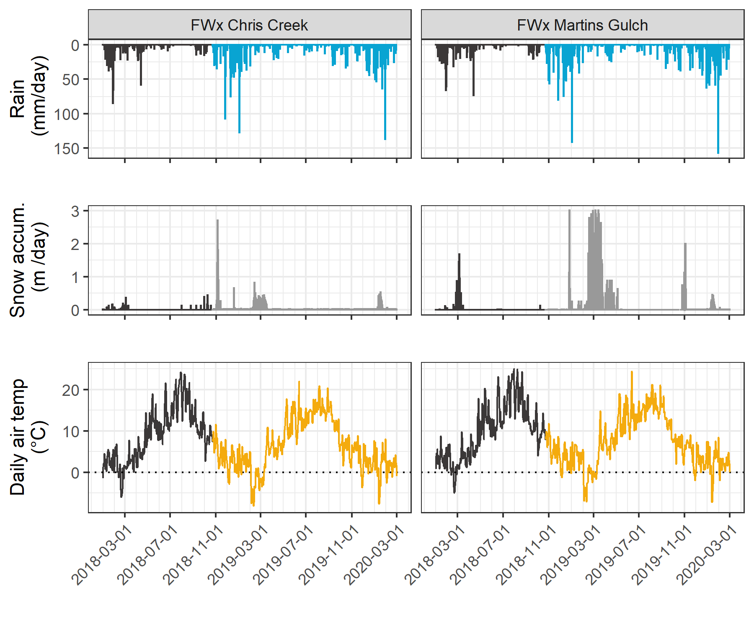

Figure 2: *Weather from two stations in the Leech water supply area. Coloured sections of plots highlight the field study period of this project.*

Table 2: *Two years of weather from CRD stations in Leech water supply area*

|  |  |  |  |  |  |  |  |
| --- | --- | --- | --- | --- | --- | --- | --- |
| Year | station name | annual precip. (mm) | max snow (m) | mean air temp. (°C) | stdev air temp.  (± °C) | mean max. temp. (°C) | mean min. temp. (°C) |
| 2018 | FWx Chris Creek | 1967.8 | 3.09 | 8.1 | 7.5 | -11.9 | 34.8 |
| 2018 | FWx Martins Gulch | 2042.3 | 3.01 | 8.9 | 7.3 | -9.5 | 32.9 |
| 2019 | FWx Chris Creek | 1428.4 | 3.09 | 7.5 | 7.2 | -13.7 | 31.9 |
| 2019 | FWx Martins Gulch | 1486.7 | 3.01 | 8.4 | 6.9 | -12.7 | 30.5 |
| Jan-Feb 2020 | FWx Chris Creek | 837.2 | 3.09 | 1.6 | 3.7 | -9.6 | 10.5 |
| Jan-Feb 2020 | FWx Martins Gulch | 930.4 | 3.01 | 2.2 | 3.6 | -9.3 | 11.2 |

Using the R package *Rainmaker* (USGS), rain data were used to define events that corresponded to sampling campaigns. Seasons were operationally defined based on periods with or without major rain events, where “wet” season included major events and “dry” season did not.

### River sampling

Sixteen months of bi-weekly field work was completed with the goals of contributing to the characterization of the Leech Water Supply Area (LWSA) while furthering our understanding of the variability of dissolved organic matter (DOM) dynamics in hydrologic response across a second growth forested watershed. A total of 446 samples were collected from November 2018 to February 2020, all samples were analyzed and some were excluded during QA/QC, resulting in 393 unique samples included in data analyses and results (Table 3). Samples were collected and analyzed at UBC for DOC concentration and DOM character via high temperature combustion and UV-Vis spectroscopy (respectively). In addition, two sets of replicate samples from four sites were sent to forWater partners at the University of Waterloo for source water analyses of drinking water treatability metrics; and an additional 42 samples were collected on behalf of the CRD for analysis of a suite of total metals at an external laboratory (see Appendix).

Table 3: *Summary of samples collected*

|  |  |
| --- | --- |
| sample category | total count |
| synoptic Grab samples outside of monitoring sites | 53 |
| opportunistic Grab samples | 17 |
| monitoring sites synoptic Grab samples | 153 |
| monitoring sites vertical Rack samples | 170 |
| total samples analyzed for results | 393 |

#### Synoptic sampling

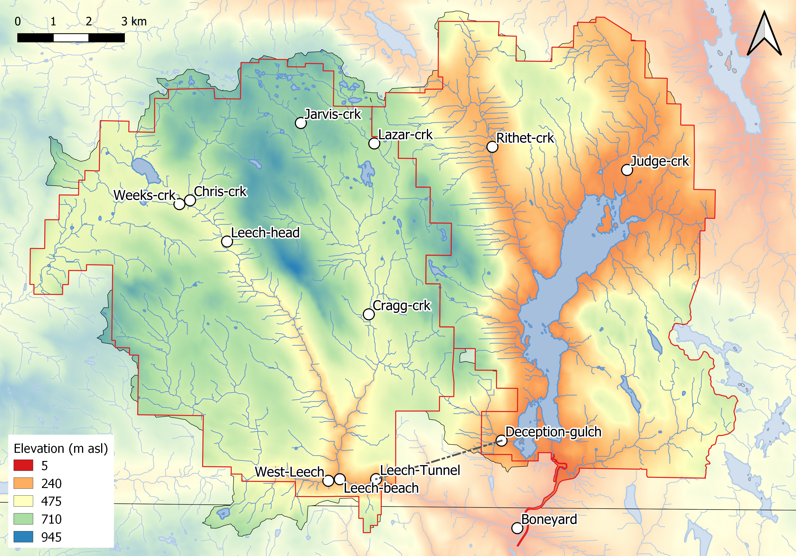

Figure 3: *Synoptic sampling sites across the Greater Victoria Water Supply Areas.*

Thirteen sites were selected for synoptic water sampling and water quality analyses, and their results were used to elucidate temporal patterns in DOM and DOC dynamics. Synoptic samples were collected bi-weekly to monthly from October 2018 to February 2020; a total of 206 unique synoptic samples were collected (229 including replicates). Figure 3 shows the locations of the synoptically sampled sites. Grab sampling at these sites involved collecting river samples in triple-rinsed acid-washed 250mL amber HDPE bottles. Samples were capped with minimal headspace and transported on in a cooler (on ice) to the lab for analysis.

#### Sampling across nested catchments of the Leech watershed

Across the Leech Water Supply Area (LWSA), six of the synoptic sampling sites were selected for more intensive monitoring. These sites represented the LWSA drainage basin defined from the the point of (future) diversion, the Leech Tunnel, and five sub-basins nested within the Leech Tunnel catchment. Figure 4 shows a map of the six monitoring sites and their catchment boundaries which were delineated using each sampling site as the drainage outlet. The sub-basins represent important portions of the Leech River system: two headwater streams (Weeks and Chris Creek, sites 1 & 2), the head of Leech River below the confluence of the two headwater streams (site 3), two mainstem rivers that feed the Leech (Cragg Creek and West Leech, sites 4 & 5). Site 6 was located at the Leech River Tunnel and the drainage area included the entire LWSA.



Figure 4: *Research sites in the Leech Water Supply Area. Sites are named and numbered, where the number indicates both the sequence of vertical rack installations as well as the relative progression from headwaters to mouth. Each research basin boundary is outlined in black, and the water supply area boundary is delineated in red.*

Table 4 includes watershed characteristic data for each of the six research site basins. Weeks Creek (site 1), had the greatest proportion of wetland and open water compared to the other sub-basins. Chris Creek (site 2) and Cragg Creek (site 4) had no metasedimentary parent material (Argillite-Metagraywacke or Metagraywacke). Cragg Creek, draining from the east, was the only sub-basin with predominantly metamorphic parent material (Wark-Gneiss, 78%). West Leech (site 5) was the only sub-basin that did not have Wark-Gneiss nor Chert-Argillite-Volcanic groups as parent materials, and was the only sub-basin of the Metchosin igneous complex (16% Methchosin-volcanics). Like Weeks basin (site 1), which also drains from the West, WestLeech is predominantly underlain by Argillite-Metagreywacke (metasedimentary parent material).

Table 4: *Watershed characteristics summary for study sites*

|  |  |  |  |  |  |  |
| --- | --- | --- | --- | --- | --- | --- |
| Site number | 1 | 2 | 3 | 4 | 5 | 6 |
| Full Site name | Weeks Main Creek | Chris Creek | Leech River Head | Cragg Creek | West Leech | Leech River Tunnel |
| Short-hand name (used throughout report) | Weeks | ChrisCrk | LeechHead | CraggCrk | WestLeech | Tunnel |
| Latitude | 48.5757 | 48.5774 | 48.5665 | 48.5478 | 48.5069 | 48.507 |
| Longitude | -123.8456 | -123.8403 | -123.8257 | -123.7711 | -123.7847 | -123.7674 |
| Elevation (m a.s.l) at installation | 521 | 522 | 476 | 509 | 248 | 207 |
| Sub-basin Class | Headwater | Headwater | Mainstem (headwater) | Mainstem | Mainstem | Outlet (mainstem) |
| Strahler order | 3 | 3 | 4 | 4 | 4 | 5 |
| Drainage area (km2) | 11.5 | 5.9 | 20.6 | 28.1 | 20.9 | 95.3 |
| Forest cover (%) | 94.5 | 99 | 96.6 | 97.8 | 98.5 | 97.6 |
| Wetland cover (%) | 4.2 | 0.8 | 2.6 | 1.6 | 0.4 | 1.1 |
| Open water coverage (%) | 2.9 | 0.6 | 1.8 | 0.9 | 0.3 | 0.7 |
| Average slope (degrees) | 9.1 | 10.5 | 10.2 | 9.5 | 11.3 | 11.8 |
| Standard dev. of mean slope (degrees) | 7 | 6.2 | 7.1 | 6.1 | 7.9 | 8.5 |
| Minimum (non-zero) slope (degrees) | 8 | 10 | 9 | 9 | 9 | 10 |
| Maximum slope (degrees) | 44 | 38 | 50 | 40 | 56 | 61 |
| Parent Material |  |  |  |  |  |  |
| Wark-Gneiss (%) | 13.6 | 44.9 | 20.5 | 77.6 | 0 | 30.6 |
| Argillite-Metagreywacke (%) | 64.2 | 0 | 42.1 | 0 | 76.8 | 45.1 |
| Metagreywacke (%) | 0 | 0 | 0 | 0 | 7.2 | 1.6 |
| Chert-Argillite-Volcanic (%) | 22.2 | 55.1 | 37.4 | 22.4 | 0 | 17.9 |
| Metchosin Volcanics (%) | 0 | 0 | 0 | 0 | 16 | 4.2 |
| Gabbro Stocks (Sooke-Gabbro, %) | 0 | 0 | 0 | 0 | 0 | 0.7 |
| Forest Harvest History |  |  |  |  |  |  |
| 1980s forest harvest (%) | 11.2 | 56.3 | 28.6 | 30.8 | 21.6 | 24.2 |
| 1990s forest harvest (%) | 11.7 | 3 | 9.6 | 8.7 | 3 | 5.9 |
| 2000s forest harvest (%) | 4.5 | 3.4 | 4.1 | 1.1 | 1.1 | 2.9 |
| 2010 & 2011 forest harvest (%) | 0.6 | 0 | 0.4 | 0.7 | 0.1 | 0.9 |

##### Installations

At each of the six monitoring sites, a vertical sampling rack was installed. These racks collect discrete water samples during the rising limb of stormflow, without employing costly pump-samplers. Each vertical rack also included a water level logger that recorded continuous stage (at ten-minute intervals). Vertical sampling racks achieved advanced synoptic sampling within stormflow by providing synchronized spatial sampling resolution that would otherwise be difficult to achieve (i.e., sampling multiple sites across the watershed at approximately the same time). Simultaneous stormflow sample collection can provide insights about relative hydrologic pulse responses across nested catchments (Abbott et al. 2018). Vertical racks collected samples during flows that would otherwise be difficult or unsafe to access, and were supplemented with standard grab samples between storm events and during summer baseflow.

The passive sampling bottles employ principles of a siphon design to collect river water as it reaches pre-determined levels on a vertical sampling rack. Siphon sampler bottles were based on a USGS single stage sediment sampler design (US U-59, 1961) which passively collect discrete water samples at a fixed stage on the rising limb of the hydrograph (Graczyk et al. 2000). The siphon samplers built for this research were 250 mL amber HDPE widemouth bottles with augmented screw caps. The caps were fit with two 1/4" (OD) stainless steel tubes, one longer than the other, both with a 180 $​^{∘}$ bend at the top end.

Each rack included a central stilling well (3.81cm (1.5“) PCV pipe with 1.27 cm (1/2”) holes along the length) with a measuring tape affixed to the front. Inside the stilling well was an Odyssey Capacitance Water Level Logger (Dataflow Systems Ltd., New Zealand); and on either side of the central stilling well was a slotted offset angle bar onto which hose clamps held sample bottles fit with custom siphon lids. Each rack also included sensors (HOBO TidbiT v2 Temperature Data Logger, Onset, USA) that recorded air and water temperatures (Figure 5). By combining the height at which each siphon bottle filled with observed stage (stilling-well measuring tape) and level-logger data, the date and time for collection of each rising-stage sample was determined.



Figure 5: *Vertical sampling rack and siphon sampler bottle, illustrative of installations at six sites across the LWSA (shown here is Chris Creek (site 2).*

These vertical racks collected whole water samples on the rising limb of the hydrograph. The rising limb has been shown to have higher DOC concentration than low flows between storm pulses (Yang et al. 2015; Raymond et al. 2016, 2010; Zarnetske et al. 2018). Increasing DOC on the rising limb indicates that source material is not limited and flux is driven by hydrologic connectivity; whereas source limited conditions likely drive DOM dynamics if DOC concentration decreases on the rising limb (Zarnetske et al. 2018). Analysis of rack samples clarifies the magnitude and direction of water quality changes in response to precipitation relative, which provides information about solute supply and hydrologic connectivity (Vidon, Wagner, and Soyeux 2008; Abbott et al. 2018; Creed et al. 2015; Zarnetske et al. 2018).

### Analytical techniques & data handling

Water samples were collected and transported in coolers with ice to UBC’s EcoHydrology Lab (Earth Science Building) for analysis of dissolved organic carbon (DOC) concentrations and spectroscopic absorbance (indicator of NOM character). Samples were also measured for phosphate concentration using a colourmetric (ascorbic acid) orthophosphate test kit (HACH PO-19); each sample had phosphate concentration below detectable limits (0.1 mg/L).

#### Dissolved organic carbon (DOC) concentration and characterization

For quantification of DOC, samples were analyzed for non-purgeable organic carbon (NPOC) via High-Temperature Combustion (Method 5310-B) on a Shimadzu TOC-V (Eaton, A. D., Clesceri, L. S., Greenberg, A. E., Franson 2000). For this method, samples were filtered with 0.45-micron PES filters, acidified to bring pH below 2, then sparged with hydrocarbon-free air to drive off inorganic carbon. Following sparging, samples were combusted to convert all organic carbon to carbon dioxide which was measured by non-dispersive infrared gas detector to quantify the DOC content of the sample. This method represents a direct measure of DOC; although small volatile organic compounds would be removed in the sparging process, most NOM compounds are of higher molecular weight and it is unlikely that NOM analytes would be lost (Eaton, A. D., Clesceri, L. S., Greenberg, A. E., Franson 2000; Matilainen et al. 2011).

Spectral properties of sample NOM were analyzed using a ‘spectro::lyser’ spectrophotometer (S::can, Vienna, Austria) which measures turbidity and the chromophoric portion of organic matter to estimate concentrations of total organic carbon (TOC), dissolved organic carbon (DOC), as well as nitrate-nitrogen (NO3--N). For NOM to be detected by UV-Vis absorption, the molecules must absorb ultraviolet (UV) or visible (Vis) light, which relies on the electronic structure of the molecules. UV-Vis absorption requires the presence of conjugated pi-bond systems (i.e., chromophore) in the molecule, which are common in aromatic systems. Therefore, DOC quantified by the spectro::lyser is a proxy measure that represents the chromophoric component of DOM (CDOM), which is proportional to the samples’ average aromaticity. The suite of molecules that comprise NOM generally have an aromatic character (Weishaar et al. 2003). Increasing aromaticity will lead to greater absorbance at longer wavelengths, therefore an absorbance spectrum can provide information about a samples molecular character. For example, absorption of near-UV wavelengths (i.e., 200-380 nm) is indicative of conjugated systems that are common to aromatic compounds; as such, specific UV absorbance at 254nm (SUVA254) has been adopted as a surrogate for DOM aromaticity and, to some extent, its reactivity (Weishaar et al. 2003; Chow et al. 2008). The spectro::lyser measures absorbance from 200 nm to 750 nm wavelengths, across which several spectral indicies can be calculated.

##### SUVA254

Specific ultraviolet absorbance at 254nm (SUVA254) is the ratio of UV absorption (spectral absorbance coefficient, SAC, m-1) at 254nm wavelength, normalized to DOC concentration (Weishaar et al. 2003). SUVA254 is reported in units of liter per milligram carbon per meter (Lmg-C-1m-1) and was determined by dividing the UV absorbance measured at wavelength 254nm (SAC254) by DOC concentration ( mgL-1 as NPOC). SUVA254 correlates strongly with DOM aromaticity, and also with chemical reactivity (Weishaar et al. 2003; Helms et al. 2008; Chow et al. 2008). A higher SUVA value indicates greater aromaticity, and a lower SUVA value indicates more alliphatic DOM. Because humic substances (i.e., allochthonous NOM) are more aromatic, SUVA254 is a good indicator of humic sources of DOM (Weishaar et al. 2003; Vidon, Wagner, and Soyeux 2008; Abbott et al. 2018).

With respect to SUVA254 and drinking water treatability, it’s important to consider the diversity of DOM and DBP species and the heterogeneous character contained in a water sample. While SUVA254 may indicate reactivity, it is not necessarily a strong indicator of DBP-FPs (Weishaar et al. 2003; Chow et al. 2008). This is because some DBP precursor NOM components (e.g., alliphatics), which have negligible absorptivities in the UV-Vis range, may contribute to DBPs but not SUVA254; additionally, not all NOM with measurable SUVA254 will create DBPs (Weishaar et al. 2003).

##### Spectral indices of NOM character

Based on full scan data from the Spectrolyser (250-700nm), several indices of NOM character were determined. In the absence of fluorescence excitation-emission matrices, or high resolution spectrometric methods, spectral slopes are a simple tool for getting at molecule character. Spectral slopes (i.e., the change in absorbance intensity over a range of wavelengths) are semi-quantitative indicators for assessing DOM molecular size (weight) and aromaticity (Helms et al. 2008).

Spectral slopes over the wavelength range of 275-295 nm (S275-295) and 350-400 nm (S350-400) were calculated from linear regression of loge-transformed spectral absorbance coefficients (m-1) as indicated by Helms (2008, p 958). Slope ratio (SR) is a unitless value equal to the ratio of S275-295 to S350-400 and is inversely proportional to CDOM molecular weight (Helms et al. 2008). A similar parameter is a quotient called E2:E3, which is the ratio of absorbances at wavelengths 250-nm and 365-nm, and is inversely related to aromaticity and molecular size of aquatic humic solutes (Peuravuori and Pihlaja 1997; Helms et al. 2008). E2:E3 values were calculated, along with SR , to try to elucidate molecular character of DOM in samples.

#### Quality Assurance & Quality Control

UBC based laboratory QA/QC included analysis of blanks and replicate samples. A calibration curve was generated for the Shimadzu TOC-V each time the zero-air gas cylinder was replaced and accuracy was ensured with analysis of calibration verification standards. Analytical accuracy was determined to be 3.7% based on analysis of 20 calibration verification standards included throughout sample analyses.

The spectro::lyser has been shown to effectively determine DOC content and character on unfiltered samples (Avagyan, Runkle, and Kutzbach 2014). However, suspended matter may bias absorbance values due to non-DOC light absorption or scattering. Therefore, unfiltered water samples that had detectable turbidity (greater than 0.000 FTU) were removed from data analysis; this reduced the spectral dataset by 9.5%.

##### Siphon sampler assumptions: vertical rack sampling

Rising level siphon samplers collect water from approximately 5cm below the surface (top of intake tube to inlet orifice). Data related to rack samples relies on two key assumptions: the water column is well mixed (no stratification) therefore the sample is representative of water quality at each sampling stage; and the sample is discrete such that there is no infiltration or mixing after the sample is collected. Based on the velocity and turbulence associated with flows in the step-pool formation of the sub-basins, the assumption of unstratified waters seems very reasonable. The assumption of sample discretion was validated in lab using food colouring and a flow-through bucket system where a tap water sample was collected by siphon sample bottle, food colouring was added to flow system after sample collection and circulated for 15 minutes, then the sample bottle was removed from dye chamber and the colour of the sample was compared to surrounding dyed water. There was no dye present in sample bottle following this test, which was repeated five times with different siphon-lid bottles.

##### Sample hold-times and temperatures: vertical rack sampling

Every effort was made to retrieve rack samples as quickly as possible from the racks; none the less, some samples remained on a rack for more than a few days due to logistical, access and safety considerations. Hobo TidbiT temperature sensors were deployed at each vertical rack to monitor air and water temperature, which was used in estimates of sample stability between sample collection and retrieval from racks.

Hold-time experiments were performed to assess sample stability. The hold-time experiments included replicate sample (n = 10) collection at a site, where half the samples were placed out of water on the vertical rack with siphon lids and the other half were returned to the lab for immediate analysis. Three hold-time experiments were completed such that the rack samples were left in the field for 11, 20 and 34 days before being retrieved and analyzed in comparison to their counterpart replicates (details in results section).

## Results

### Weather: precipitation and temperature from CRD weather stations

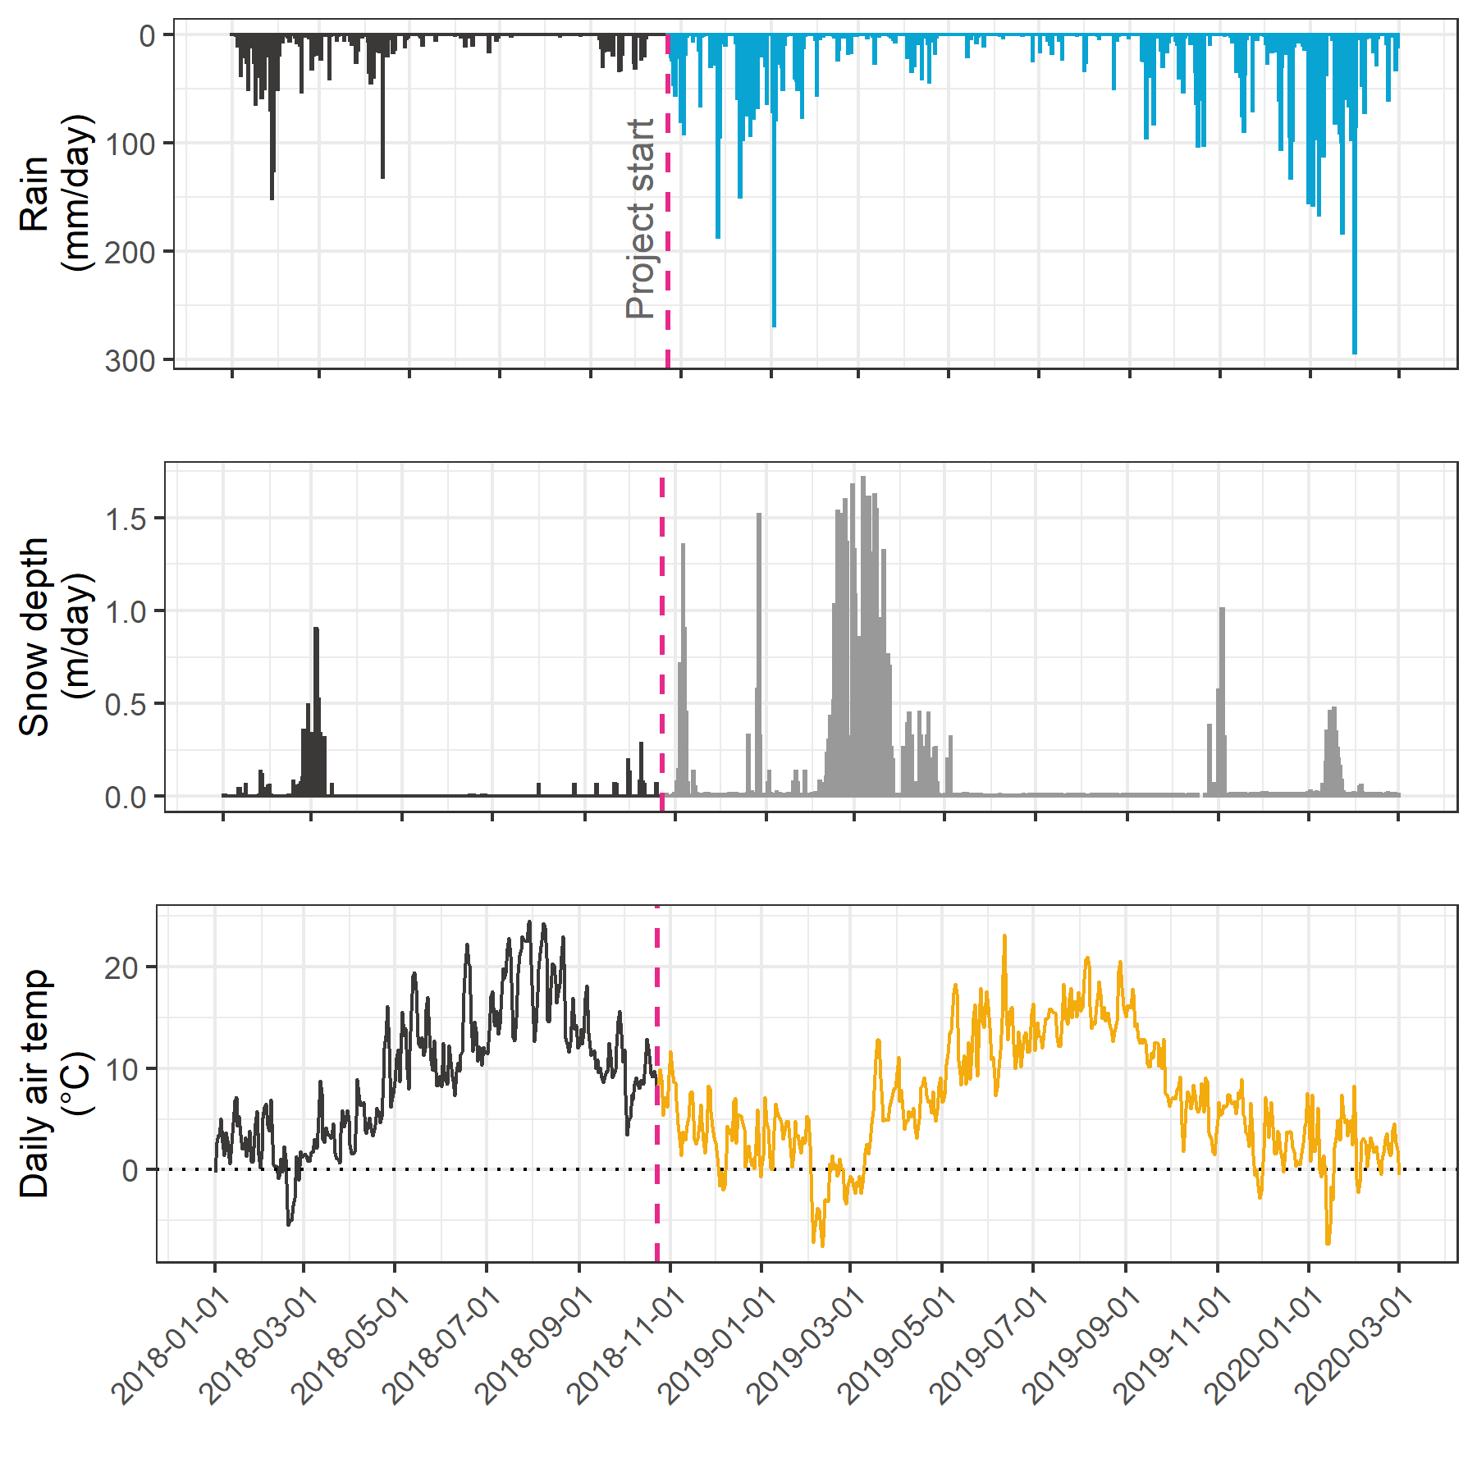The Capital Regional District (CRD) provided data from two fire-weather (“FWx”) stations in the Leech water supply area (LWSA). Chris Creek weather station (561m a.s.l) is located in the headwaters of the Leech watershed and Martin’s Gulch (512m a.s.l) is located near the future point of diversion (Leech River Tunnel). With two weather stations, there were insufficient data points to estimate sub-basin precipitation via Theissen polygons or isohyetal lines; therefore, arithmetic means were calculated based on data from Chris Creek and Martin’s Gulch stations. Average precipitation and air temperature are shown in Figure 6, with the study period highlighted.

Table 5 summarizes weather data by calender year, as well as the very wet period of January and February, 2020. It was assumed that the arithmetic means of rainfall were representative of rain conditions across the Leech watershed and these values were used to define rain events (section 5.3.1.0.1). Mean LWSA temperatures were compared to temperatures recorded at each installation site (section 5.3.1.2). As the CRD FWx stations are situated at elevation, snow depth records were not assumed to be representative of snow cover across the LWSA; however, snow melt contributed to runoff and recorded stage change at the six installation sites.

Table 5: *Average weather data from CRD stations in Leech water supply area in 2018 and 2019*

|  |  |  |  |  |  |  |  |
| --- | --- | --- | --- | --- | --- | --- | --- |
| year | mean annual rain (mm) | stdev rain. (±mm) | max. snow accum. (m) | mean temp. (°C) | st.dev temp. (±°C) | min. temp. (°C) | max. temp. (°C) |
| 2018 | 2005.1 | 52.7 | 3.09 | 8.50 | 0.60 | -10.7 | 33.8 |
| 2019 | 1457.5 | 41.2 | 3.09 | 7.93 | 0.63 | -13.2 | 31.2 |
| Jan & Feb 2020 | 883.8 | 65.8 | 3.09 | 1.90 | 0.40 | -9.4 | 10.8 |

##### Rain events

LWSA mean FWx precipitation data were used to define rain events using the USGS *Rainmaker* package in R (‘RMevents’ function). During the study period there were 151 rain events, and 18 that were classified as major events. Major rain events were defined by precipitation accumulating to 50mm or more, where the events were separated from each other by a period of 14 hours or longer. Table 6 summarizes the eighteen major rain events that occurred during the study period (2018-10-23 to 2020-02-20). Figure 7 shows stream level at each monitored sub-basin along with events and samples collected. Eight of these events were captured in the 2019 water year (2018-2019 wet season), the other ten in the 2020 water year.

Table 6: *Rain events defined by a threshold of 50mm with 14-hour inter-event period*

|  |  |  |  |  |  |
| --- | --- | --- | --- | --- | --- |
| Storm number | Major event no. | Start Date | Duration (days) | Rainfall (mm) | Intensity (mm/hr) |
| 2 | 1 | 2018-10-27 | 6.1 | 124.4 | 0.8 |
| 3 | 2 | 2018-11-03 | 0.9 | 54.8 | 2.4 |
| 15 | 3 | 2018-11-25 | 3.6 | 156.1 | 1.8 |
| 20 | 4 | 2018-12-09 | 4.9 | 205.1 | 1.7 |
| 21 | 5 | 2018-12-15 | 6.2 | 181.6 | 1.2 |
| 22 | 6 | 2018-12-22 | 2.4 | 54.5 | 0.9 |
| 26 | 7 | 2019-01-02 | 4.2 | 227.6 | 2.3 |
| 31 | 8 | 2019-01-17 | 3.0 | 68.7 | 1.0 |
| 101 | 9 | 2019-09-12 | 3.1 | 58.4 | 0.8 |
| 115 | 10 | 2019-10-15 | 6.4 | 136.2 | 0.9 |
| 123 | 11 | 2019-11-15 | 2.3 | 67.6 | 1.2 |
| 132 | 12 | 2019-12-10 | 3.1 | 70.5 | 1.0 |
| 136 | 13 | 2019-12-18 | 4.1 | 112.1 | 1.2 |
| 140 | 14 | 2019-12-31 | 2.0 | 57.1 | 1.2 |
| 141 | 15 | 2020-01-02 | 5.7 | 180.0 | 1.3 |
| 147 | 16 | 2020-01-18 | 9.9 | 238.3 | 1.0 |
| 149 | 17 | 2020-01-30 | 1.9 | 208.8 | 4.6 |
| 151 | 18 | 2020-02-05 | 3.4 | 75.9 | 0.9 |

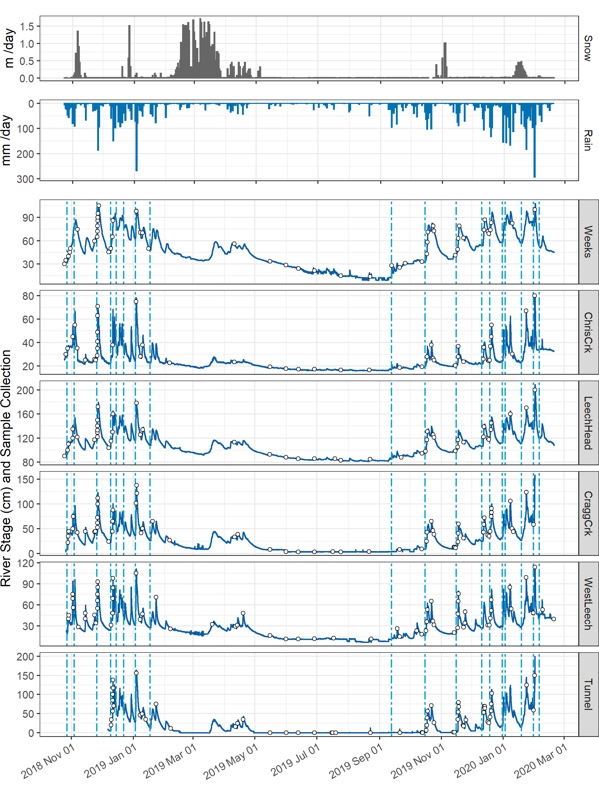

For each calender year in the study period, major rain events’ minimum and maximum values of depth, duration and intensity were identified and are summarized in the subsequent table, Table 7. The maximum intensity event of 2020, on January 30, generated incredible flows across the Leech watershed (and across Vancouver Island and most of the south coast of BC). Streamflow at CraggCrk (site 4) and the Tunnel (site 6) over-topped the vertical racks (greater than 2m tall) and ripped the level-loggers out of their stilling wells.[2] Luckily, the level-loggers were found downstream in February and (after drying the circuit boards) the data were successfully retrieved from both Odyssey loggers.

Table 7: *Minimum and maximum rain event values*

|  |  |  |  |  |  |  |
| --- | --- | --- | --- | --- | --- | --- |
| year | min. duration (days) | max. duration (days) | min rain (mm) | max rain (mm) | min intensity (mm/hr) | max intensity (mm/hr) |
| 2018 | 0.9 | 6.2 | 54.5 | 205.1 | 0.84 | 2.4 |
| 2019 | 2.0 | 6.4 | 57.1 | 227.6 | 0.78 | 2.3 |
| 2020 | 1.9 | 9.9 | 75.9 | 238.3 | 0.93 | 4.6 |

#### Temperature at vertical racks

TidbiT temperature loggers (HOBO TidbiT v2 Temperature Data Logger, Onset, USA) were attached to the top and bottom of each vertical rack installation to record air and water temperature at 30 minute intervals. Loggers at the top of racks recorded air temperature and those at the bottom recorded water temperature (Figure 8).



Figure 8: *Temperatures recorded in air and water on vertical racks at each research site.*

While loggers were installed in both positions (air and water) on each rack at the same time, it wasn’t until mid-October that all sites’ water temperature loggers were submerged. Figure 9 shows the distributions of air and water temperatures at each site, where water temperature was limited to the period when all sites water temperature loggers were submerged. Median water temperatures increased from the headwaters of Leech River to the point of diversion (Leech-Head < Cragg-Crk < West-Leech < Tunnel).

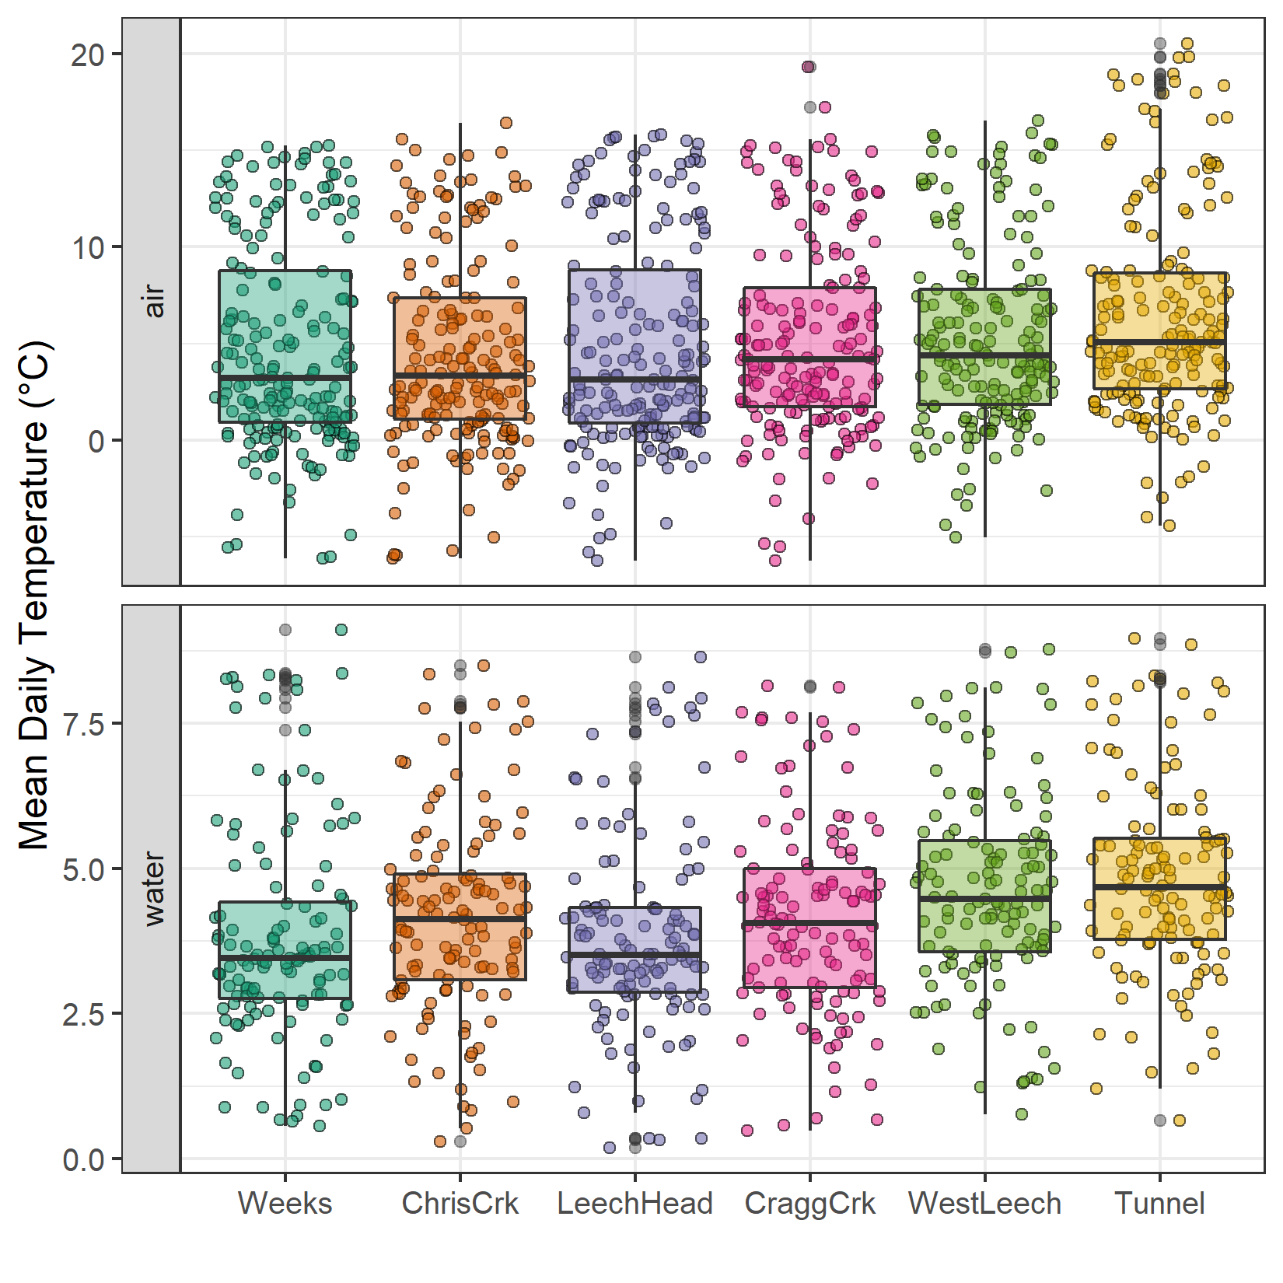

Figure 9: *Temperatures recorded in air and water on vertical racks at each research site.*

#### Air temperature comparison & linear regression

Air temperatures recorded at each of the six sites were compared to LWSA FWx for the overlapping period (August 24, 2019 to February 20, 2020). Overall, FWx temperatures were slightly higher than those recorded at each site installation. Figure 10 shows the density distribution of air temperature measured at each site compared to the LWSA FWx mean.

Results of two-sided Wilcoxon rank sum tests revealed that 15-minute air temperatures at West Leech (site-5) were similar to LWSA FWx (p-value 0.02), and the differences between the other five sites and FWx were found to be significantly different (p-values << 0.001). However, when daily mean temperatures were compared (rather than 15 minute data) the differences between sites and FWx temperatures were less dramatic (Table 8) with no statistical difference (at 90% confidence) for Cragg Crk, West Leech and the Tunnel (sites 4, 5, 6).

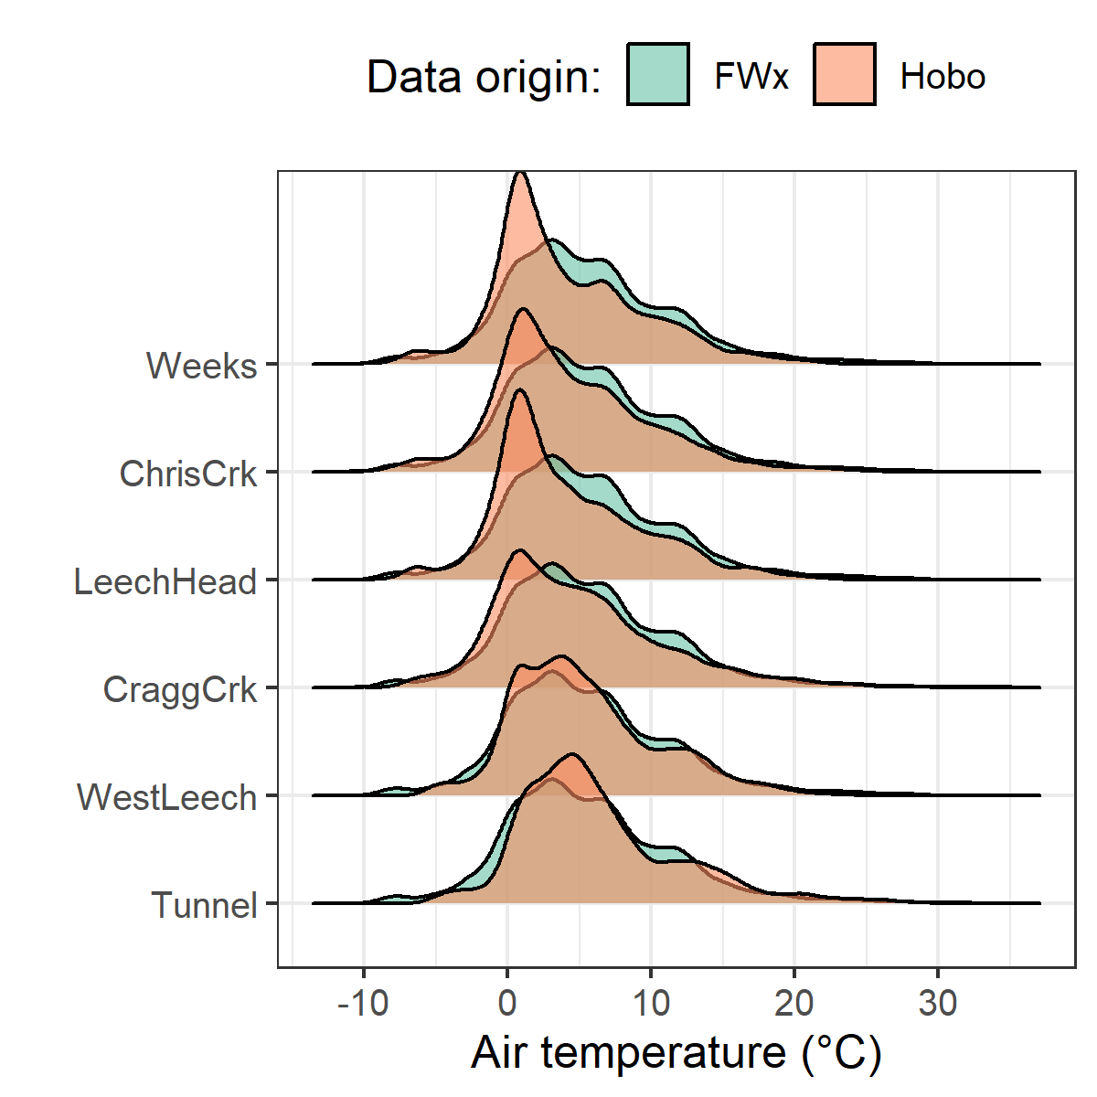

Figure 10: *Density distribution of air temperatures recorded at each sub-basin compared to mean LWSA air temperatures from CRD fire weather stations.*

Table 8: *Relationships between air temperature recorded at each research site compared to mean air temperature recorded by LWSA weather stations.*

|  |  |
| --- | --- |
| Site | p-value |
| Weeks | 0.0016 |
| ChrisCrk | 0.0071 |
| LeechHead | 0.0010 |
| CraggCrk | 0.0472 |
| WestLeech | 0.5757 |
| Tunnel | 0.2927 |

Despite some differences between FWx and Hobo site data, the overlapping FWx and TidbiT daily mean air temperature data were used to generate linear regression relationships to estimate air temperatures at each site for the time preceding Hobo TidbiT deployment (Figure 11). Table 9 summarizes the average percent error of estimated air temperatures based on a test period of overlapping data. Estimated mean daily air temperatures at each site were used in flagging Rack sample data for quality control with respect to days samples remained on vertical racks (hold-times).

Table 9: *Summary of predicted air temperature at each site compared to mean LWSA temperature from CRD FWx stations for the same time period*

|  |  |  |  |  |  |  |  |
| --- | --- | --- | --- | --- | --- | --- | --- |
| Site | Error (%) | Median Temp. (°C) | Estimated Median (°C) | Min. Temp (°C) | Estimated Min. (°C) | Max. Temp (°C) | Estimated Max. (°C) |
| Weeks | 35.0 | 2.9 | 3.9 | -6.1 | -7.6 | 15.3 | 17.7 |
| ChrisCrk | -10.7 | 3.3 | 4.0 | -6.1 | -7.5 | 15.6 | 18.0 |
| LeechHead | -28.9 | 2.7 | 3.8 | -6.2 | -7.3 | 15.7 | 17.2 |
| CraggCrk | 84.2 | 3.7 | 4.7 | -6.2 | -7.0 | 17.2 | 18.9 |
| WestLeech | -61.1 | 4.4 | 5.0 | -5.0 | -6.0 | 16.5 | 18.4 |
| Tunnel | -6.9 | 5.1 | 5.8 | -4.5 | -5.5 | 20.5 | 19.5 |

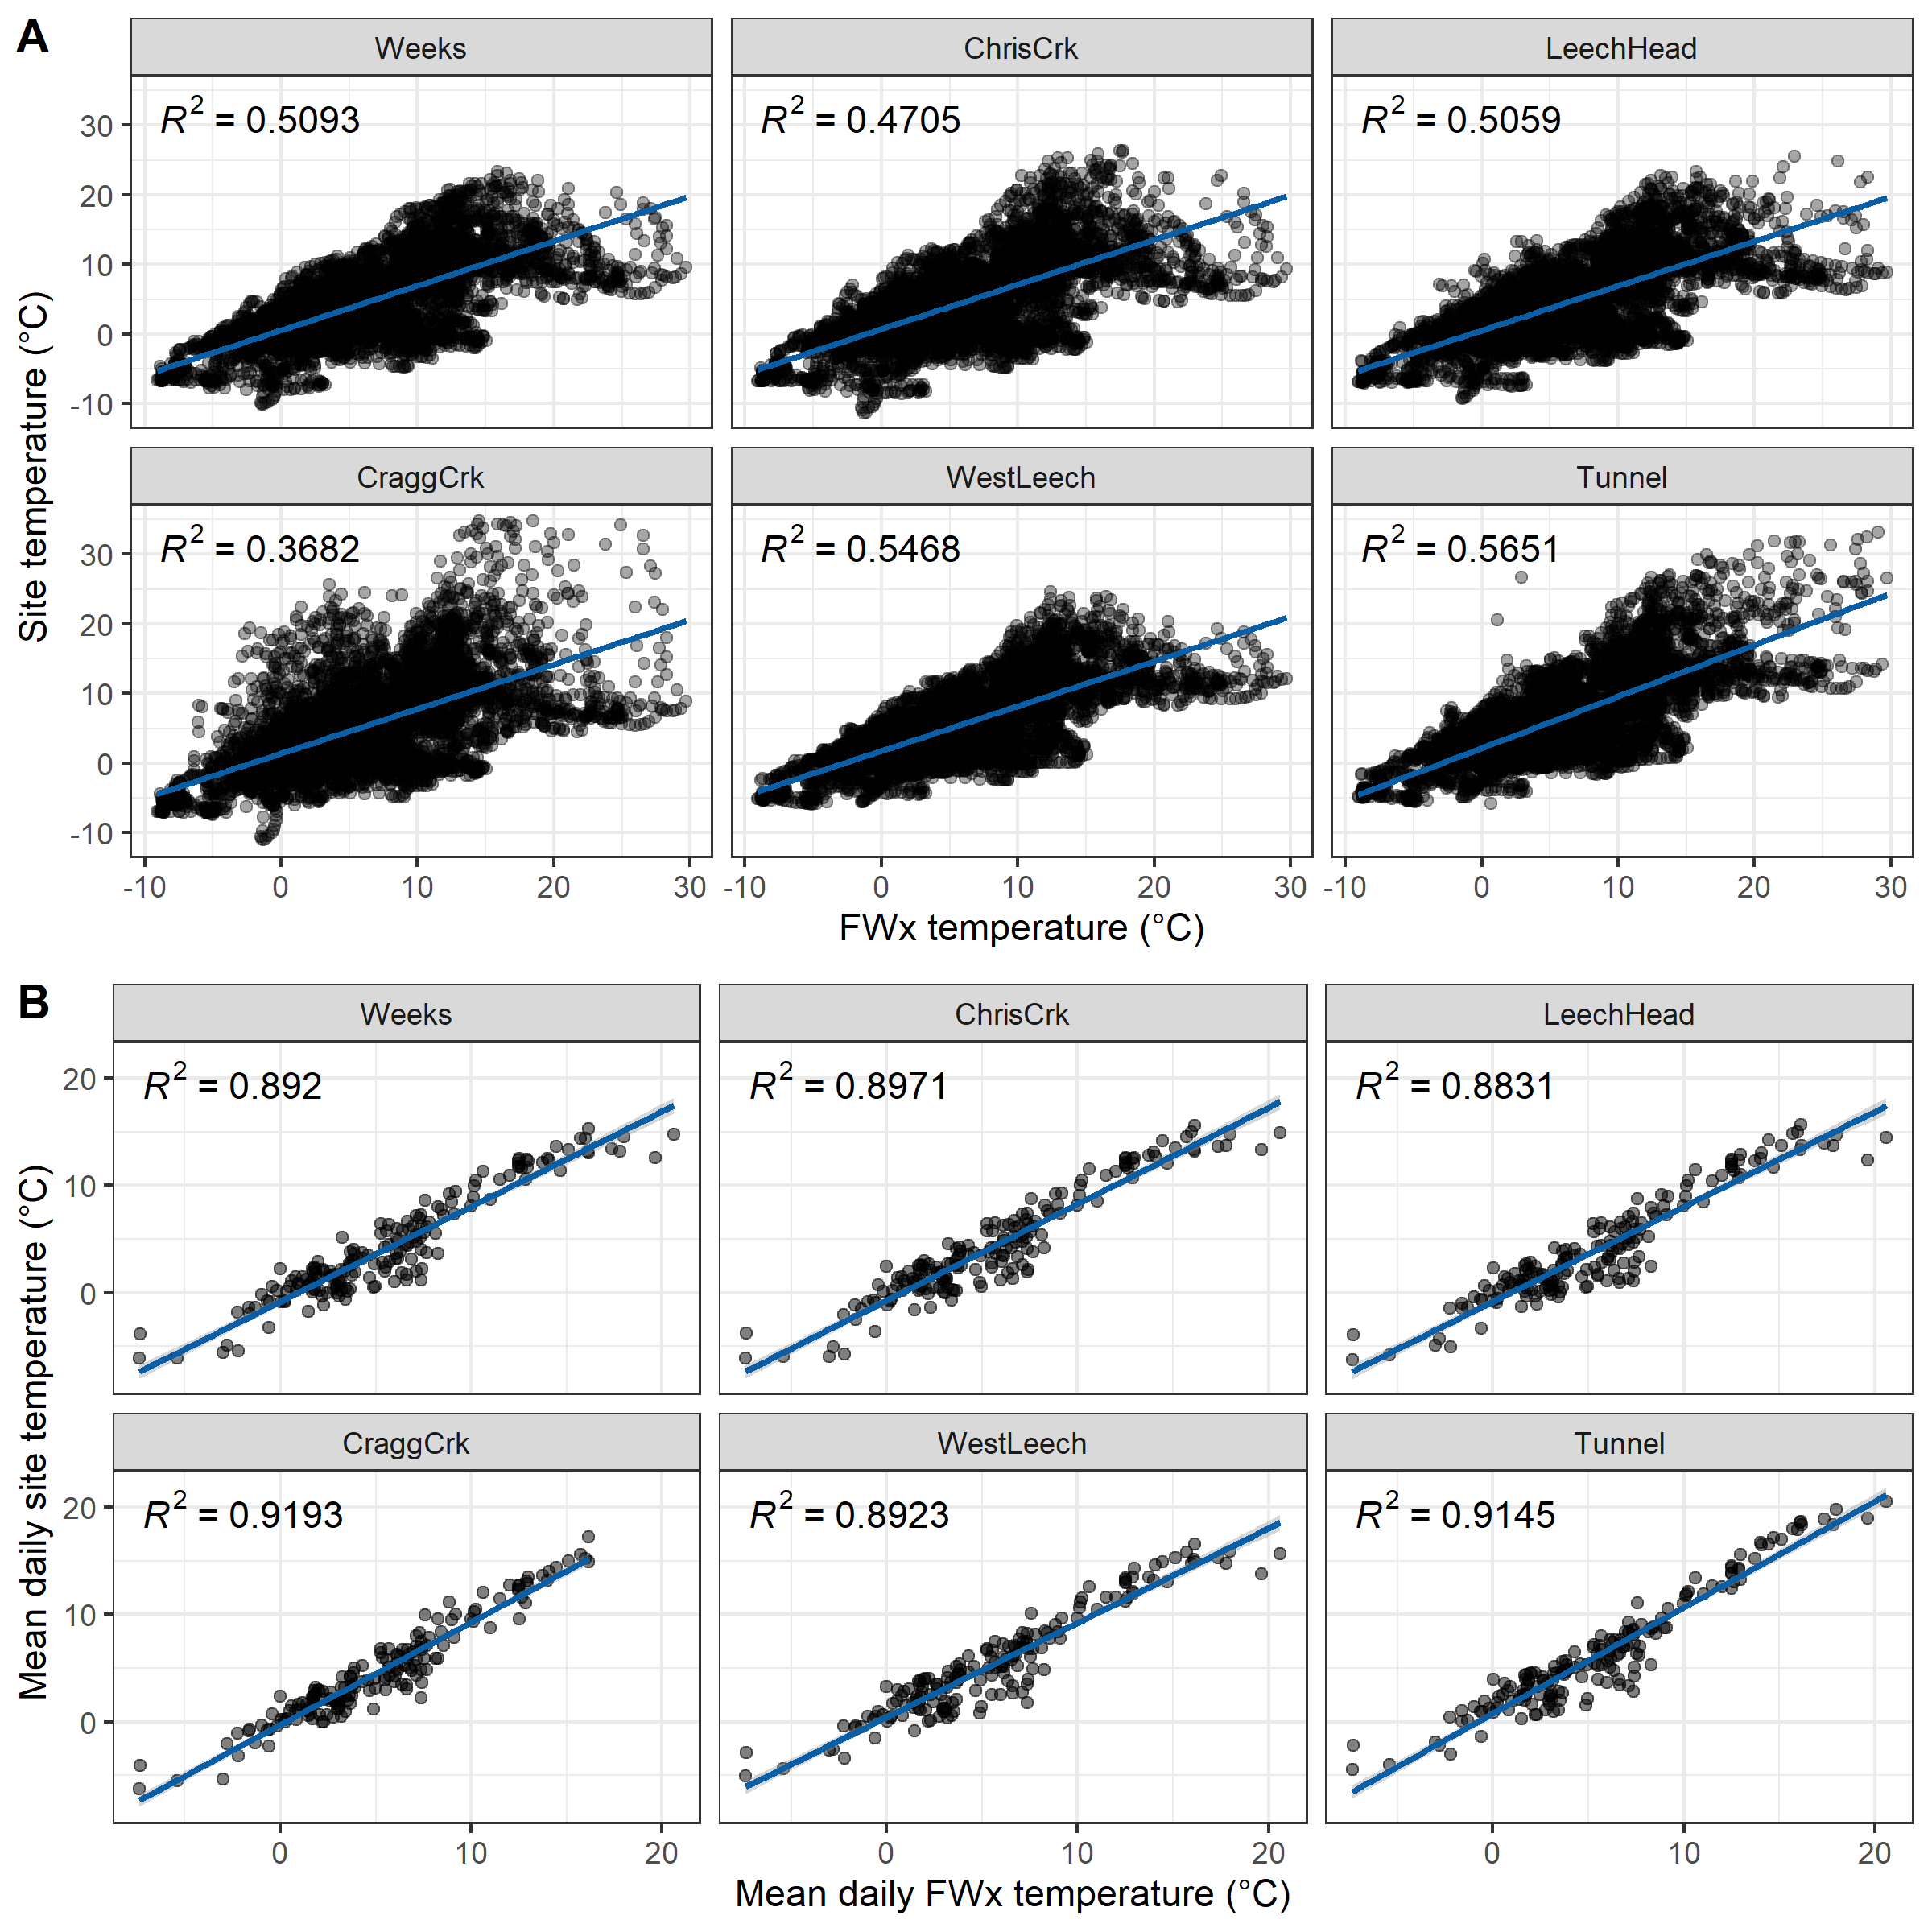

Figure 11: *Relationships between air temperature recorded at each research site compared to mean air temperature recorded by LWSA weather stations. Plots in section A (top) show the relationships for the full data set and plots in section B show daily mean temperatures, the data that was used in linear regression.*

### Quality control: vertical rack hold-time experiments

Hold-time experiments were conducted at the Tunnel site to assess stability of river water samples held in siphon bottles on the vertical rack. Figure 12 summarizes air temperature and timing of the three hold-time sets.

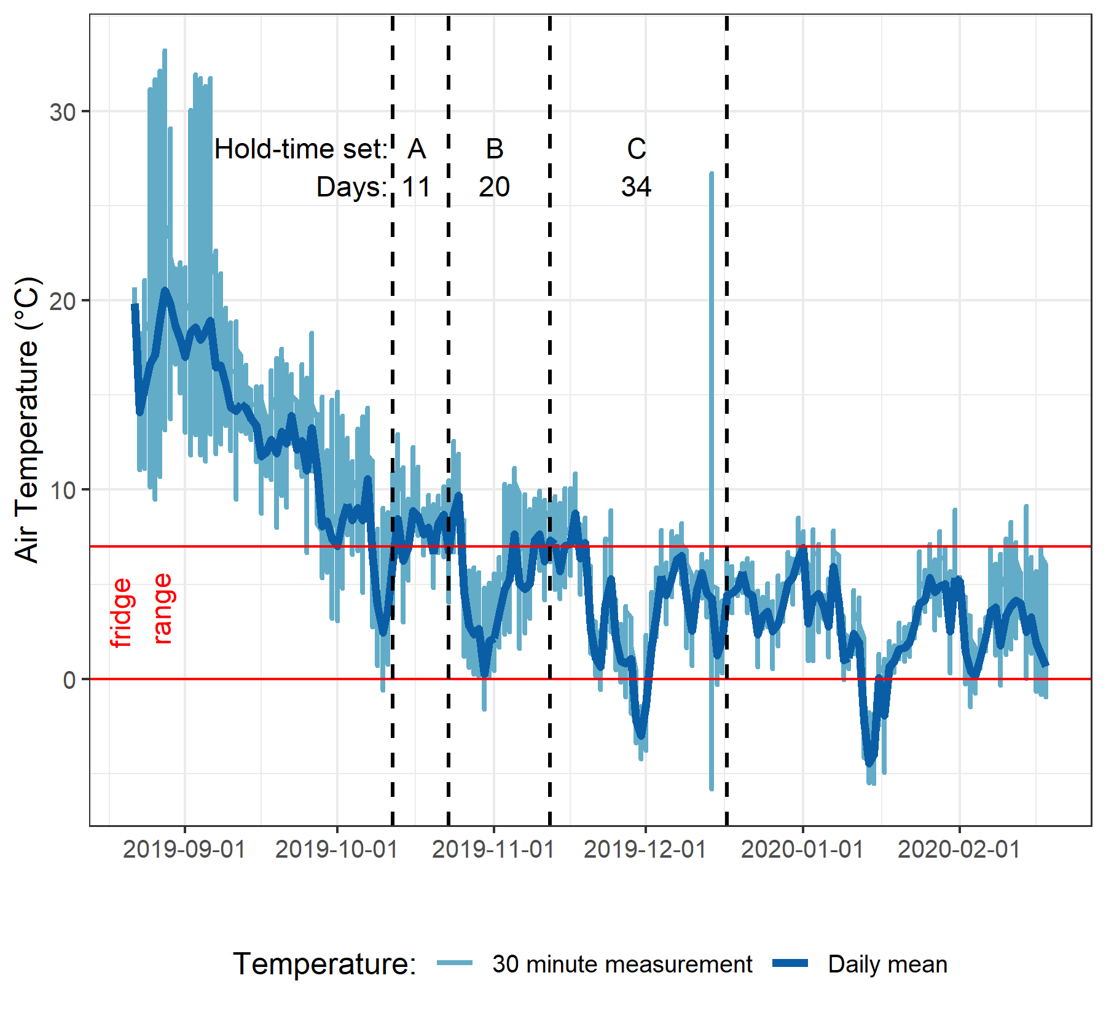

Figure 12: *Plot of air temperature during vertical rack hold-time experiments. Red horizontal lines indicate the 0-7°C range of a typical laboratory refrigerator and dashed vertical lines separate the three sets of hold-time samples from collection of grab samples to retrieval of held samples.*

Each hold-time set included ten replicate samples, each collected at the same time in the same way from the same location. For each hold-time set, five samples were returned to the lab for immediate quantification of DOC and measurement of UV absorbance (“fresh” samples) and five were placed on the vertical rack, capped with siphon lids to simulate rack samples, and collected at a later date for analysis (“held” samples). Figure 13 shows results of sample analyses for DOC and UV254 absorbance of the fresh and held samples of each set, Hold-time sets were compared using two-sided paired Wilcoxon signed rank tests (a.k.a ‘Mann-Whitney’ test)[3] and Table 10 summarizes the number of days the rack samples were held, the mean air temperature over that period, and the percent change in DOC concentration and UV absorbance at 254nm, as well as Wilcoxon test results comparing fresh and held samples.

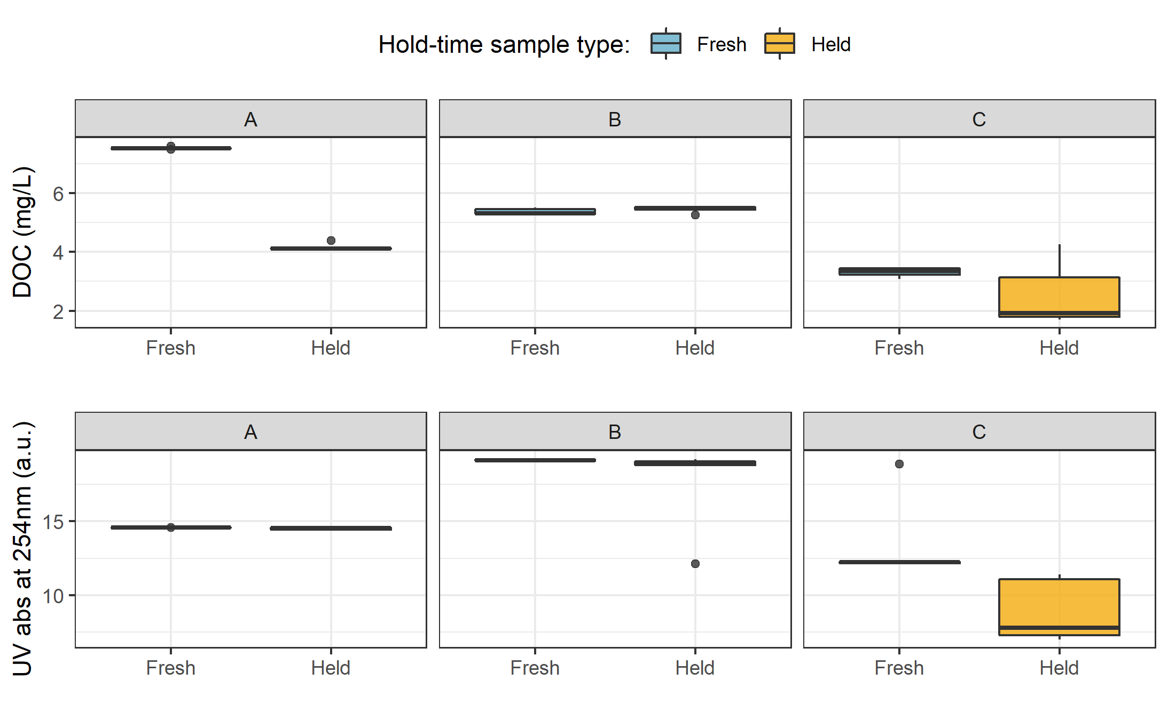

Figure 13: *Sample DOC concentrations and UV absorbance at 254nm contrasting hold-time samples from collection of grab samples to retrieval of held samples.*

Table 10: *Results comparing hold-time sample sets*

|  |  |  |  |  |  |  |  |  |
| --- | --- | --- | --- | --- | --- | --- | --- | --- |
| Set | Days held | Temp range | DOC change (%) | sig.diff (DOC) | p-value (DOC) | UV 254 change (%) | sig.diff (UV 254) | p-value (UV 254) |
| A | 11 | 7.1 ± 2.2 | -45 | * | 0.0625 | 0 |  | 0.1250 |
| B | 20 | 6.0 ± 2.7 | 1 |  | 0.4375 | -8 | * | 0.0625 |
| C | 34 | 4.3 ± 3.2 | -23 |  | 0.1875 | -34 | * | 0.0625 |

While there was no change in UV absorbance for samples from hold-time set-A, there was a significant (at 90% confidence level) change in DOC concentration (p-value = 0.063). Samples collected for hold-time set-A were DOC-rich “first flush” samples, and the Rack samples were held for 11 days at average temperature of 7°C (slightly above laboratory refrigerator temperatures). For set-A, mean DOC concentration was 45% lower in the held samples compared to the fresh grab samples. Set-B had a hold-time of 20 days with average air temperature at 6°C and there was no significant changes in either DOC concentration or UV254 (<10% change). Hold-time Set-C included samples held for 34 days at an average of 4.4°C, including a period of sub-zero temperatures. While set-C did not show significant changes in DOC concentration (23% reduction), there were significant changes to UV254 (34% decrease in absorbance). In addition to the change in absorbance, Set-C held samples had greater variability for both DOC and UV254 compared to the fresh sample counterparts.

These results suggest that early-season (“first flush”) samples may contain more labile DOC which is unstable and should be analyzed immediately after collection, whereas later season samples contain DOC which is relatively more stable for up to and including 20 days when held at temperatures that approximate a refrigerator. A hold-time of 34 days with periods of freezing (set-C) significantly changed sample DOM character via a reduction in aromaticity, and while it did not statistically alter DOC concentration there was a notable increase in held sample DOC standard deviation. Additional tests would be required to determine if the change in DOM character was caused by the length of time the sample was held, or perhaps due only to freezing and thawing, or a combination of both time and temperature.

##### QA/QC data handling

Based on results of the hold-time experiments, results of sample analyses were updated to include QA/QC data flags. Hold-times were calculated for each sample and Rack samples that remained held for fewer than 20 days at temperatures between 0-7°C were flagged as acceptable (“OK”). Rack samples that were held for 20 days or longer and samples identified as early-wet-season (“first-flush”) with a hold-time of 7+ days were flagged as unacceptable. Due to possible freeze-thaw changes, any samples that underwent freezing and thawing were also flagged. QA/QC flags were used to filter data, reducing the number of Rack samples included in analyses by 16.25%. Of 203 Rack samples, 33 were flagged resulting in 170 quality-assured Rack samples included in analyses. Some Grab samples were excluded from analysis due to contamination or

### Nested sub-catchments of the Leech watershed

Six locations across the Leech Water Supply Area (LWSA) were set up as monitoring sites where vertical racks were installed to measure continuous stage and collect water samples as the rivers rose in response to precipitation events. Figure 14 shows major precipitation events and stream response over the study period as well as the timing and stage of samples collected.

Across the LWSA, fluctuations in river stage were temporally synchronized. River responses among the six sites were confirmed to be congruent with high confidence (p-value < 0.001, based on 1050 randomizations) via Kendall’s coefficient of concordance (Kendall’s W = 0.9721) and Spearman’s ranked correlation (ρ = 0.9666).

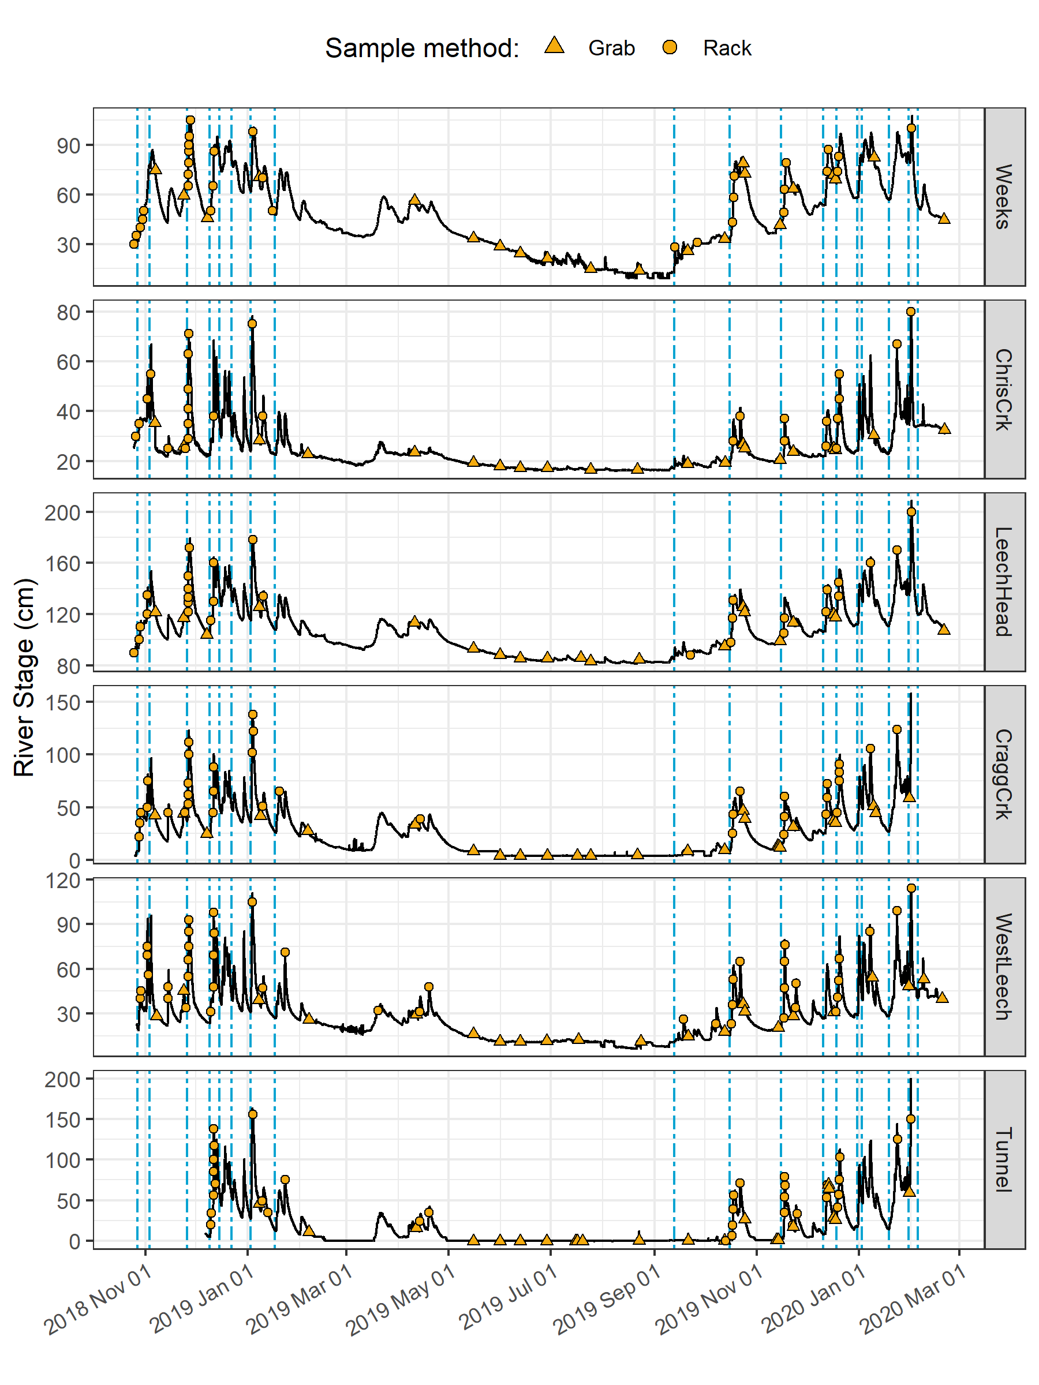

Figure 14: *Rain events, stream response and sample collection across the Leech Water Supply Area. Dashed vertical lines indicate the start of rain events and points indicate the timing and stage of river samples collected.*

#### Spatial variance & DOC concentrations

Sampling of the six research sites was achieved through a combination of vertical rack sampling and synoptic grab sampling. The number of river samples passively collected on vertical racks more than doubled the number of river samples collected by standard grab sampling. Vertical racks collected river samples on the rising hydrograph limb, which has been shown to have higher DOC concentration that non-storm flow (Yang et al. 2015; Raymond et al. 2016, 2010) and can be difficult or dangerous to capture by standard grab sampling, particularly across multiple sites. Indeed, samples with maximum DOC concentrations were captured by vertical racks at five of the six sites, with the exception of Leech River head (*‘LeechHead’*, site 3) where peak DOC happened to be collected as a Grab sample (Table 11).

Table 11: *Summary of DOC across the six LWSA installation sites including breakdown of sample type collected.*

|  |  |  |  |  |  |  |  |  |
| --- | --- | --- | --- | --- | --- | --- | --- | --- |
| Site | Sample type | Sample count | Mean DOC (mg/L) | sd (± mg/L DOC) | RSD (± %) | Min. (mg/L) | Median (mg/L) | Max. (mg/L) |
| Weeks | Grab | 21 | 9.5 | 3.0 | 31 | 6.38 | 9.02 | 18.74 |
| Weeks | Rack | 28 | 10.2 | 3.7 | 36 | 3.78 | 9.94 | 19.07 |
| ChrisCrk | Grab | 19 | 4.2 | 2.3 | 54 | 1.84 | 3.33 | 9.04 |
| ChrisCrk | Rack | 23 | 5.5 | 1.7 | 32 | 2.59 | 5.41 | 9.16 |
| LeechHead | Grab | 19 | 6.8 | 1.7 | 25 | 3.99 | 6.19 | 11.64 |
| LeechHead | Rack | 25 | 7.4 | 1.7 | 23 | 3.95 | 7.26 | 10.57 |
| CraggCrk | Grab | 30 | 4.1 | 1.3 | 32 | 1.79 | 3.74 | 7.47 |
| CraggCrk | Rack | 32 | 5.3 | 1.5 | 29 | 3.00 | 4.91 | 8.22 |
| WestLeech | Grab | 21 | 4.3 | 1.8 | 42 | 2.00 | 4.23 | 9.08 |
| WestLeech | Rack | 36 | 6.7 | 2.2 | 33 | 2.89 | 6.49 | 10.95 |
| Tunnel | Grab | 38 | 4.2 | 1.7 | 41 | 1.65 | 3.71 | 8.85 |
| Tunnel | Rack | 26 | 5.6 | 1.7 | 30 | 2.69 | 5.61 | 9.02 |
| All sites | Grab | 148 | 5.3 | 2.7 | 52 | 1.65 | 4.77 | 18.74 |
| All sites | Rack | 170 | 6.8 | 2.8 | 41 | 2.59 | 6.39 | 19.07 |
| ALL SITES | SUMMARY | 318 | 6.1 | 2.9 | 47 | 1.65 | 5.65 | 19.07 |

Figure 15 shows the distribution of DOC concentrations at each of the six sites. Highest concentrations and variance in DOC occurred at the Weeks Main creek headwater site (*‘Weeks’*, site 1), a sub-basin in the northwest of the Leech watershed which includes Weeks Lake and surrounding wetlands. Lowest average concentration and variance in DOC was recorded at Cragg Creek (*‘CraggCrk’*, site 4), a mainstem river that drains the east sub-basin of the Leech watershed, including Jarvis Lake and the western slopes of Survey Mountain. DOC concentration and variance at Leech River Tunnel (*‘Tunnel’*, site 6) was similar to CraggCrk.

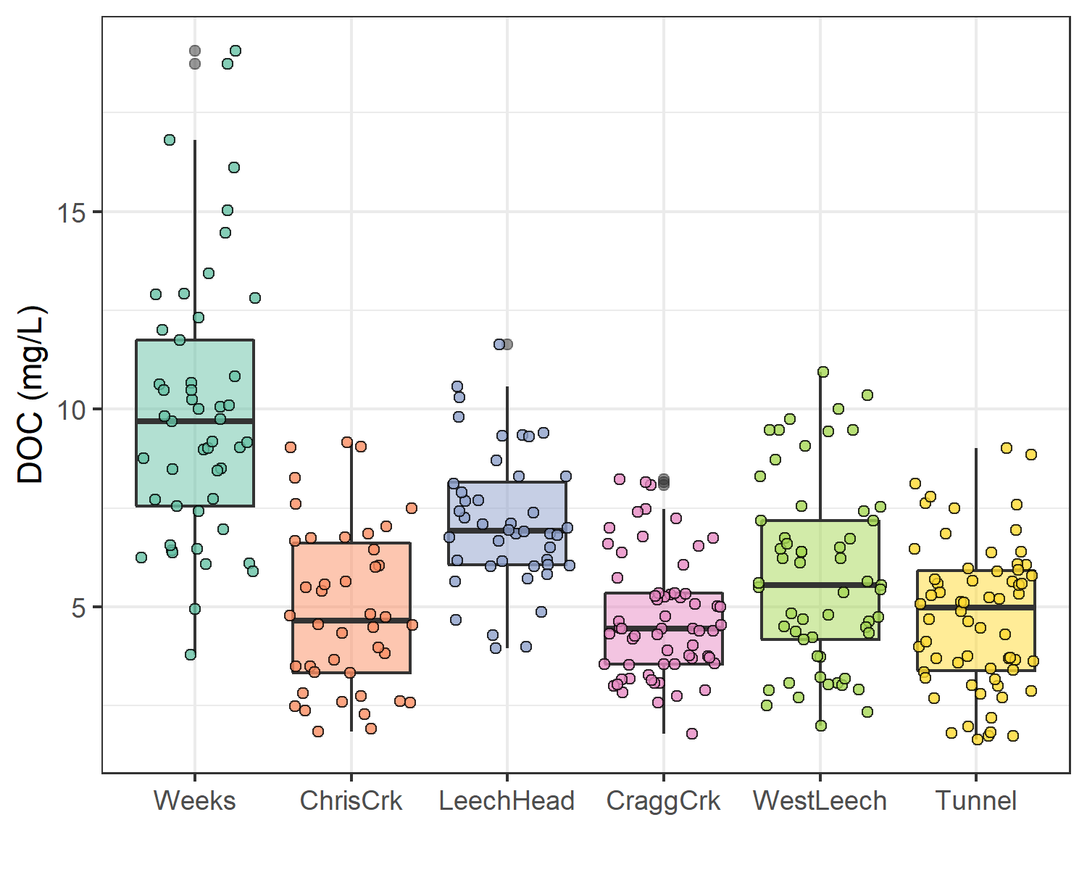

Figure 15: *Dissolved organic carbon (DOC) concentrations across the Leech watershed over sixteen months, collected by standard grab sampling and on vertical racks (318 samples total).*

As the Leech River Tunnel will be the point of diversion for future inter-basin transfers from Leech water supply area (LWSA) to the Sooke Reservoir basin, the Tunnel (site 6) is the effective outlet of the LWSA where runoff from each nested catchment is integrated. Similarly, Weeks and ChrisCrk (sites 1 & 2) are integrated at LeechHead (site 3), which is just below the headwaters’ confluence. Table 12 summarizes the range and variability in DOC within each site and among all sites, with categorical groupings of sub-basins.

Table 12: *Summary of DOC across the six LWSA research sites with each nested catchment classified by basin type.*

|  |  |  |  |  |  |  |  |  |
| --- | --- | --- | --- | --- | --- | --- | --- | --- |
| Site | Basin type | Sample count | Mean DOC (mg/L) | Stdev (± mg/L DOC) | RSD (± %) | Min. (mg/L) | Median (mg/L) | Max. (mg/L) |
| Weeks | headwater | 49 | 9.9 | 3.4 | 34 | 3.78 | 9.69 | 19.07 |
| ChrisCrk | headwater | 42 | 4.9 | 2.1 | 42 | 1.84 | 4.65 | 9.16 |
| LeechHead | mainstem | 44 | 7.2 | 1.7 | 24 | 3.95 | 6.92 | 11.64 |
| CraggCrk | mainstem | 62 | 4.7 | 1.5 | 33 | 1.79 | 4.45 | 8.22 |
| WestLeech | mainstem | 57 | 5.8 | 2.4 | 41 | 2.00 | 5.55 | 10.95 |
| Tunnel | outlet | 64 | 4.8 | 1.8 | 39 | 1.65 | 4.98 | 9.02 |
| summary | headwater | 91 | 7.6 | 3.8 | 50 | 1.84 | 6.95 | 19.07 |
| summary | mainstem | 163 | 5.8 | 2.1 | 37 | 1.79 | 5.55 | 11.64 |
| summary | all nested catchments (sites 1-5) | 254 | 6.4 | 3.0 | 46 | 1.79 | 6.09 | 19.07 |

The relative standard deviation (RSD) in DOC observed at LeechHead was lower than that of the two headwater sites upstream, and median DOC observed at LeechHead was very near to the median for the headwaters sites. Overall, there was greater variance among headwater sites than there was within each headwater site. For the higher order rivers, the variance observed at each mainstem was comparable to the variance among the three mainstems. Results of Levene’s test confirmed that variance in DOC concentrations was not homogeneous across the six sites of the LWSA (p-value = 8.2-10).[4]

To identify which pairs of sites had equal DOC variance Levene’s test was applied to sample DOC results. Table 13 classifies each site comparison by basin-type and summarizes resulting Levene’s test p-values for each pair. Of the nine comparisons made among the six sites, all pairs with WestLeech (site 5) and/or Weeks (site 1) did not have homogeneous variance with any other sites, while all other combinations of sites showed homoscedasticity in DOC. Both of these heteroscedastic sub-basins drain the west side of LWSA.

Table 13: *Results of Levene’s test comparing DOC variance between pairs of sites. Significance stars indicate confidence levels:* ** 99% (alpha = 0.01); ** 95% (alpha = 0.05); * 90% (alpha = 0.1), 90% confidence was the threshold for supporting the null hypothesis of homoscedasticity.*

|  |  |  |  |
| --- | --- | --- | --- |
| Comparison Group | Site Comparison | p.value | Significance |
| headwaters | Weeks & ChrisCrk | 0.01047 | ** |
| headwaters | LeechHead & Weeks | 0.00051 | *** |
| headwaters | LeechHead & ChrisCrk | 0.15472 | homoscedastic |
| mainstems | LeechHead & CraggCrk | 0.47012 | homoscedastic |
| mainstems | LeechHead & WestLeech | 0.01858 | ** |
| mainstems | CraggCrk & WestLeech | 0.00051 | *** |
| mainstem to outlet | LeechHead & Tunnel | 0.50170 | homoscedastic |
| mainstem to outlet | CraggCrk & Tunnel | 0.10260 | homoscedastic |
| mainstem to outlet | WestLeech & Tunnel | 0.03433 | ** |

#### Temporal trends in DOC: seasonality

Over the study period, DOC concentrations followed similar trends across each of the six LWSA sites (Figure 16). DOC was highest early in the wet season and progressively decreased through the fall and winter, reaching minimum concentrations in the spring before progressively increasing again through the summer.

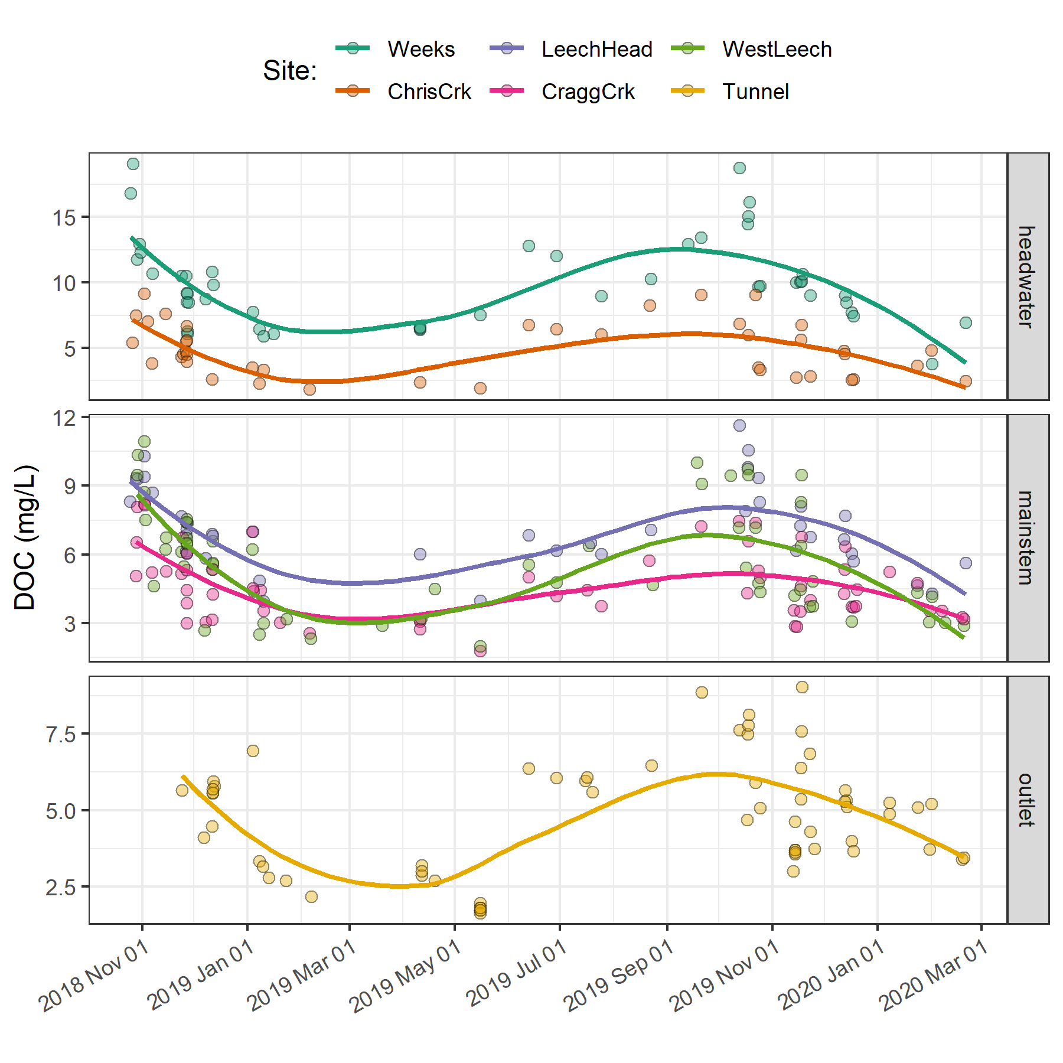

Figure 16: *Trends in dissolved organic carbon concentrations over sixteen months (Oct 2018 to Feb 2020) at six sites across the Leech water supply area (n = 323: 153 grab samples, 170 vertical rack samples.*

Overall, there was very little difference between mean DOC concentration through the wet season (6.2 ± 3 mg/L) compared to the dry season (5.5 ± 3 mg/L). However, there were far fewer samples collected in the dry season than during the wet season (Figure 17.

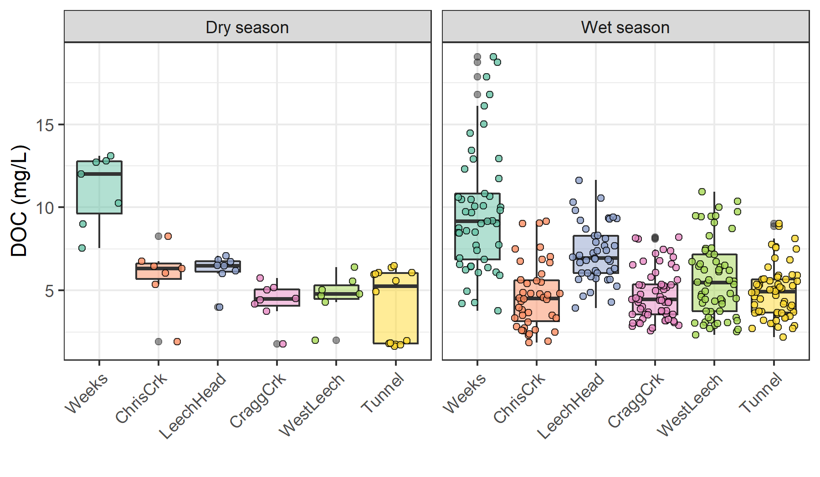

Figure 17: *Boxplots of DOC concentrations at six LWSA sites during dry and wet seasons.*

The wet season was better represented (more samples) than the dry and therefore more interesting in terms of DOC concentration patterns, and the wet season is more relevant with respect to water supply because that is when flows are great enough to allow diversion for inter-basin transfer. High flows also showed increased DOC concentrations. Stormflow samples collected on vertical Racks showed higher DOC than Grab samples manually collected across wet seasons (Figure 18.

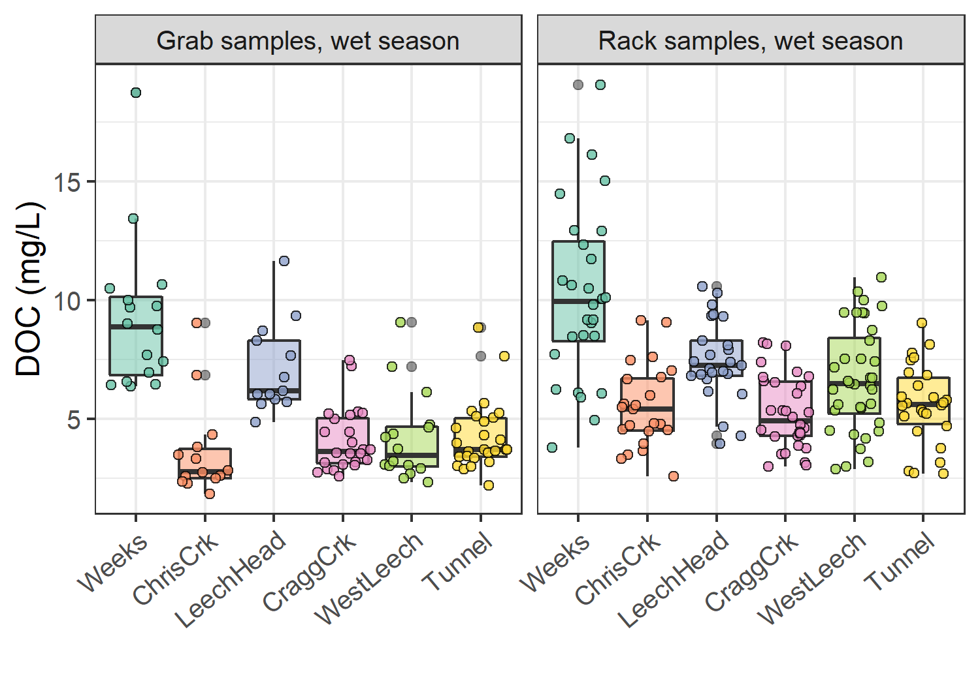

Figure 18: *Wet-season dissolved organic carbon concentrations grouped by site and sample collection method, where Grab samples were manually obtained (n = 109) and Rack samples were collected passively on vertical racks fit with siphon sampler bottles (n = 170).*

#### Spatiotemporal synchrony in local extrema: river stage and DOC

* underdevelopment

Streams responded harmoniously to precipitation across the LWSA, with synchronous changes in stage, but was a similar harmony present for fluctuations in DOC or spectral properties? Aqueous DOC was quantified from discrete river samples, and therefore the temporal synchrony of peaks could not be evaluated in the same manner as stage, which was continuously recorded.

* rising limb DOC (unsure if this is helpful)

*Figure 19 shows rising limb sample DOC concentrations across rain events at the LWSA sub-basins. While there was a typically some increase in DOC with increasing river stage, seasonality appeared to have a greater influence on DOC concentrations than river rise (highest DOC early in the wet season).*

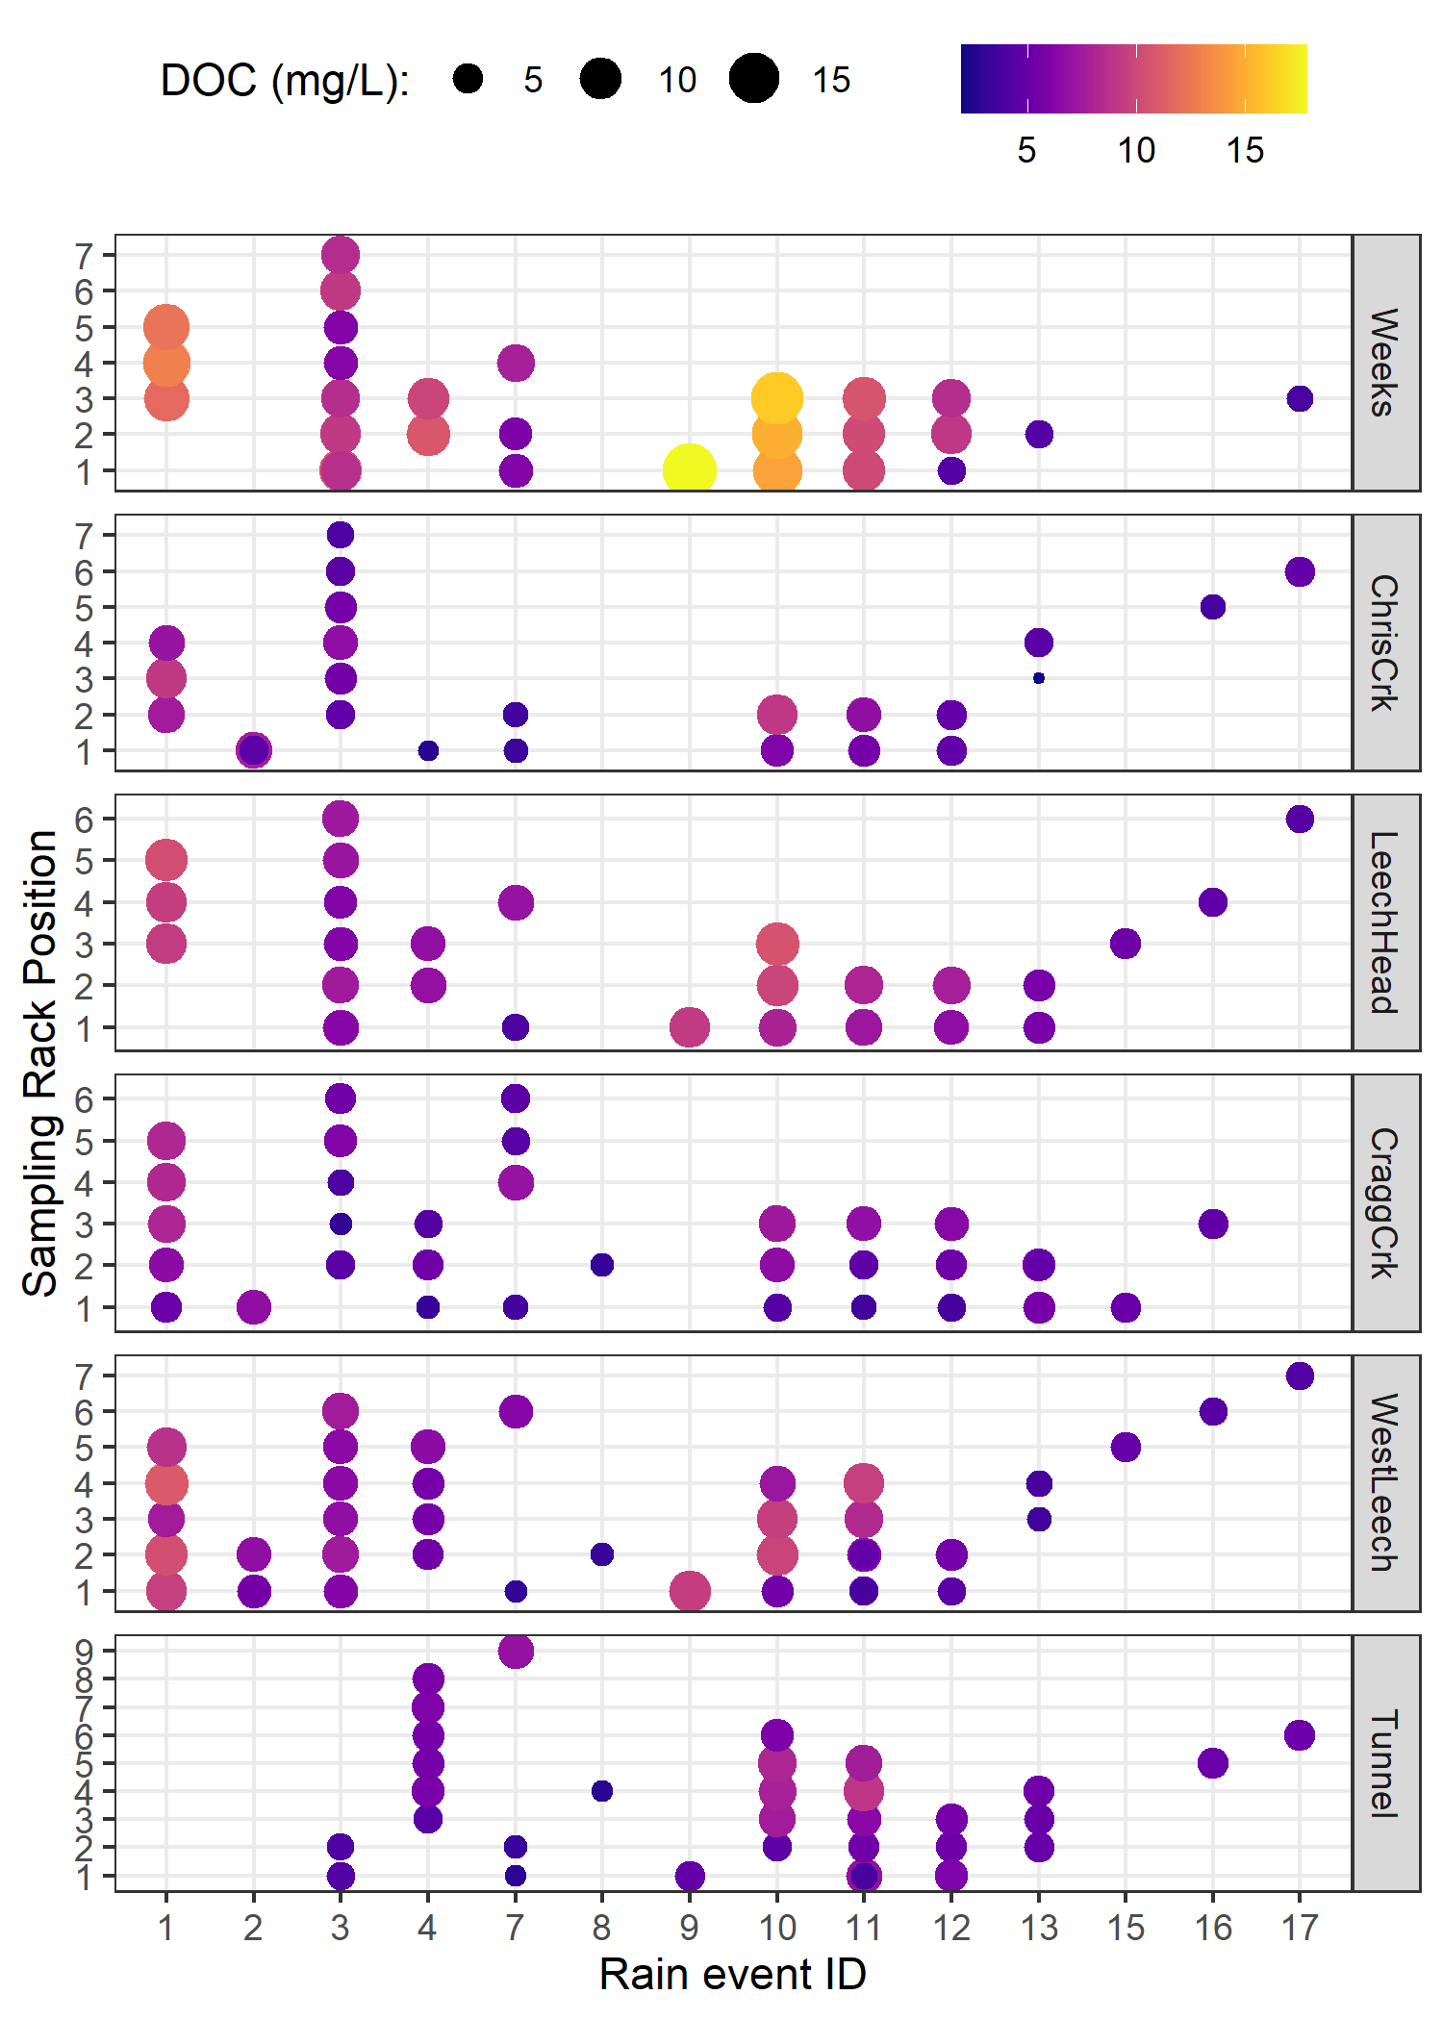

Figure 19: *DOC concentration trends in rising limb samples categorized by rain events*

*I think the following is good though*:

Each river sample was matched to stage and had a corresponding time-stamp, therefore temporal synchrony in DOC could be inferred based on relationships between peak DOC and stage. To determine if local DOC extrema (maxima and minima concentrations) were captured in conjunction with the local extrema of sampled flows (minima and maxima of sampled stage), synchrony tests were run on sample results. For each site, results of samples were grouped by collection period and rain event to identify samples with extreme DOC concentrations as well as samples collected at extreme stage (max/min). Samples corresponding to maxima and minima DOC and stage were compared to determine how often they overlapped (i.e. was the sample with max DOC also the sample collected at the highest stage?). Table 14 summarizes proportions of common DOC and stage extrema samples, where 1 indicates perfect agreement between samples of extreme DOC and sample-stage, and zero indicates complete asynchrony between DOC and stage highs and lows.

Table 14: *Proportion of samples for which peak DOC was found in the highest sample stage.*

|  |  |  |
| --- | --- | --- |
| Site | Proportion of common maxima | Proportion of common minima |
| Weeks | 0.588 | 0.647 |
| ChrisCrk | 0.800 | 0.800 |
| LeechHead | 0.889 | 0.889 |
| CraggCrk | 0.800 | 0.900 |
| WestLeech | 0.864 | 0.773 |
| Tunnel | 0.765 | 0.941 |
| all sites | 0.789 | 0.825 |

The majority of samples showed congruence between highs and lows of DOC with stage. West Leech was the only site which had a greater proportion of common maxima compared to minima, all other sites had more frequent occurrence of low DOC occurring at low stage that they did of high DOC occurring at high stage. Overall, each sites samples showed majority, but not absolute, agreement in extremes of DOC-stage relationships. Figure 20 shows the extrema samples with stage at each site.

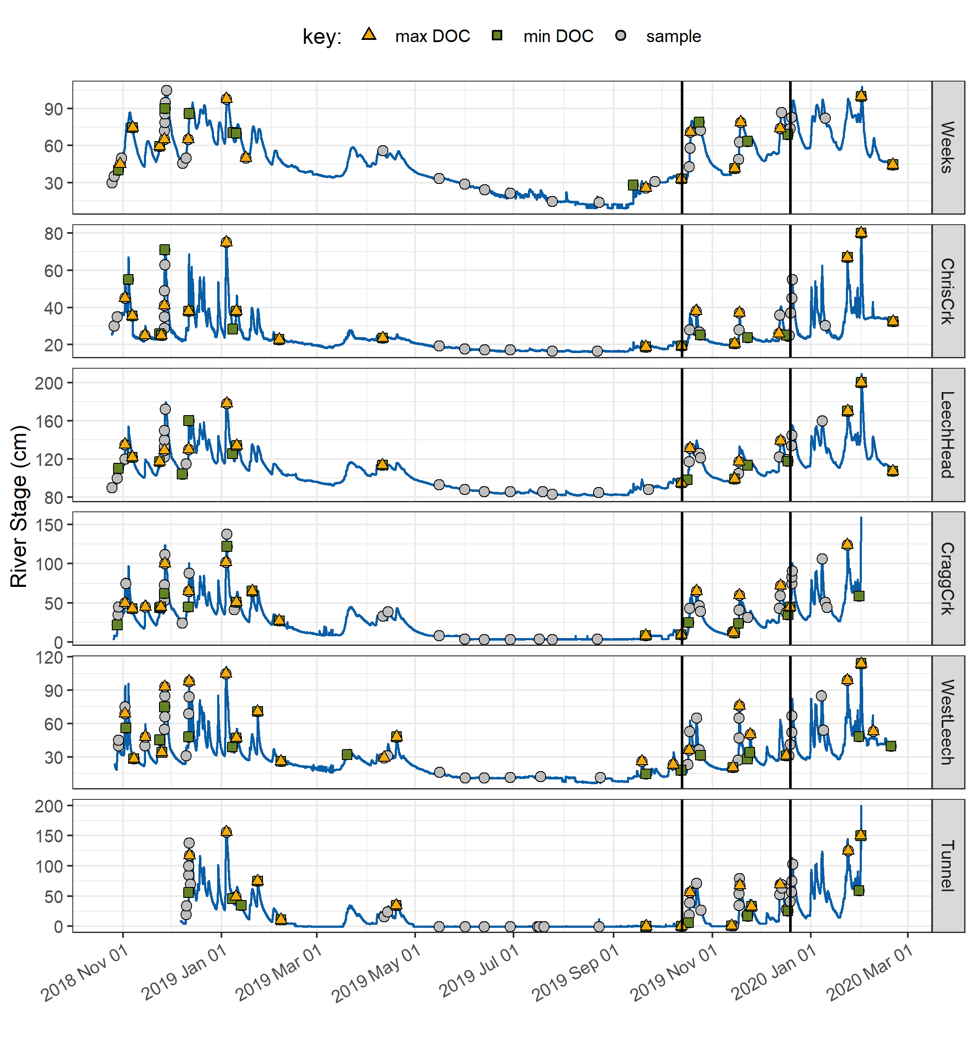

Figure 20: *Stage and samples collected, highlighting samples with maximum and minimum DOC concentrations for each rain event and collection period. Black vertical lines indicate a subset of samples that were assessed more closely.*

* *needs work:*
* Rates of stream response (times to peak): Table 15

Table 15: *Summary of stream response to precipitation events across the LWSA.*

|  |  |  |  |  |  |  |
| --- | --- | --- | --- | --- | --- | --- |
| site | shortest time to peak stage (hr) | fastest time to peak stage (hr) | smallest change in stage (cm) | largest change in stage (cm) | fastest time to peak (cm/hr) | slowest time to peak (cm/hr) |
| Weeks | 16.5 | 159.8 | 9.9 | 47.9 | 0.2 | 0.6 |
| ChrisCrk | 15.0 | 192.3 | 5.3 | 44.6 | 0.0 | 2.7 |
| LeechHead | 33.0 | 167.7 | 22.1 | 57.1 | 0.3 | 1.3 |
| CraggCrk | 18.2 | 125.2 | 32.7 | 97.3 | 0.3 | 5.4 |
| WestLeech | 25.8 | 122.8 | 36.7 | 70.2 | 0.3 | 1.4 |
| Tunnel | 18.2 | 123.8 | 29.0 | 135.3 | 0.4 | 7.4 |

* DOC changes in stormflow
* range of DOC in each event: Table 16

Table 16: *Summary of DOC changes within stormflow response to precipitation events across the LWSA (samples from wet season only).*

|  |  |  |  |  |  |  |
| --- | --- | --- | --- | --- | --- | --- |
| site | lowest DOC in stormflow (mg/L) | highest DOC in stormflow (mg/L) | smallest change in DOC (mg/L) | largest change in DOC (mg/L) | smallest difference in DOC during stormflow (%) | largest difference in DOC during stormflow (%) |
| Weeks | 6.1 | 16.1 | 1.0 | 6.4 | 9.6 | 53.2 |
| ChrisCrk | 2.3 | 9.2 | 1.2 | 3.9 | 26.1 | 82.0 |
| LeechHead | 5.7 | 10.3 | 0.1 | 2.0 | 1.2 | 29.5 |
| CraggCrk | 3.0 | 8.2 | 1.2 | 3.2 | 28.8 | 67.5 |
| WestLeech | 2.5 | 10.9 | 0.1 | 5.8 | 4.5 | 94.6 |
| Tunnel | 3.4 | 5.9 | 0.0 | 2.0 | 1.4 | 42.5 |

*needs work:*

To better understand how timing of peak DOC varied among sites during the wet season, a subset of samples was selected for closer analysis (highlighted in Figure 20 and expanded in Figure 21). The subset included samples from rain events 10-12; a subset deemed to be representative of DOC concentrations and rain events across the wet seasons, as there were no significant differences between DOC concentrations or rain events (amount and intensity) for this subset of samples compared to the rest of the study period (Table 17). There were significant differences in UV254 absorbance for events 10-12 compared to the rest of the study period, therefore this subset was not considered representative of spectral trends overall and was only examined for DOC trends.

Table 17: *p-values from Wilcoxon tests comparing the subset of rain events 10-12 and those samples’ DOC results to all other sampled rain events, showing no significant difference between the groups.*

|  |  |  |
| --- | --- | --- |
| site | Parameter | p.value |
| Weeks | DOC (mg/L) | 0.3469 |
| ChrisCrk | DOC (mg/L) | 0.4864 |
| LeechHead | DOC (mg/L) | 0.1514 |
| CraggCrk | DOC (mg/L) | 0.9821 |
| WestLeech | DOC (mg/L) | 0.8507 |
| Tunnel | DOC (mg/L) | 0.0613 |
| LWSA | Rain (mm) | 0.5735 |
| LWSA | Intensity (mm/hr) | 0.4265 |

* Rates of stream response (times to peak): Table 18

Table 18: *Summary of stream response to precipitation events 10-12 across the LWSA.*

|  |  |  |  |  |  |  |  |  |
| --- | --- | --- | --- | --- | --- | --- | --- | --- |
| site | max. rain intensity (mm/hr) | min. rain intensity (mm/hr) | shortest time to peak stage (hr) | fastest time to peak stage (hr) | smallest change in stage (cm) | largest change in stage (cm) | fastest time to peak (cm/hr) | slowest time to peak (cm/hr) |
| Weeks | 0.9 | 1.2 | 57.3 | 159.8 | 34.6 | 47.9 | 0.3 | 0.6 |
| ChrisCrk | 0.8 | 1.2 | 34.2 | 192.3 | 5.3 | 18.6 | 0.0 | 0.5 |
| LeechHead | 1.0 | 1.2 | 33.0 | 38.8 | 31.9 | 36.5 | 0.9 | 1.0 |
| CraggCrk | 1.0 | 1.2 | 35.3 | 39.5 | 46.8 | 49.0 | 1.2 | 1.3 |
| WestLeech | 1.0 | 1.0 | 25.8 | 25.8 | 36.7 | 36.7 | 1.4 | 1.4 |
| Tunnel | 1.0 | 1.2 | 25.8 | 37.3 | 65.9 | 78.3 | 1.8 | 3.0 |

* DOC changes in stormflow
* range of DOC in each event: 19

Table 19: *Summary of DOC changes within stormflow response to precipitation events 10-12 across the LWSA.*

|  |  |  |  |  |  |  |
| --- | --- | --- | --- | --- | --- | --- |
| site | lowest DOC in stormflow (mg/L) | highest DOC in stormflow (mg/L) | smallest change in DOC (mg/L) | largest change in DOC (mg/L) | smallest difference in DOC during stormflow (%) | largest difference in DOC during stormflow (%) |
| Weeks | 7.4 | 16.1 | 1.6 | 6.4 | 16.3 | 49.8 |
| ChrisCrk | 2.6 | 6.7 | 2.2 | 3.9 | 60.1 | 82.0 |
| LeechHead | 5.7 | 8.1 | 1.4 | 2.0 | 18.2 | 29.5 |
| CraggCrk | 3.5 | 6.8 | 2.7 | 3.2 | 53.0 | 63.1 |
| WestLeech | 3.7 | 9.5 | 5.8 | 5.8 | 87.1 | 87.1 |
| Tunnel | 3.7 | 5.6 | 2.0 | 2.0 | 42.5 | 42.5 |

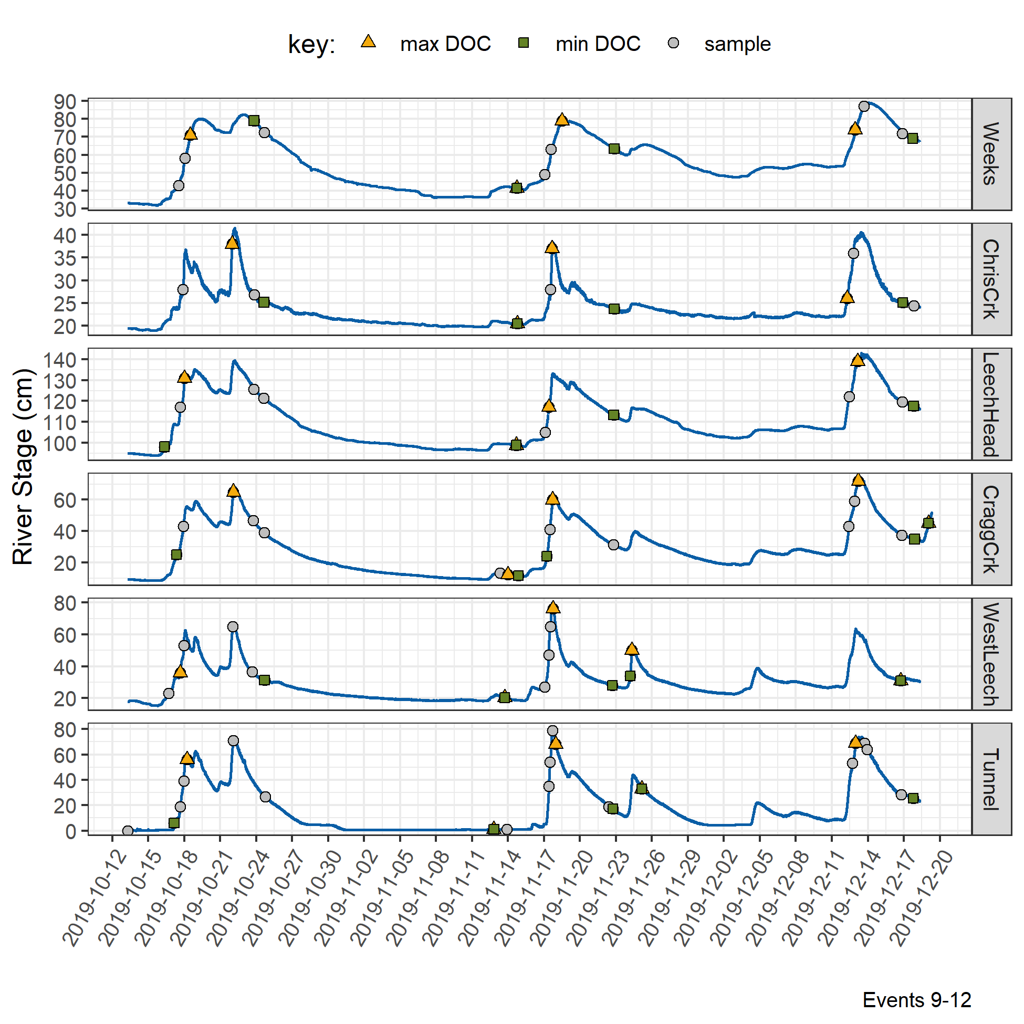

Figure 21: *Stage and samples collected for the subset of samples collected over rain events 9-12, highlighting samples with maximum and minimum DOC concentrations for each rain event and collection period.*

* density plots of stage with DOC, UV254 and SUVA~254 for each site: 22

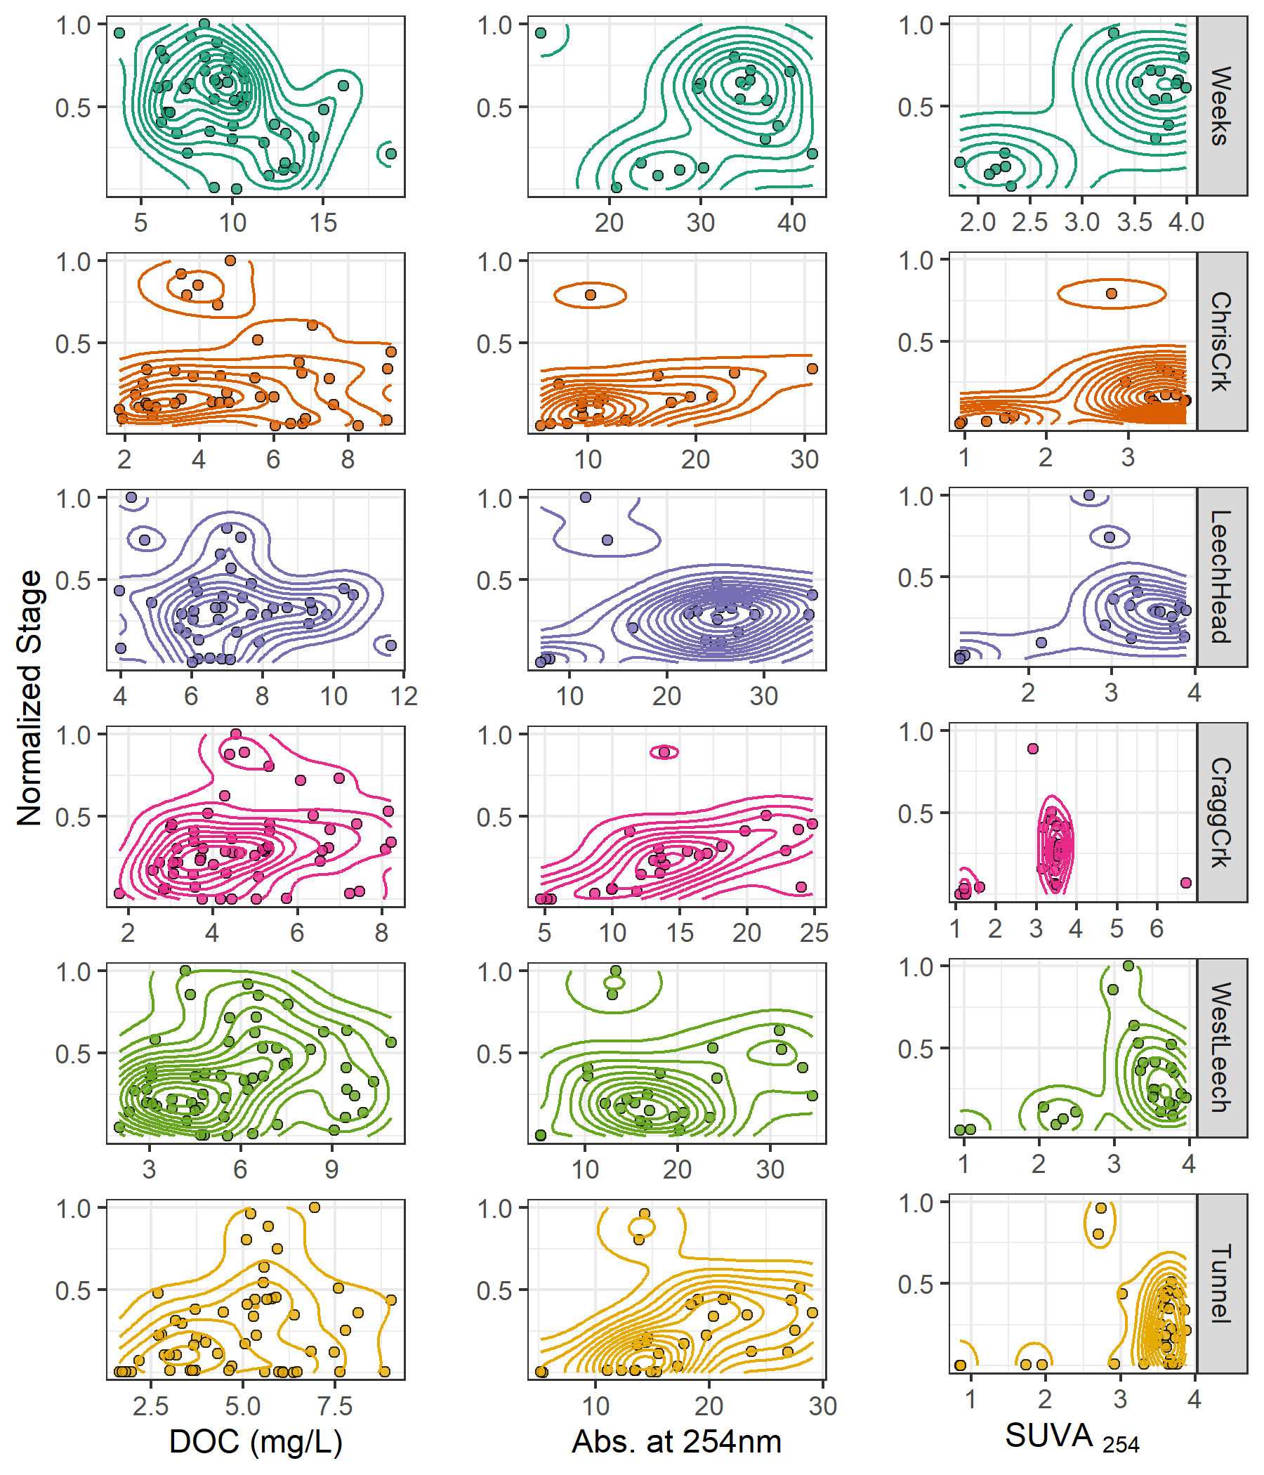

Figure 22: *Two dimensional density distributions of normalized stage in relation to DOC concentration and DOM molecular character parameters.*

### Synoptic Sampling

Thirteen river sites across the Leech and Sooke water supply areas were sampled synoptically over the sixteen month study period (3). DOC concentrations from the 201 quality assured synoptic grab samples are shown in Figure 23 and summarized in Table 20.

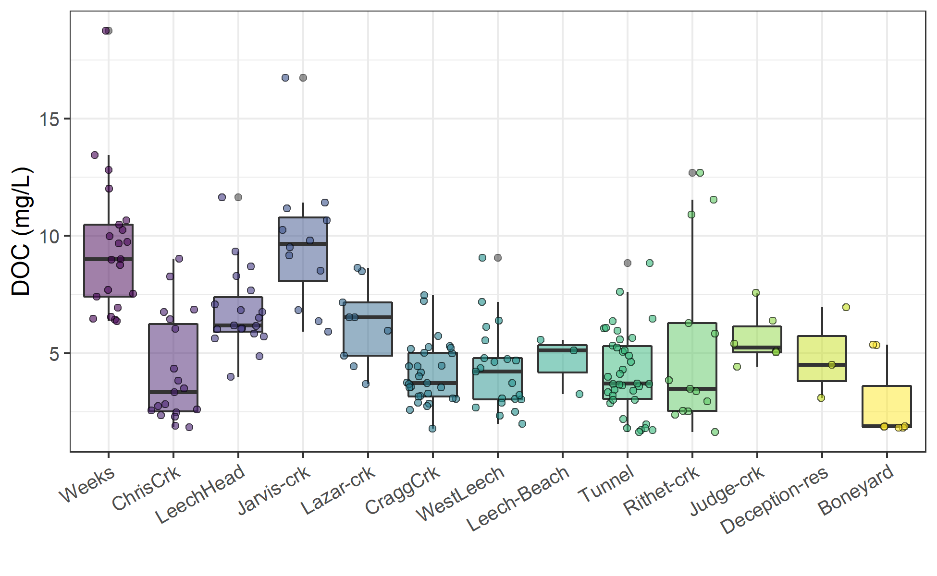

Figure 23: *Synoptic sampling results of dissolved organic carbon concentrations from 13 sites over 16 months (201 grab samples).*

Table 20: *Summary of dissolved organic carbon across thirteen synoptically sampled river sites*

|  |  |  |  |  |  |  |  |  |
| --- | --- | --- | --- | --- | --- | --- | --- | --- |
| site | description | count | DOCmean | DOCsd | RSD | DOCmin | DOCmedian | DOCmax |
| Weeks | headwater of Leech Rv., LWSA | 21 | 9.5 | 3 | 31 | 6.4 | 9.0 | 19 |
| ChrisCrk | headwater of Leech Rv., LWSA | 19 | 4.2 | 2 | 54 | 1.8 | 3.3 | 9 |
| LeechHead | mainstem river, LWSA | 19 | 6.8 | 2 | 25 | 4.0 | 6.2 | 12 |
| Jarvis-crk | headwater of Cragg Crk., LWSA | 12 | 9.7 | 3 | 30 | 5.9 | 9.7 | 17 |
| Lazar-crk | headwater of Cragg Crk., LWSA | 9 | 6.3 | 2 | 27 | 3.7 | 6.5 | 9 |
| CraggCrk | mainstem river, LWSA | 30 | 4.1 | 1 | 32 | 1.8 | 3.7 | 7 |
| WestLeech | mainstem river, LWSA | 21 | 4.3 | 2 | 42 | 2.0 | 4.2 | 9 |
| Leech-Beach | below confluence of WestLeech with Leech Rv. | 3 | 4.7 | 1 | 26 | 3.3 | 5.1 | 6 |
| Tunnel | inlet of Leech Tunnel, LWSA outlet | 38 | 4.2 | 2 | 41 | 1.6 | 3.7 | 9 |
| Rithet-crk | key tributary to Sooke Reservoir, SWSA | 13 | 5.4 | 4 | 71 | 1.6 | 3.5 | 13 |
| Judge-crk | key tributary to Sooke Reservoir, SWSA | 6 | 5.7 | 1 | 20 | 4.4 | 5.3 | 8 |
| Deception-res | outlet of Leech Tunnel, SWSA | 3 | 4.9 | 2 | 40 | 3.1 | 4.5 | 7 |
| Boneyard | downstream from Leech Tunnel | 7 | 2.9 | 2 | 60 | 1.8 | 1.9 | 5 |
| all sites | summary | 201 | 5.5 | 3 | 53 | 1.6 | 5.1 | 19 |

Rithet Creek, the largest tributary to Sooke Reservoir, showed a range of DOC concentrations comparable to those observed at the Tunnel site. And median DOC at Judge Creek, the second largest tributary to Sooke Reservoir, was greater than concentrations at any of the LWSA mainstem rivers and the Tunnel site.

#### Seasonal patterns in DOM character

The synoptic samples collected over sixteen months were used to assess seasonality in source water DOM character. DOC concentrations were measured directly as NPOC and were estimated by UV-vis absorbance using a Spectrolyser. More aromatic molecules of NOM will absorb more UV energy at 254nm wavelength than non-aromatic molecules; therefore, spectroscopic estimates of DOM are proxy measures of sample aromaticity (e.g., humic substances). As chromophores are required (i.e. responsible) for UV absorbance, absorbance-based DOC estimates will be referred to as chromophoric-DOM or CDOM. DOC concentrations (NPOC) were compared to CDOM to evaluate if and when molecular character of river samples may have shifted. Of the 371 synoptic samples, 276 had data for both NPOC and CDOM, Figure 24 shows DOC (NPOC) plotted against CDOM for all quality assured data (i.e., both Rack and Grab samples).

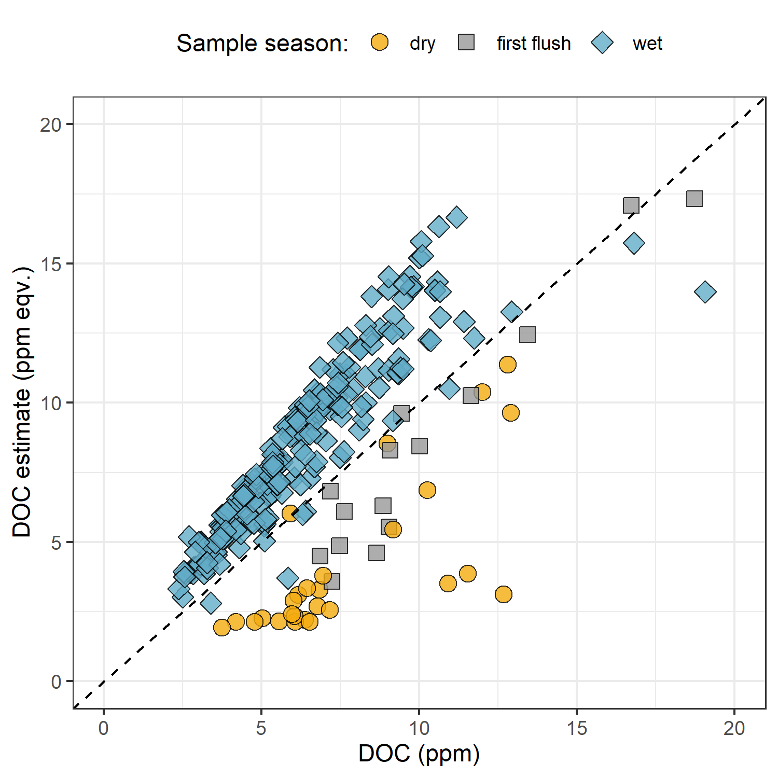

Figure 24: *Dissolved organic carbon measured directly (as NPOC) plotted against concentrations estimated via UV-Vis spectroscopy, with a dashed lined indicating best fit (1:1). The 276 samples are grouped by season (nwet = 210, nfirst-flush = 15, ndry = 27).*

Characteristics of wet-season samples caused positive bias in absorbance-based DOC estimates, while dry-season sample characteristics lead to negative bias in UV-based DOC estimates. The separation of wet and dry season samples suggests that river DOM had more aromatic character (more humic-like or allochthonous NOM) during the wet-season than during the dry-season.

While an aromatic NOM sample will have stronger absorbance at 254-nm relative to a non-aromatic sample, the concentration of NOM also effects the intensity of absorbance (based on the Beer-Lambert law). Because UV-Vis absorbance is proportional to both the aromaticity and the concentration of NOM in a sample, Specific UV absorbance at 254-nm (SUVA254) is a widely adopted indicator of a sample’s aromaticity. SUVA254 was calculated by dividing each samples absorbance at 254nm by its DOC concentration; a larger SUVA254 value indicates a sample with more aromatic character than a sample with low SUVA254. Figure 25 shows seasonally grouped samples’ DOC plotted against SUVA254, which indicates a greater aromatic character of river water during the wet season compared to dry season.

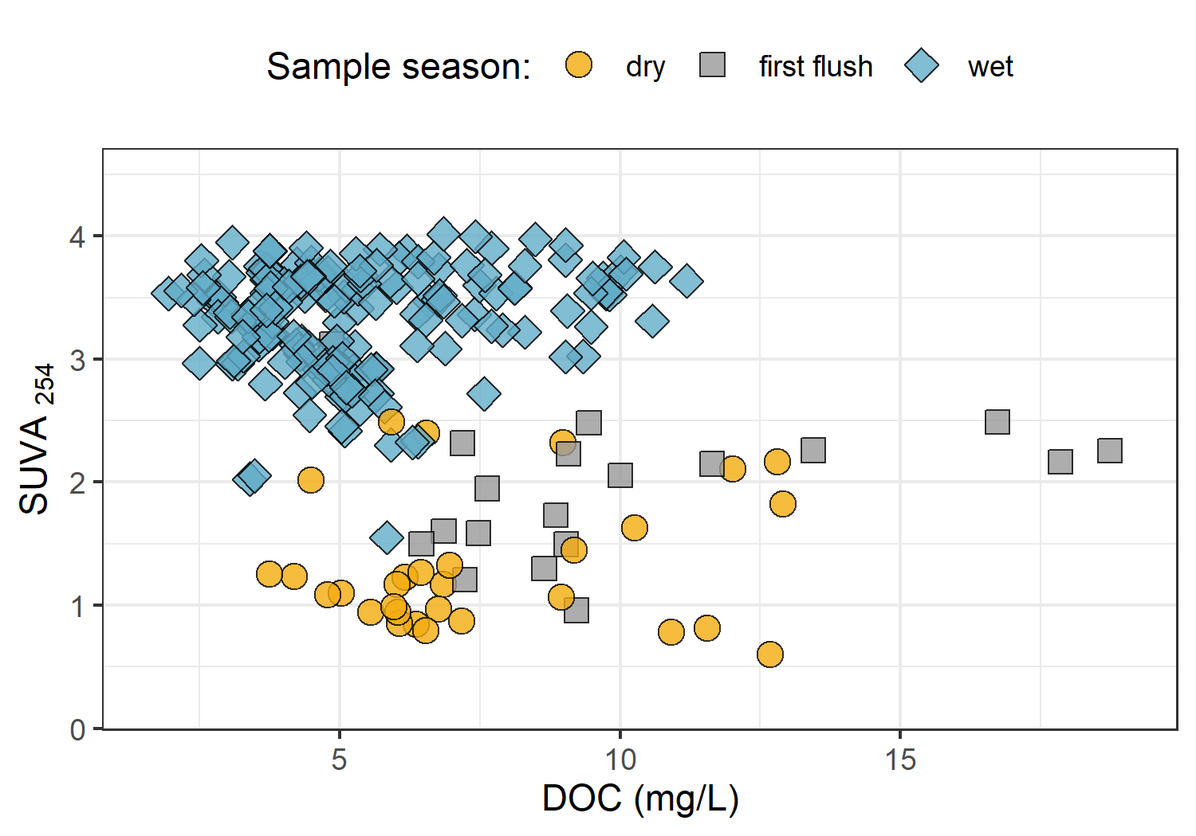

Figure 25: *Dissolved organic carbon plotted against specific UV absorbance at 254 nm (SUVA{254}) with samples (n = 282) grouped by season (n{wet} = 237, n{first-flush} = 18, n{dry} = 27) showing greater aromaticity (more humic-like organic matter) in wet season samples.*

***Random Forests***

* in progress –

## Discussion

* in progress: this section will be included in the next draft, following feedback on results

## Conclusions

# References

Abbott, Benjamin W., Gérard Gruau, Jay P. Zarnetske, Florentina Moatar, Lou Barbe, Zahra Thomas, Ophélie Fovet, et al. 2018. “Unexpected spatial stability of water chemistry in headwater stream networks.” *Ecology Letters* 21 (2): 296–308. <https://doi.org/10.1111/ele.12897>.

Aiken, George R., Heileen Hsu-Kim, and Joseph N. Ryan. 2011. “Influence of dissolved organic matter on the environmental fate of metals, nanoparticles, and colloids.” *Environmental Science and Technology* 45 (8): 3196–3201. <https://doi.org/10.1021/es103992s>.

Avagyan, Armine, Benjamin R. K. Runkle, and Lars Kutzbach. 2014. “Application of high-resolution spectral absorbance measurements to determine dissolved organic carbon concentration in remote areas.” *Journal of Hydrology* 517: 435–46. <https://doi.org/10.1016/j.jhydrol.2014.05.060>.

British Columbia Ministry of Environment. 2017. “Source Drinking Water Quality Guidelines: Guideline Summary.” Victoria, B.C.: Prov. B.C. <https://www2.gov.bc.ca/gov/content/governments/organizational-structure/ministries-organizations/ministries/environment-climate-change>.

Canadian Council of Ministers of the Environment. 2004. “From source to tap : guidance on the multi-barrier approach to safe drinking water.”

Chow, Alex T., Randy A. Dahlgren, Qian Zhang, and P. K. Wong. 2008. “Relationships between specific ultraviolet absorbance and trihalomethane precursors of different carbon sources.” *Journal of Water Supply: Research and Technology - AQUA* 57 (7): 471–80. <https://doi.org/10.2166/aqua.2008.064>.

CRD. 2017. “Regional Water Supply 2017 Strategic Plan.” Victoria, B.C.: Capital Region District, Integrated Water Services. <https://www.crd.bc.ca/project/past-capital-projects-and-initiatives/water-supply-plan>.

———. 2019. “Leech Water Supply Area Restoration Update: Report to Regional Water Supply Commission (Wednesday, June 19, 2019).” Victoria, B.C.: Capital Regional District. <https://doi.org/IWSS-297445977-5079>.

Creed, IF Irena F, DM Diane M Mcknight, Brian A Pellerin, Mark B Green, Brian A Bergamaschi, George R Aiken, Douglas A Burns, et al. 2015. “The river as a chemostat : fresh perspectives on dissolved organic matter flowing down the river continuum.” *Canadian Journal of Fisheries and Aquatic Sciences* 14 (April): 1–14. <https://doi.org/10.1139/cjfas-2014-0400>.

Critten, John C. Trussell, Rhodes. Hand, David. Howe, Kerry. Tchobanoglous, George. 2014. *MWH Water Treatment Principles and Design*. <https://doi.org/10.1016/B978-0-12-382092-1.00019-1>.

Delpla, Ianis, and Manuel J. Rodriguez. 2016. “Experimental disinfection by-product formation potential following rainfall events.” *Water Research* 104: 340–48. <https://doi.org/10.1016/j.watres.2016.08.031>.

Dudley, N, and S Stolton. 2003. “Running Pure: The importance of forest protected areas to drinking water.” World Bank / WWF Alliance for Forest Conservation; Sustainable Use. [http://scholar.google.com/scholar?hl=en{\&}btnG=Search{\&}q=intitle:Running+Pure{\#}1](http://scholar.google.com/scholar?hl=en%7B\&%7DbtnG=Search%7B\&%7Dq=intitle:Running+Pure%7B\#%7D1).

Eaton, A. D., Clesceri, L. S., Greenberg, A. E., Franson, M. A. H. 2000. “Total Organic Carbon (TOC) - 5310 A.” In *Standard Methods for the Examination of Water and Wastewater*, 6th ed., 19–20. Washington, DC: American Public Health Association. <http://www.standardmethods.org/>.

Emelko, Monica B., Uldis Silins, Kevin D. Bladon, and Micheal Stone. 2011. “Implications of land disturbance on drinking water treatability in a changing climate: Demonstrating the need for " source water supply and protection" strategies.” *Water Research* 45 (2): 461–72. <https://doi.org/10.1016/j.watres.2010.08.051>.

Graczyk, David J., Dale M. Robertson, William J. Rose, and Jeffrey J. Steur. 2000. “Comparison of water-quality samples collected by siphon samplers and automatic samplers in Wisconsin.” Middleton, Dane County, Wisconsin: U.S. Department of the Interior U.S. Geological Survey. <https://doi.org/10.3133/fs06700>.

Health Canada. 2019. “Guidance on Natural Organic Matter in Drinking Water.” <https://www.canada.ca/content/dam/hc-sc/documents/programs/consultation-organic-matter-drinking-water/NOM20190129-eng.pdf>.

HealthCanada. 2006. “Drinking Water Chlorination.” <https://www.canada.ca/en/health-canada/services/healthy-living/your-health/environment/drinking-water-chlorination.html>.

HealthLinkBC. 2018. “Drinking Water Chlorination,” no. 49. <https://www.healthlinkbc.ca/healthlinkbc-files/drinking-water-chlorination>.

Helms, John R, Avon Stubbins, Jason D Ritchie, Elizabeth C Minor, and Kenneth Mopper. 2008. “Absorption Spectral Slopes and Slope Ratios as Indicators of Molecular Weight , Source , and Photobleaching of Chromophoric Dissolved Organic Matter Author ( s ): John R . Helms , Aron Stubbins , Jason D . Ritchie , Elizabeth C . Minor , David J . Kieber.” *Limnology and Oceanography* 53 (3): 955–69. <https://www.jstor.org/stable/40058211>.

Hua, Guanghui, David A. Reckhow, and Ibrahim Abusallout. 2015. “Correlation between SUVA and DBP formation during chlorination and chloramination of NOM fractions from different sources.” *Chemosphere* 130: 82–89. <https://doi.org/10.1016/j.chemosphere.2015.03.039>.

Jacangelo, Joseph G., Jack DeMarco, Douglas M. Owen, and Stephen J. Randtke. 1995. “Selected processes for removing NOM: An overview.” *Journal / American Water Works Association* 87 (1): 64–77. <https://doi.org/10.1002/j.1551-8833.1995.tb06302.x>.

Johnson, Lucinda, Carl Richards, George Host, and John Arthur. 1997. “Landscape influences on water chemistry in Midwestern stream ecosystems.” *Freshwater Biology* 37: 193–208. <https://doi.org/doi:10.1046/j.1365-2427.1997.d01-539.x>.

LaZerte, Bruce. 1991. “Metal transport and retention: the role of dissolved organic carbon.” December. Ontario: Dorset Research Centre, for Ontario Ministry of the Environment. <https://archive.org/details/metaltransportre00lazeuoft/mode/2up>.

Li, Angzhen, Xu Zhao, Ran Mao, Huijuan Liu, and Jiuhui Qu. 2014. “Characterization of dissolved organic matter from surface waters with low to high dissolved organic carbon and the related disinfection byproduct formation potential.” *Journal of Hazardous Materials* 271: 228–35. <https://doi.org/10.1016/j.jhazmat.2014.02.009>.

Matilainen, Anu, Egil T. Gjessing, Tanja Lahtinen, Leif Hed, Amit Bhatnagar, and Mika Sillanpää. 2011. “An overview of the methods used in the characterisation of natural organic matter (NOM) in relation to drinking water treatment.” *Chemosphere* 83 (11): 1431–42. <https://doi.org/10.1016/j.chemosphere.2011.01.018>.

Matilainen, Anu, Mikko Vepsäläinen, and Mika Sillanpää. 2010. “Natural organic matter removal by coagulation during drinking water treatment: A review.” *Advances in Colloid and Interface Science* 159 (2): 189–97. <https://doi.org/10.1016/j.cis.2010.06.007>.

Meyer, Judy L., and Cathy M . Tate. 1983. “The Effects of Watershed Disturbance on Dissolved Organic Carbon Dynamics of a Stream.” *Ecology* 64 (1): 33–44. <https://www.jstor.org/stable/1937326>.

Mistick, Emily. 2019. “Forest harvest and water treatability: Analysis of dissolved organic carbon in headwater streams of contrasting forest harvest history during base flow and storm flow.” PhD thesis, UNIVERSITY OF BRITISH COLUMBIA.

Mosher, Jennifer J., Louis A. Kaplan, David C. Podgorski, Amy M. McKenna, and Alan G. Marshall. 2015. “Longitudinal shifts in dissolved organic matter chemogeography and chemodiversity within headwater streams: a river continuum reprise.” *Biogeochemistry* 124 (1-3): 371–85. <https://doi.org/10.1007/s10533-015-0103-6>.

Oni, S. K., M. N. Futter, K. Bishop, S. J. Köhler, M. Ottosson-Löfvenius, and H. Laudon. 2013. “Long-term patterns in dissolved organic carbon, major elements and trace metals in boreal headwater catchments: Trends, mechanisms and heterogeneity.” *Biogeosciences* 10 (4): 2315–30. <https://doi.org/10.5194/bg-10-2315-2013>.

Palleiro, L., M. L. Rodríguez-Blanco, M. M. Taboada-Castro, and M. T. Taboada-Castro. 2013. “The influence of discharge, pH, dissolved organic carbon, and suspended solids on the variability of concentration and partitioning of metals in a rural catchment.” *Water, Air, and Soil Pollution* 224 (8). <https://doi.org/10.1007/s11270-013-1651-9>.

Peuravuori, Juhani, and Kalevi Pihlaja. 1997. “Molecular size distribution and spectroscopic properties of aquatic humic substances.” *Analytica Chimica Acta* 337 (2): 133–49. <https://doi.org/10.1016/S0003-2670(96)00412-6>.

Pike, R., M. Feller, J. Stednick, K Rieberger, and M Carver. 2010. “Water Quality and Forest Management.” In *Compendium of Forest Hydrology and Geomorphology in British Columbia: Volume 2 of 2*, 400–439. [https://www.for.gov.bc.ca/hfd/pubs/docs/lmh/Lmh66/LMH66{\_}volume2of2.pdf](https://www.for.gov.bc.ca/hfd/pubs/docs/lmh/Lmh66/LMH66%7B_%7Dvolume2of2.pdf).

Rautu, Roxana. 2019. “Linking Seasonal and Spatial Stream Carbon Dynamics to Landscape Characteristics in Selected Watersheds on the Olympic Peninsula.” PhD thesis, University of Washington.

Raymond, Peter A, James E Saiers, Source Biogeochemistry, No September, Peter A Raymond, and James E Saiers. 2010. “Event controlled DOC export from forested watersheds.” *Biogeochemistry* 100 (1): 197–209. <https://doi.org/10.1007/sl0533-010-9416-7>.

Raymond, Peter A, James E Saiers, William V Sobczak, and E James. 2016. “Hydrological and biogeochemical controls on watershed dissolved organic matter transport: pulse-shunt concept.” *Ecology* 97 (1): 5–16. <https://www.jstor.org/stable/24702986>.

Richardson, Susan D., Michael J. Plewa, Elizabeth D. Wagner, Rita Schoeny, and David M. DeMarini. 2007. “Occurrence, genotoxicity, and carcinogenicity of regulated and emerging disinfection by-products in drinking water: A review and roadmap for research.” *Mutation Research - Reviews in Mutation Research* 636 (1-3): 178–242. <https://doi.org/10.1016/j.mrrev.2007.09.001>.

Stanley, Emily H., Stephen M. Powers, Noah R. Lottig, Ishi Buffam, and John T. Crawford. 2012. “Contemporary changes in dissolved organic carbon (DOC) in human-dominated rivers: Is there a role for DOC management?” *Freshwater Biology* 57 (SUPPL. 1): 26–42. <https://doi.org/10.1111/j.1365-2427.2011.02613.x>.

Ussery, Joel, and AECOM. 2015. “Leech Water Supply Area: An Assessment for Source Water Protection and Land Management.” April. Victoria, B.C.: Capital Regional District, Watershed Protection Division, Integrated Water Services.

Vannote, Robin L., G. Wayne Minshall, Kenneth W. Cummins, James R. Sedell, and Colbert E. Cushing. 1980. “The River Continuum Concept.” *Canadian Journal of Fisheries and Aquatic Sciences* 30 (1): 130–37.

Vidon, Philippe, Laura E. Wagner, and Emmanuel Soyeux. 2008. “Changes in the character of DOC in streams during storms in two Midwestern watersheds with contrasting land uses.” *Biogeochemistry* 88 (3): 257–70. <https://doi.org/10.1007/s10533-008-9207-6>.

Weishaar, James L., George R. Aiken, Brian A. Bergamaschi, Miranda S. Fram, Roger Fujii, and Kenneth Mopper. 2003. “Evaluation of specific ultraviolet absorbance as an indicator of the chemical composition and reactivity of dissolved organic carbon.” *Environmental Science and Technology* 37 (20): 4702–8. <https://doi.org/10.1021/es030360x>.

Yang, Liyang, Jin Hur, Sonmin Lee, Soon Woong Chang, and Hyun Sang Shin. 2015. “Dynamics of dissolved organic matter during four storm events in two forest streams: source, export, and implications for harmful disinfection byproduct formation.” *Environmental Science and Pollution Research* 22 (12): 9173–83. <https://doi.org/10.1007/s11356-015-4078-6>.

Zarnetske, Jay P., Martin Bouda, Benjamin W. Abbott, James Saiers, and Peter A. Raymond. 2018. “Generality of Hydrologic Transport Limitation of Watershed Organic Carbon Flux Across Ecoregions of the United States.” *Geophysical Research Letters* 45 (21): 11, 702–11, 711. <https://doi.org/10.1029/2018GL080005>.

The forWater Network

The forWater NSERC Network for source water protection strategies is a transdisciplinary, cross-Canada, applied research collaboration focused on the connections between treated drinking water quality and land-use impacts of forest management. The majority of source drinking water originates in forested headwaters, so forWater researchers are studying water quality in watersheds across Canada, under a variety of different forest management strategies. Through collaborative analyses, forWater is working to evaluate source water treatability metrics, downstream propagation effects, and resource economic with the ultimate goal of providing a framework for treatment demands as they relate to forested source water.

Greater Victoria Regional Water Supply System

The Capital Regional District (CRD) owns and operates the water supply system for the Greater Victoria region. As a water purveyor, CRD supplies an average of 130 million liters of treated water to customers each day (130,000 m3day-1) (CRD 2017). The provision of safe and sustainable drinking water has three tiers of regulation above the CRD: federal, provincial, and regional. Federally, Health Canada publishes Canadian Drinking Water Quality Guidelines which outline quantitative bounds for microbial, chemical, radiological parameters and physical aesthetic characteristics for safe drinking water. The province of British Columbia sets requirements for planning, reporting and regualting of drinking water providers through the Drinking Water Protection Act and the Water Sustainability Act, and the Public Health Act and Regulations. Regionally, the CRD reports to the Vancouver Island Health Authority (Island Health) regarding water quality information and provincial legislation.

The Greater Victoria Water Supply Area (GVWSA) includes 20,549 hectares (205.49 km2) of protected drinking water catchment lands. The primary water supply is sourced from Sooke reservoir, the secondary supply source is Goldstream reservoir and the designated (supplemental) future water supply is the Leech River watershed {FIGURE YYY, figure of watersheds with insert of VanIsle (small) and western north america (even smaller)}. Unfiltered source water is first treated with ultraviolet light and free chlorine (to deactive parasites, bacteria and viruses); secondarily, ammonia is added to produce chloramine, a long-lasting disinfectant that persists through distribution systems (CRD 2017).

The Leech River watershed is a sub-catchment of the Sooke River watershed (~25% by area), located west of Sooke Reservoir (primary water supply for the Greater Victoria Area). In anticipation of future water demands and uncertainty related to rainfall and climate change, the Capital Regional District (CRD) purchased 9,628 hectares (about 92%) of the Leech River watershed in 2007 (84%) and 2010 (additional 8%), and designated the Leech Water Supply Area (LWSA) for future supplemental water supply.

In 1977, the CRD obtained a provincial water licence authorizing the diversion of up to 30.6 million cubic meters per year from the Leech River to the Sooke Reservoir (Ussery and AECOM 2015). Based on the 2017 strategic plan statement of a daily average water supply of 130,000 m3 (2017), the Leech water license could contribute about 65% of 2017 average water supply. The license allows diversion only as long as minimum flows (>5.7 m3s-1) are maintained to protect fish and downstream ecology (Ussery and AECOM 2015). Based on current hydroclimatic dynamics, the water license flow requirements will exclude the summer months from inter-basin transfer and limit streamflow diversion to the winter (November to approximately April). The Leech Tunnel was constructed in the 1980’s to transfer Leech River water into the Sooke Reservoir. The Tunnel is not currently operational, and it’s anticipated that inter-basin transfer won’t be required until 2050 or later.

Leech River Watershed Site Details

The Leech River watershed (“the Leech”) is located on south-east Vancouver Island, British Columbia, Canada. Like most of coastal BC, it is in the Coastal Western Hemlock Biogeoclimatic Zone. The hydroclimatic regime of the Leech is pluvial (i.e. rain-dominated). Annual rainfall is typically between xxxx - yyyy mm (~2500 mm/yr). This areas has a strong seasonal distribution of rainfall: approximately 90% of rain falls from September to April, with only about 10% of annual rainfall occurring from May to August [*REFS*]. Across the Leech, elevation ranges from approximately 200 m above sea level (asl), near the Leech Tunnel, to 941 m asl in the centre of the watershed, at the top of Survey Mountain. While the majority of precipitaiton falls as rain, snow does accumulate for short periods at higher elevations.

Around 99% of the Leech WSA is forested. The Leech forests are dominated by western red cedar, western hemlock, and Douglas fir; subspecies include Amabalis fir (Pacific silver fir), white pine, yellow cedar (at higher elevations), Alder, broadleaf maple, and arbutus. Prior to purchase by the CRD, the LWSA was privately managed forest land that was harvested from the mid-1940’s to 2007 (Ussery and AECOM 2015). Approximately 95% of the Leech watershed was harvested by clear cut prior to 2007 (Ussery and AECOM 2015, @CRD2019); as a result, ~94% of LWSA forests are younger than 60 years old and a large portion of stands are under 30 years of age. Now designated as a Water Supply Area, the CRD manages the Leech for source water protection, ecosystem services, and forest resilience. As forest fires pose a serious threat to monocultured and even-aged stands (*REFS*), particularly during the drought of summer, forest fuel management is an important preemptive risk reduction for the CRD (CRD 2019).

The Leech River system is composed of three mainstem rivers, numerous tributaries, and four small headwater lakes. Hydrologic responses vary with terrain steepness, soil infiltrability, vegetation, percent cover of lakes and wetlands, air temperature and the intensity and duration of precipitation. In the Leech, runoff peaks in the winter under saturated conditions. In the wet season, rivers in the Leech watershed are flashy: they respond rapidly to precipitation events, rising and falling dramatically. In 1993 CRD Water Services set up a hydrometric monitoring station on the Leech River (about 3.5 km downstream of the Tunnel) to measure discharge with hourly stage measurments (Ussery and AECOM 2015). Peak flow on the lower Leech River was recorded as 168 m3s-1 (in October, 2003) (Ussery and AECOM 2015). However, the rating curve at this historic gauging station was not verified over time and hydraulic action rendered it fairly unreliable.

Overall, the hydrology of the LWSA is poorly understood, as are water quality dynamics. In the mid-1980’s, some water was transfered from the Leech River into Deception Gulch and Reservoir (adjacent to but physically separated from Sooke Reservoir). The mixing resulted in biological water quality problems that included odour and raised concerns about the operational usage of the existing tunnel. The Leech River Tunnel and anticipated inter-basin transfer will provide interesting research opportunities which are beyond the scope of this thesis research. Before work is done on inter-basin transfers, the hydrology and water quality of the Leech River system need to be better understood. Understanding source water quality, as well as the timing and magnitude of flows, is an essential component to multiple barrier approach to ensuring clean drinking water.

Installation / monitoring sites

Six sites were selected across the Leech Water Supply Area. The six research sites represent five nested catchments and the entire water supply area basin defined from the point of (future) diversion, the Leech Tunnel.

***Weeks Outlet***

The Weeks Outlet research site monitors water draining approximately 16 km2 of the northwest Leech River watershed, including a wetland (Jordan Meadows fen) and Weeks Lake (approximately 27 ha) (Ussery and AECOM 2015). Jordan Meadows wetland drains to the east and joins the outflow of Weeks Lake (south end of the lake). The wetland and lake outflow streams join and flow east to Research Site #1, “Weeks Outlet”, which is a third order stream (Strahler) of the western headwaters of Leech River. The channel is fairly straight and bed material is primarily silt/clay. The water at this site was noteabley tannin-coloured. This research site was located about 0.4 km west (upstream) of the confluence with Chris Creek.

A large culvert upstream of the monitoring site was replace with a bridge in August of 2019. The culvert had been perched above the streambed level and was obstructing the movement of fish and water flow. Prior to the culvert removal, several groundwater seeps were observed downstream; these seeps maintained base flow of summer waters in this low-relief stream reach. There were high levels of iron (above guidlines for aesthetic objectives) in the water downstream of the culvert, possibly due to culvert rust.

***Chris Creek***

Chris Creek is the western headwaters of Leech River. This research site is approximately 0.2 km east (upstream) of the confluence with the Weeks Outlet stream. The study site on Chris Creek monitors waters draining from approximately 9.6 km2 of forested land, including Worley Lake (approximately 3.5 ha) (Ussery and AECOM 2015). The monitoring site of Chris Creek was downstream of a bridge, on a slightly sinuous reach with boulders and bedrock dominated morphology and turbulent cascading step-pools. There is a brige that passes over Chris Creek and a large collection of coarse woody debris downstream of the bridge, upstream of the monitoring site.

***Leech Head***

Research site 3 was approxiamtely 1.4 km downstream of the confluence of Weeks Outlet stream and Chris Creek. The “Leech Head” study site was in a deep pool between riffles, it’s a 4th order stream with predominantly Schist bedrock and fairly low relief (~2%) and relatively straight morphology. The water at this site was often coloured by tannins (likely from the Weeks outlet stream contributions). There once was a logging bridge across the river at this site, and some rip-rap remains on either bank.

***Cragg Creek***

Cragg Creek is a mainstem river that originates in the northeast of the Leech River watershed. Cragg Creek is a 4th order stream and this research site location has a drainage area of approximately 37 km2, which includes Jarvis Lake (15 ha). The Cragg Creek research station was installed upstream of a road bridge, at a CRD hydrological monitoring site (installed over the span of this thesis project). The bed morphology at this site is Schist bedrock and the stream is straight channel with fairly high width-to-depth ratio. Upstream of the bridge Cragg Creek flows turbulently along a low slope, and downstream of the bridge it cascades into several deep pools. From the Cragg Creek research site, the river flows approximately 4.5 km through a steep revine to confluence with the Leech River (this confluence is around 6 km downstream of the Leech Head site, site #3).

***West Leech***

Originating in the west of the Leech River watershed, West Leech River is a 4th order mainstem river. The West Leech research site monitors a drainage area of approximately 35 km2 which includes a small lake (Boulder lake) at the southwest of Leech watershed. This reasearch site has boulder and bedrock substrate, fairly straight channel with relatively high width-to-depth ratio and pool-riffle morphology. The West Leech site is approxiamtely 120m upstream of the confluence with Leech mainstem (~1.5km downstream of the confluence of Cragg Creek with Leech River).

***Leech Tunnel***

This research site is at the point of future diversion, the Leech Tunnel. The Leech River is 5th order, and this research site has a drainage area of approximately 99 km2. The stream bed here is dominated by Schist bedrock and boulders. The bedrock in the center of the channel is deeply incised, but overall the river is wider than is is deep. The Tunnel site is approximately 1km downstream of the West Leech confluence.

Extended Methods

In riverine systems, peak flows are critical times for mass transport of dissolved and suspended materials. Therefore water quality sampling should include proportional representation of stormflow pulses relative to between-storm flows and baseflow. Sampling programs can range from low-cost synoptic grab sampling campaigns to high-cost programmable pump samplers (e.g. ISCO). Synoptic grab sampling was completed across the six primary Leech research sites, as well as four supplemental sites. In addition to synoptic sampling, passive sampling techniques were employed to collect stormflow samples.

Siphon sampler background – separate from vertical rack? Mark’s suggestion

***Vertical racks***

*Passive water sampling on the rising limb of hydrograph*

Each vertical rack included a central stilling well (1.5" PCV pipe (conduit) with 1/2" holes drilled along the length) that had a measuring tape affixed to the front. Inside the stilling well was an Odyssey Capacitance water level logger (odysseydatarecording.com). To either side of the central stilling well, slotted offset angle bars were fixed and siphon sampler bottles were attached to the slotted angle bars with hose clamps.

The siphon sampler bottles were based on a USGS single stage sediment sampler design (US U-59, 1961) which passively collect discrete water samples at a fixed stage on the rising limb of the hydrograph. The siphon samplers built for this research were 250 mL amber HDPE widemouth bottles with augmented screw caps. The caps were fit with two 1/4" (OD) stainless steel tubes, one longer than the other, both with a 180 $​^{∘}$ bend at the top end.

The lower tube acts as an inlet that intakes water once the stream level is at or above the crown of the bend, while the taller tube acts as a vent to allow air to exit the sample bottle as it is displaced with water. Once the sample bottle is full, there is no exchange with the surrounding stream water due to an air lock created in the vent tube bend. The validity of assuming discrete sample collection was addressed in the Methods QA/QC section.

Sampling bottles could be placed at any height, and were generally staggered at 10-20 cm intervals. For each sampler bottle, the height of the intake tube (filling stage) was measured relative to the measuring tape on the central stilling well, which was referenced to the stage recored by water level logger inside to extract the date and time of sample collection (REF TO R SCRIPT).

*Benefits, challenges and assumptions*

The benefits of using these vertical racks as a method of sampling include: low cost (about $500 CND per installation), low power (two 1/2-AA batteries in each logger), self-contained (no external power source or data logger required), customizable design, passive sampling (no pumps). The downsides of using this technique are similar to any autosampler, in that someone must visit the field sites regularly for set-up and collection of samples, but because there are minimal powered components, mis-firing is not an issue. The only reason a sample wouldn’t be collected was if the stream stage did not reach a bottles intake. The primary drawback of this technique is that sampling is limitied to the rising limb of the hydrograph, which limits the elucidation of stormflow water quality dynamics. There is some uncertainty about timing between sample collection and sample retrieval, every effort was made to return to each research site following precipitation events to retrieve collected samples, and it was assummed that any sample held on the rack was stable due to low air and river temperatures during the wet season. The assumption of river-as-a-refrigerator was addressed by deploying temperature sensors on each vertical rack (August 2019), and also with hold-time experiments.

Field protocol

Following the installation of a vertical sampling rack, the field protocol was to visit the site approximately biweekly (or more frequently, based on storms) to check, collect and set the rack. Every time a site was visited, a grab sample was also collected. When a bottle was placed on its rack (attached by 3" hose clamp), the filling stage (height of intake tube crown) was recorded relative to the central still well tape. Bottles were staggered, generally from water level to approximately 120 cm above water level (as experience showed that a bottle should always be placed above the stage of anticipated peak streamflow). Following a rain event, each site was revisited to collect rack samples; for full bottles, the siphon lid was replaced with a labelled HDPE lid and samples were transported in a cooler with ice packs back to the lab and refrigerated until analysis.

Prototype for falling limb passive sampling

*Development of a modified siphon sampler designed for passive water collection on the falling limb of hydrograph*

In keeping with goals of low-cost, low-powered passive sampling, a falling-limb sampler was designed based on principles of the rising limb siphon sampler. The rising limb sampler collects a discrete water sample when river stage exceeds the crown of the inlet tube, so long as the vent is unobstructed; obstruction of the siphon sampler vent was the key component of the falling limb sampler prototype design. There were a half-dozen iterations in design prior to the model which was field-deployed in the Leech WSA (winter 2019). Each design iteration included a valve on the siphon vent which remained closed as the river rose, and opened when stream stage dropped below a certain point (allowing air to exit the sample bottle and a water sample to be collected). A number of valve options were explored, including: an external tube plug, in internal tube plug, and a self-sealing silicone bite-valve (i.e. Camelback Big BiteTM for hydration packs). The final design iteration used a tube pinch valve (SP Science) to close and open the air vent. The mechanism that triggers the vent valve to open is a simple fixed pulley, where the valve is connected to a weighted-cup by a wire that passes through two loops which alter the direction of force. The river rises and fills the cup with stream water, the cup remains full when the river recedes, and when the stream drops low enough that the full cup is no longer buoyant, the weight of water in the cup exerts a force on the lever of the pinch-valve, causing it to release the vent tube and triggering sample collection. The vent valve and trigger mechanism are contained in a 4" sewer pipe (a “filling well”), which was attached to supplemental support bars on the vertical rack. One prototype was field deployed at Cragg Creek (subbasin site 4) as a proof of concept and work will continue to improve the design and operation.

Collaborative sampling

forWater-coordinated treatability analyses sites

Four of the synoptic sampling sites were selected as treatability sampling sites, where source water was collected and shipped to collaborative researchers in the forWater Network for analyses of drinking water treatability metrics. The four treatability sites were:

1. Leech River at the future point of diversion (near Leech Tunnel inlet)
2. Deception Reservoir, downstream from Deception Gulch (outlet of Leech Tunnel)
3. Rithet Creek (main tributary to Sooke Reservoir)
4. Judge Creek (2nd largest tributary to Sooke Reservoir)

These sites were selected to represent future supplemental source water , the future balancing reservoir between the Leech and Sooke water supply areas, and the current tributary source waters to the Sooke Reservoir.

Sets of samples were collected during winter of the 2020 water year (November 12, 2019 and February 18, 2020) and were shipped to the Universities of Alberta and Waterloo for treatability analyses. At the University of Waterloo, samples were analyzed for treatability parameters including: maximum potential disinfection byproduct formation potential (for trihalomethanes (THMs) and haloacetic acids (HAAs) in μg/L), pH, UV254(cm-1), DOC (mg/L), Turbidity (NTU), and Zeta Potential (mV). Relationships between disinfection by-product formation potentials (DBP-FPs), UV-absorbance at 254nm, and DOC concentrations were examined.

At the University of Alberta, field-filtered samples were analyzed using a spectrofluorometer (for excitation emission matrices spectra), as well as an Fourier transform ion cyclotron resonance mass spectrometer to determine molecular characteristics of the DOM.

Sampling for Metals on behalf of the CRD

Aquatic NOM can play an important role in the transport of metals because it has the physiochemical ability to act as a ligand to create coordinated complexes with metals. From November 2018 to July 2019, I collected eight sets of samples for metals analysis from the six sub-basin monitoring sites. Metals samples were collected on behalf of the CRD and were analyzed at Bureau Veritas Laboratories (BL Labs, formerly Maxxam Analytics Inc., Sidney, BC). For each metals sample collected, a parallel Grab sample was analyzed for DOC (at UBC). Reports from BL Labs were provided by the CRD (for the samples collected in association with this research) and data were used to evaluate relationships between DOC and metals in solution.

Results extended

Malahat 5 year weather

The LWSA weather stations were recently installed and therefore data during the study period could not be compared to a record from previous years. A nearby weather station operated by the BC Ministry of Transportation and Infrastructure (Malahat, station ID 62091) had data available from late 2013 which was used to check if weather during the study period departed from previous year trends. Figure 26 shows Malahat weather data, which are summarized in Table 21.



Figure 26: *Five year weather from nearby Malahat station (MoTI ID 62091).*

Table 21: *Annual weather data from Malahat station (MoTI ID 62091)*

|  |  |  |  |
| --- | --- | --- | --- |
| year | annual precip. (mm) | mean air temp. (°C) | std.dev. (± °C) |
| 2014 | 1260 | 10.6 | 6.7 |
| 2015 | 1281 | 11.3 | 6.3 |
| 2016 | 1526 | 10.6 | 6.2 |
| 2017 | 1331 | 10.5 | 7.1 |
| 2018 | 1636 | 10.6 | 6.6 |
| 2019 | 1494 | 10.1 | 6.3 |

Malahat weather station data were grouped by years 2016-2017 and 2018-2019 to check if there was a statistical difference in precipitation and air temperature for the two years prior to this study compared to the two years associated with this study (Figure 27). Table (tab:MalahatTest) summarizes the results Wilcoxon rank sum test comparing these two sets. Based on this two-set, two-year comparison, it was determined that precipitation during the 2018-2019 period was different than the 2016-2017 period.



Figure 27: *Weather from the Malahat station for two year periods prior to and during this study (MoTI ID 62091).*

Table 22: *Results of Wilcoxon test for Malahat weather data before and during the study period*

|  |  |  |
| --- | --- | --- |
| Parameter | p.value | signifcance |
| rain | 1.910000e-10 | at 99% |
| temp_mean | 3.904246e-01 |  |
| temp_min | 3.826166e-01 |  |
| temp_max | 4.694509e-01 |  |

DOC association with other water quality parameters

***Metals & DOC***

Aqueous natural organic matter (NOM) can play an important role in transportation of metals in solution because it has the physiochemical ability to act as a ligand and create coordinated complexes with metals. From November 2018 to July 2019, seven sets of samples were collected from six sites in the LWSA for metals analysis. Metals samples were collected on behalf of the CRD and were analyzed at Bureau Veritas Laboratories in Sidney, BC (formerly Maxxam Analytics Inc.). For each metals sample collected, a parallel Grab sample was collected and analyzed for DOC at UBC. A suite of total metals were included in the analyses, many of which were below detection limits. Samples which had detectable metals concentrations were plotted against parallel sample DOC concentrations (Figure 28 shows DOC with total metals in μg/L, and Figure 29 shows metals in mg/L).

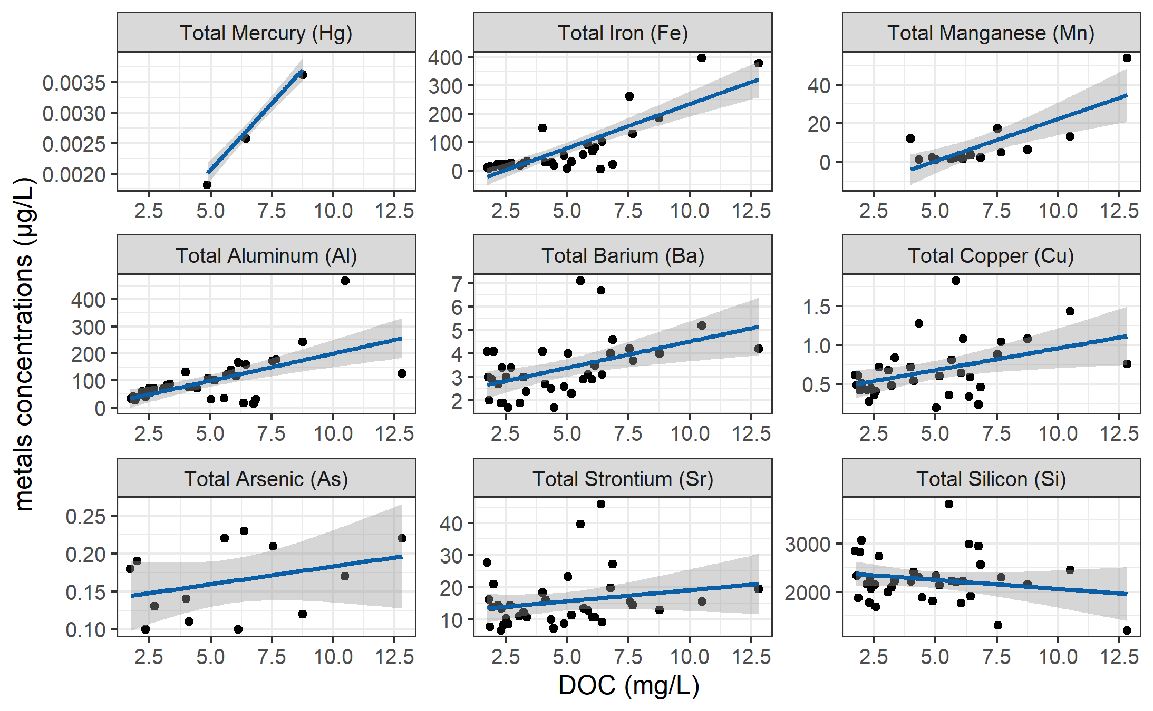

Figure 28: *Concentrations of total metals (in µg/L) and dissolved organic carbon.*

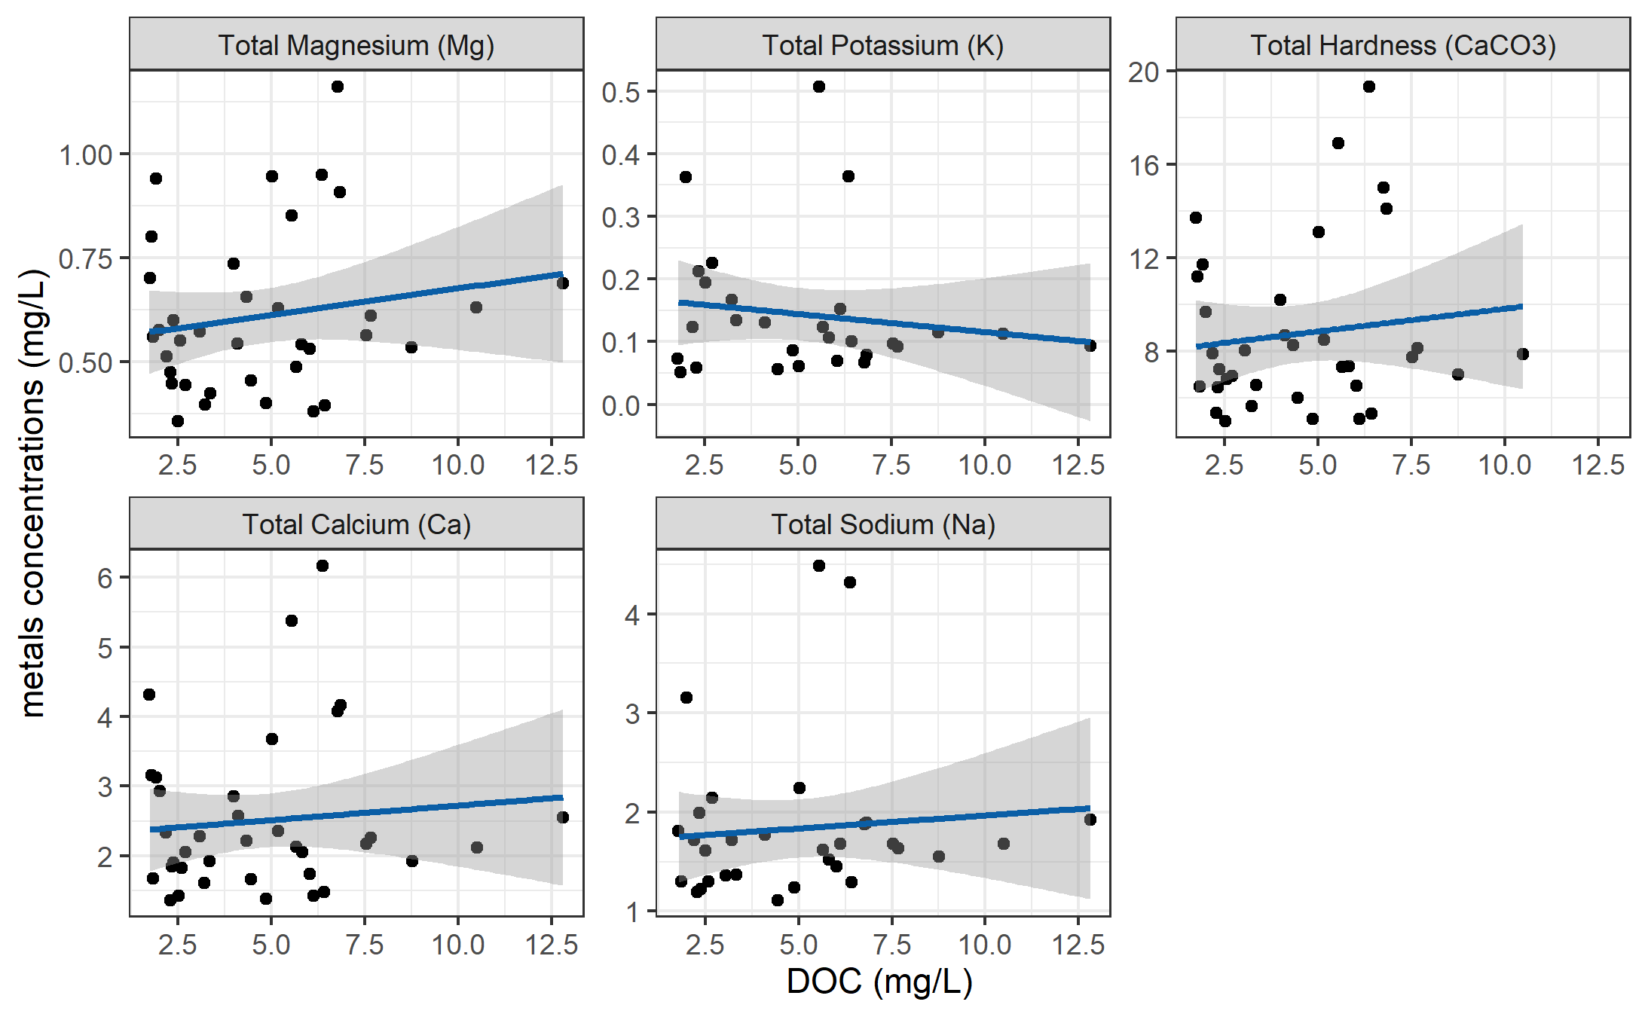

Figure 29: *Concentrations of total metals (in mg/L) and dissolved organic carbon.*

DOC concentrations had strong positive relationships with total mercury, iron, manganese, aluminum. While the relationships were not as strong, DOC was also positively related to concentrations of barium, copper, and arsenic. There was a weak inverse relationship between DOC with silicon and potassium (Table 23). All metals concentrations were below maximum allowable concentrations and aesthetic objectives for drinking source water quality guidelines (British Columbia Ministry of Environment 2017).

Table 23: *Relationships between total metals with dissolved organic carbon*

|  |  |  |  |  |  |
| --- | --- | --- | --- | --- | --- |
| Metal | unit | count | slope | Y intercept | R squared |
| Total Mercury (Hg) | ug/L | 3 | 0.00 | 0.00 | 0.9998 |
| Total Iron (Fe) | ug/L | 40 | 30.86 | -74.47 | 0.6933 |
| Total Manganese (Mn) | ug/L | 18 | 4.38 | -21.41 | 0.5939 |
| Total Aluminum (Al) | ug/L | 42 | 20.13 | -1.21 | 0.3965 |
| Total Barium (Ba) | ug/L | 42 | 0.22 | 2.28 | 0.2251 |
| Total Copper (Cu) | ug/L | 39 | 0.06 | 0.40 | 0.1762 |
| Total Arsenic (As) | ug/L | 14 | 0.00 | 0.14 | 0.1112 |
| Total Strontium (Sr) | ug/L | 42 | 0.69 | 12.21 | 0.0445 |
| Total Silicon (Si) | ug/L | 42 | -37.45 | 2433.98 | 0.0383 |
| Total Magnesium (Mg) | mg/L | 42 | 0.01 | 0.55 | 0.0298 |
| Total Potassium (K) | mg/L | 32 | -0.01 | 0.17 | 0.0216 |
| Total Hardness (CaCO3) | mg/L | 41 | 0.19 | 7.87 | 0.0153 |
| Total Calcium (Ca) | mg/L | 42 | 0.04 | 2.30 | 0.0095 |
| Total Sodium (Na) | mg/L | 37 | 0.03 | 1.70 | 0.0081 |

***Nitrate & DOC***

Each sample that was analyzed on the Spectrolyser resulted in an estimate of DOC and nitrate concentrations based on sample UV-Vis light absorption. Estimated concentrations of nitrate were positively related to DOC concentration and UV-absorbance based estimates of DOC concentration were more strongly correlated to nitrate estimates (Figure 30). Nitrate can be a spectroscopic interferant for DOM estimates, and it’s unclear how the spectrolyser destinguishes between the two.

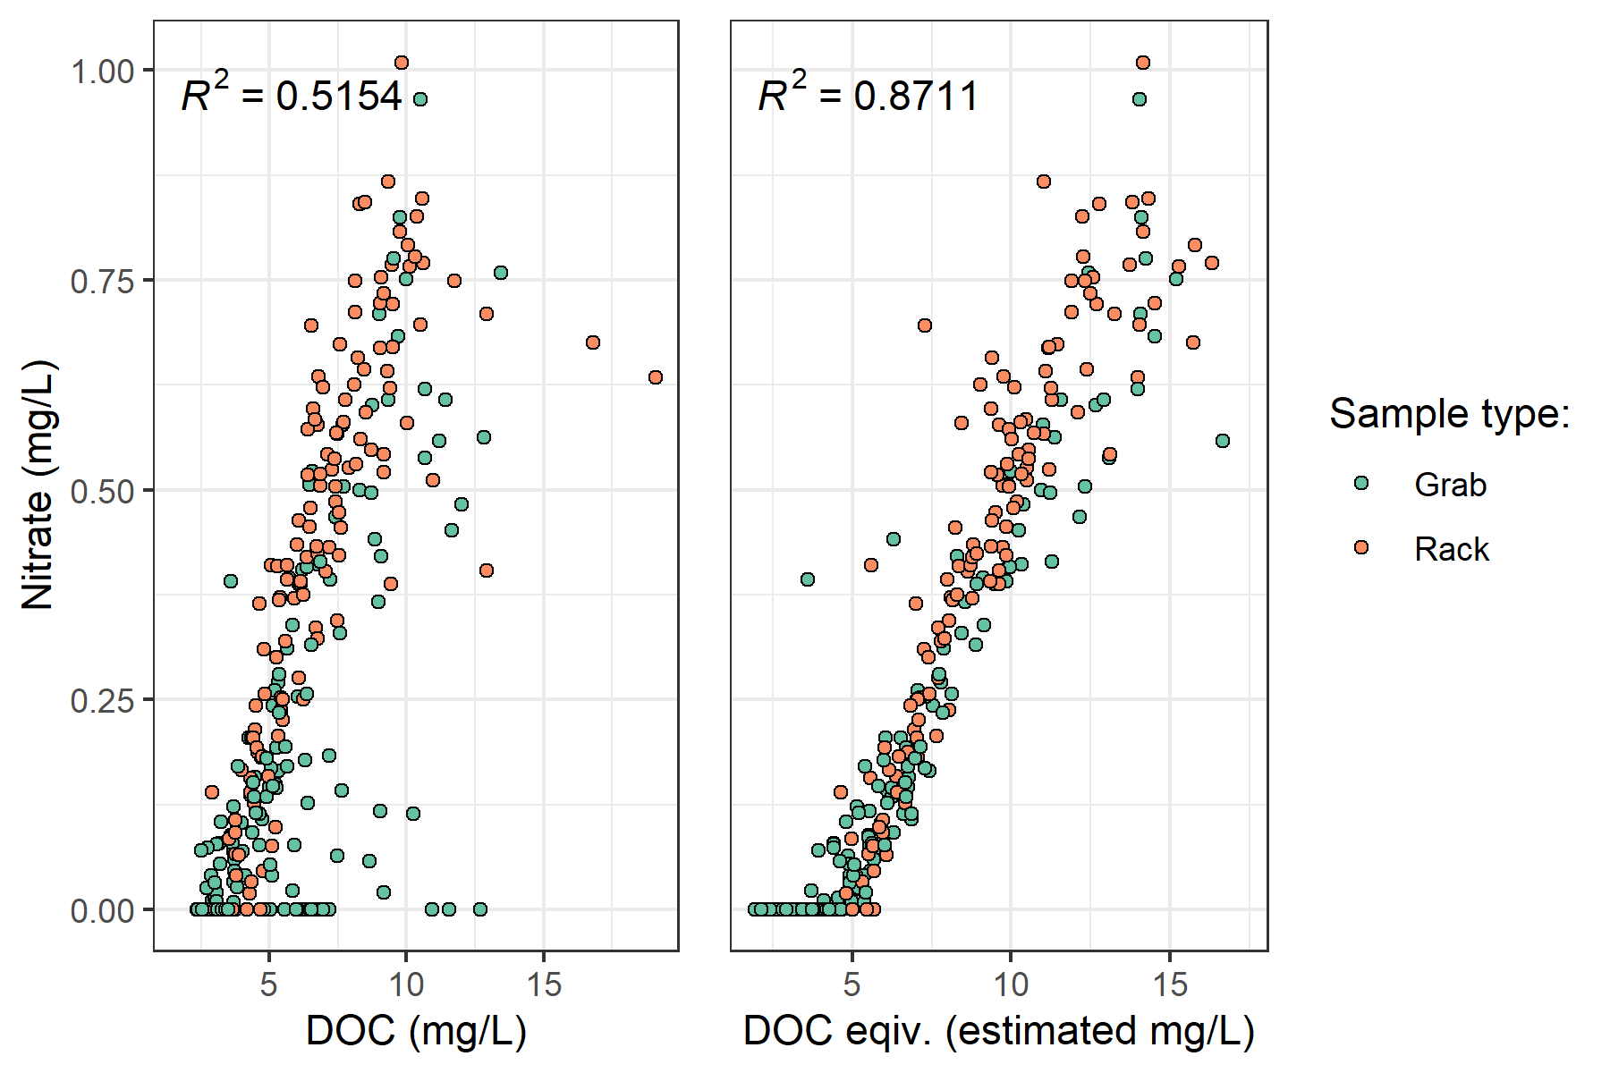

Figure 30: *Concentration of nitrate (estimated via UV-Vis absorption) and dissolved organic carbon.*

***Treatability & DOC***

Dissolved organic matter – particularly high molecular weight aromatic compounds – are precursors to disinfection by-products (DBPs), which are formed during chlorination of source drinking water. Drinking water supply for the CRD is treated simply by chlorinating raw source water, and therefore source water NOM could have important implications for treatability. To assess the potential of source water to form potentially harmful DBPs, samples were collected from four locations and sent to partners at the University of Waterloo for treatability analyses (specifically, DBP formation potentials (DBP-FPs)). Results from two sets of samples at four selected sites showed positive correlations between DOC concentrations and DBP-FPs, and even stronger relationships between DBP-FPs and UV absorbance at 254-nm – an indicator of NOM aromaticity (Figure 31). The relatively stronger correlation between DBP-FPs and UV-254 indicates that while DOM concentration is an important indicator of source water treatability challenges, the aromaticity of source water NOM may be an even more important driver.

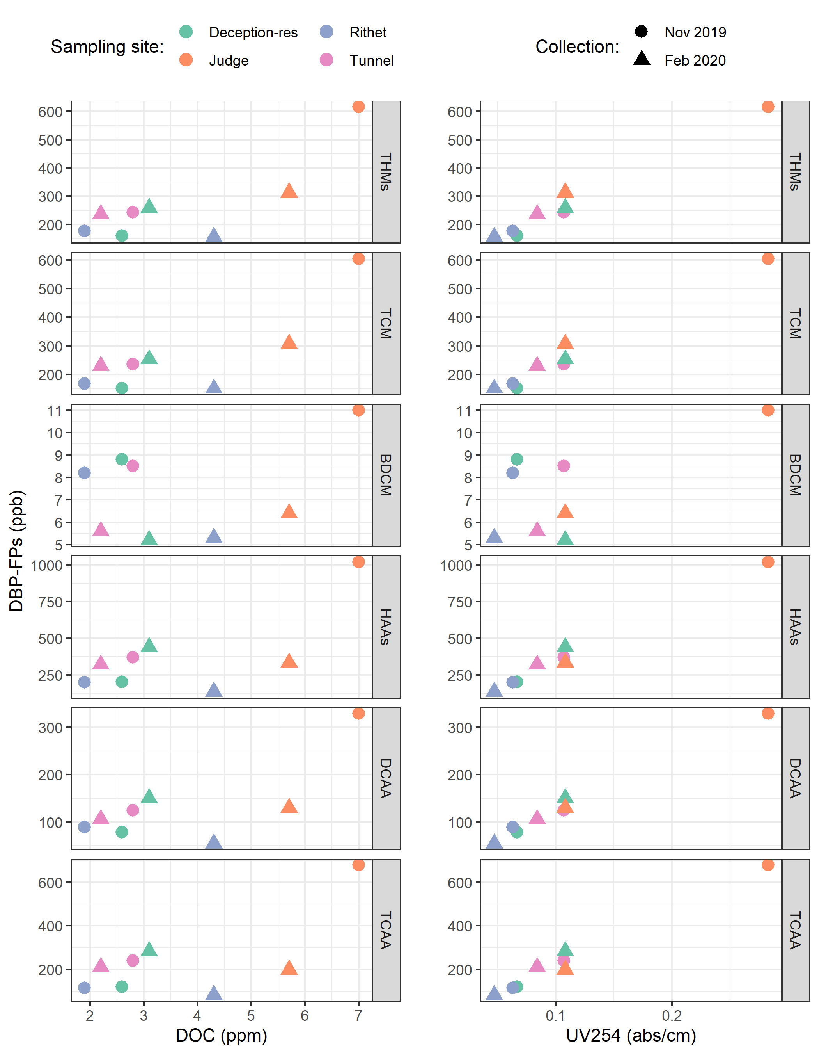

Figure 31: *Plots of disinfection by-product formation potentials (DBP-FPs) with dissolved organic carbon (left column) and UV absorbance at 254 nm (right column). Samples collected at four sites on two occasions.*

While UV-254 is a good indicator of NOM aromaticity and also appears to be correlated to DBP-FPs, naturally occurring aqueous chemicals (such as nitrate and iron) can interfere with spectroscopic analyses and lead to positive bias in DOM estimates. While aqueous nitrate may lead to an over estimate absorbance-based DOM concentrations, aqueous nitrogen can also play an important roll as a precursor to nitrogenous-DBPs when in combination with NOM, which could make UV{254} an even better indicator of DBP-FP.

* TO DO: add comparison of treatability metrics at Tunnel versus Sooke Tribs

***?***

* Gauging Streamflow (?)
* Instrument calibration
* Calibration verification (cal vers)

1. Any and all geospatial data provided by the CRD was used with permission from the Capital Regional District.
2. Following the Jan.30, 2020 major event, changes to the stream-bed morphology were evident at LeechHead (site 3) in the form of gravel and cobble deposition, and there was evidence of substantial coarse woody debris transport at ChrisCrk (site 2).
3. The Wilcoxon signed-rank test is a non-parametric paired difference test used in comparing two related samples to assess whether their means differ, or are the same (null hypothesis); it is an alternative to paired Student’s t-tests, suitable for when the differences between two sample’s means are not assumed to be normally distributed.
4. Levene’s test is used to check for homogeneity of variance (homoscedasticity), it’s an alternative to the Bartlett’s test that’s less sensitive to departures from normality in the data.